Excerpts from a Diary kept while working in the District Attorney's office during the investigation of Kennedy's assassination
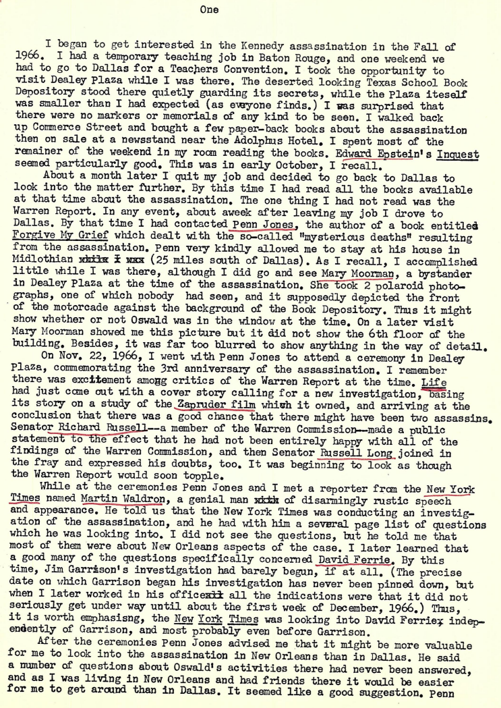
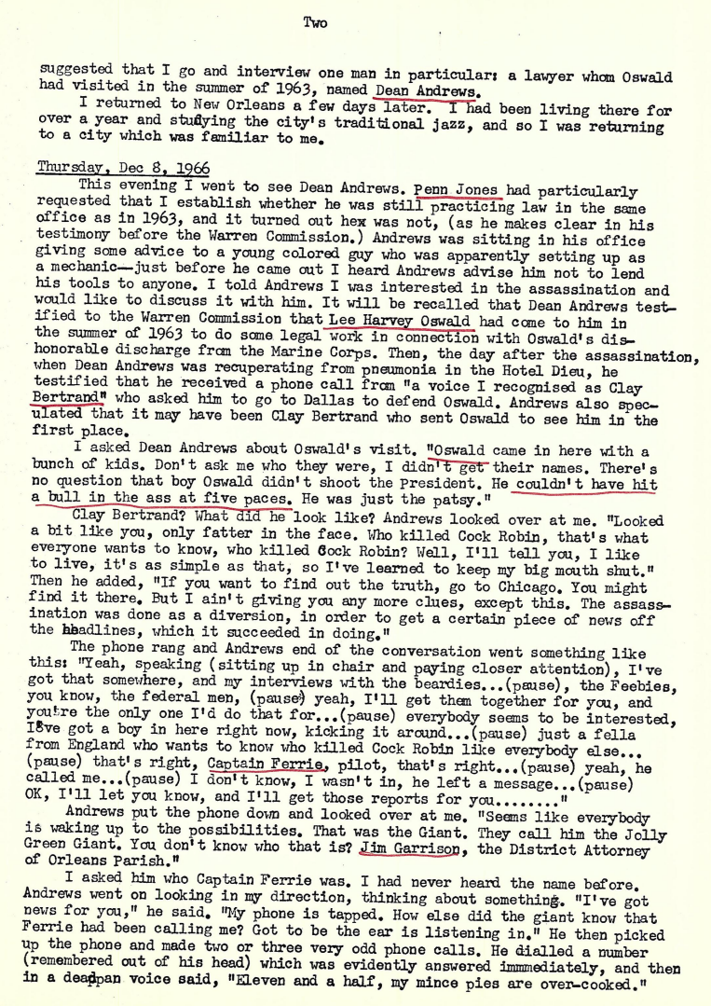
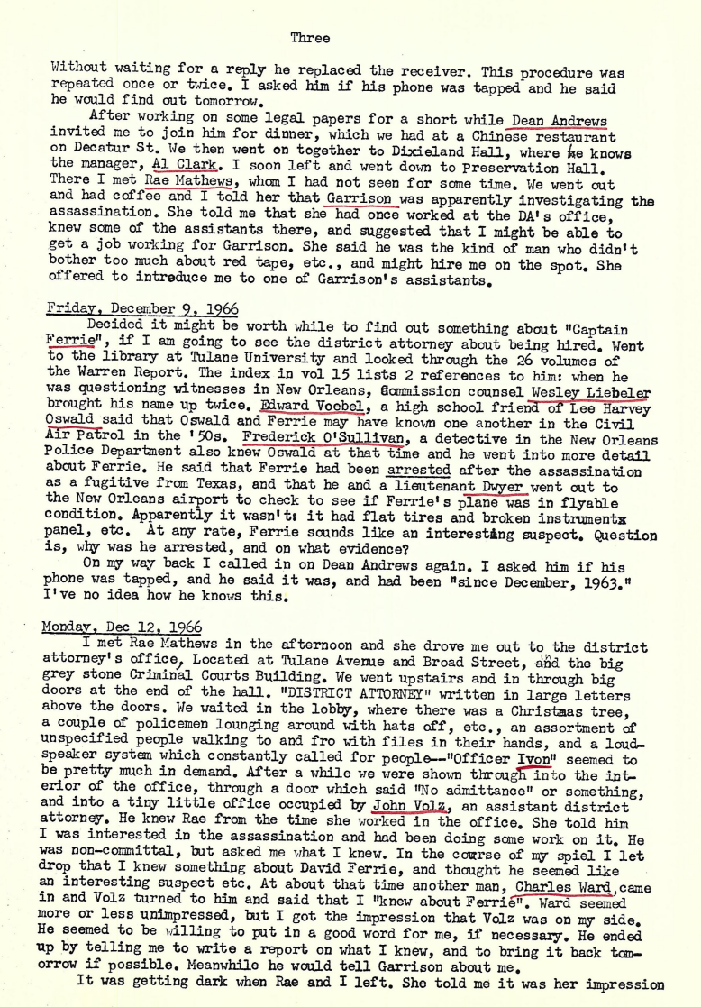
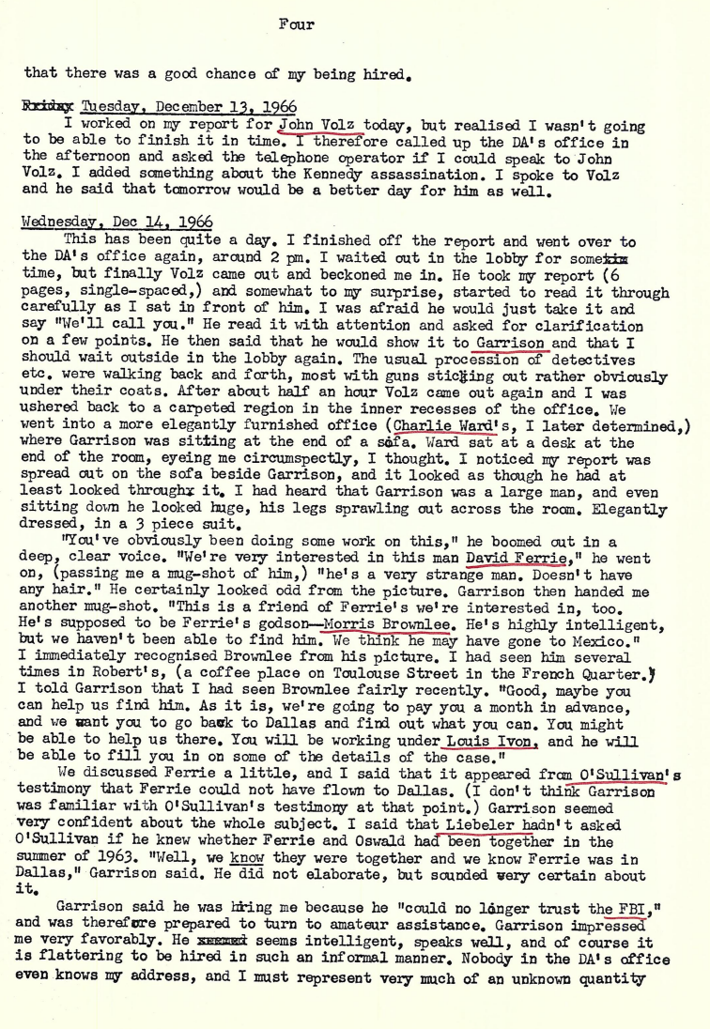
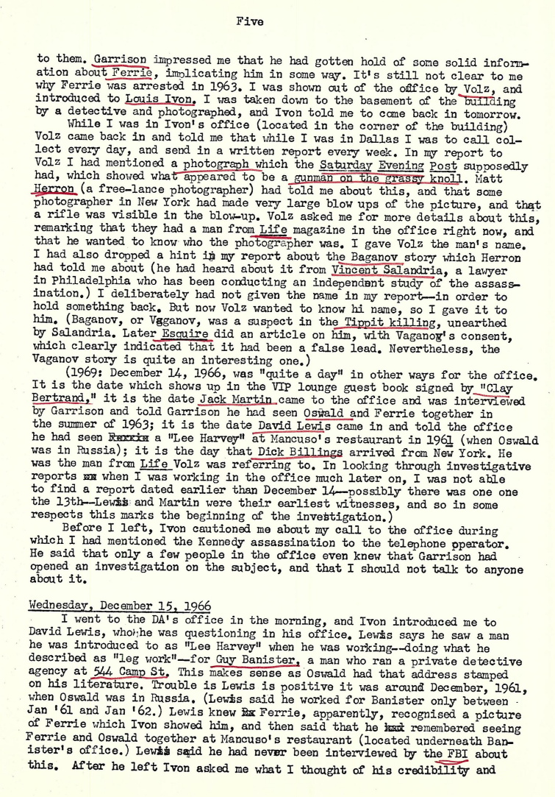
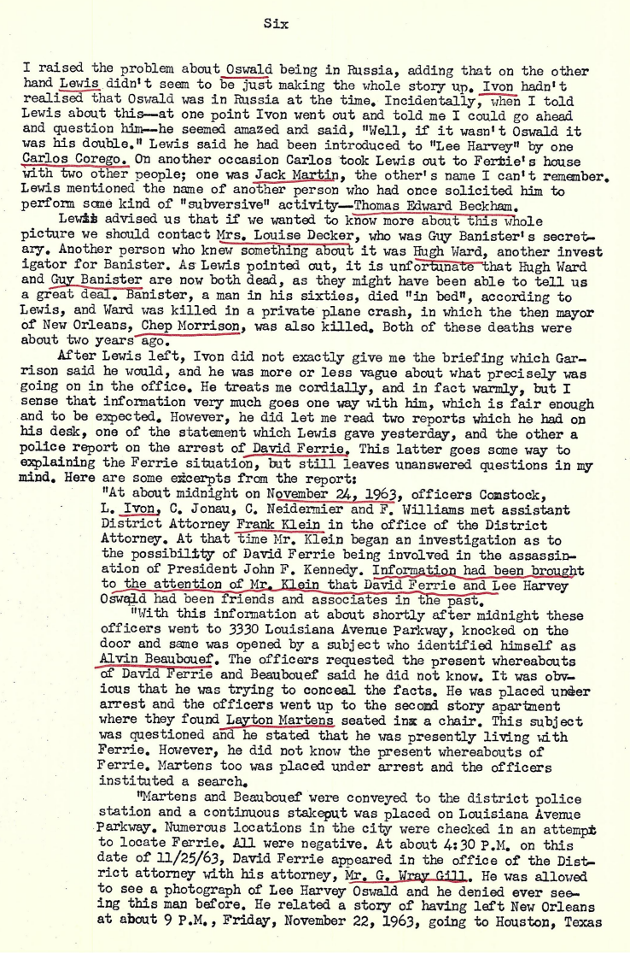
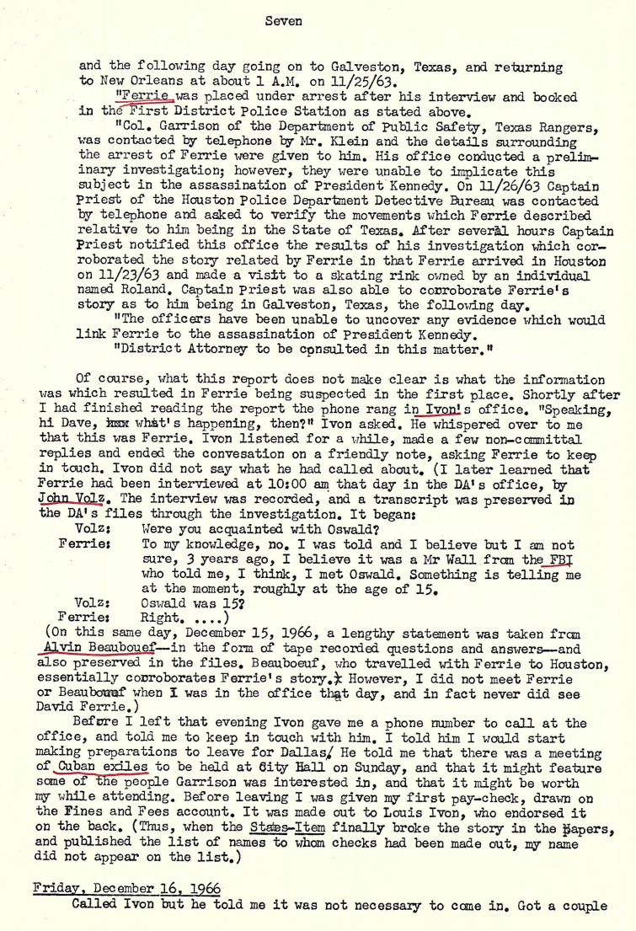
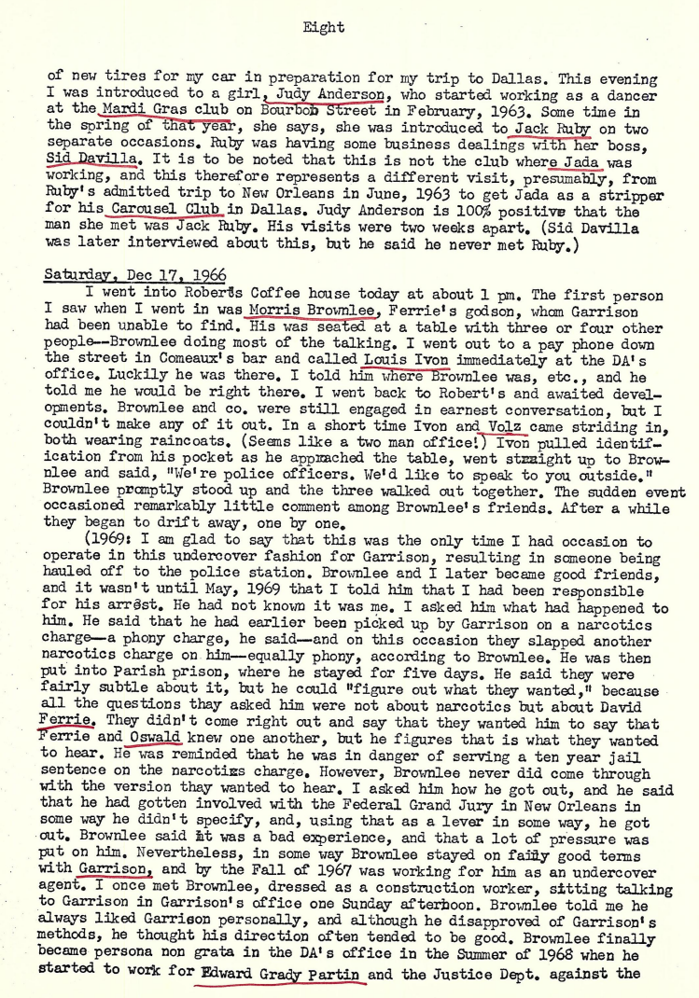
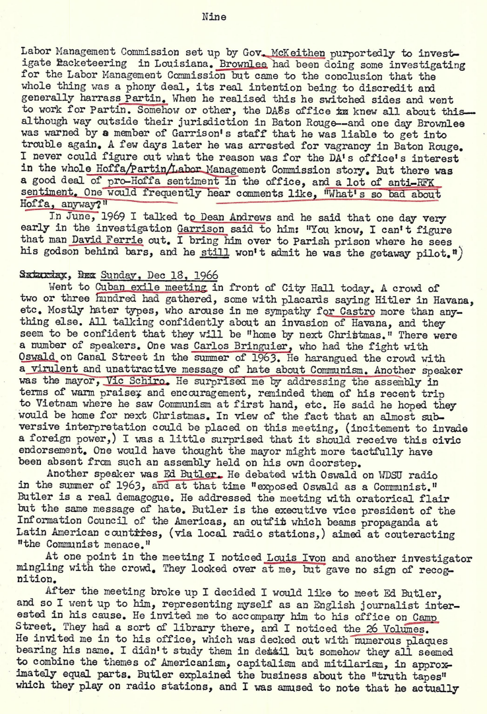
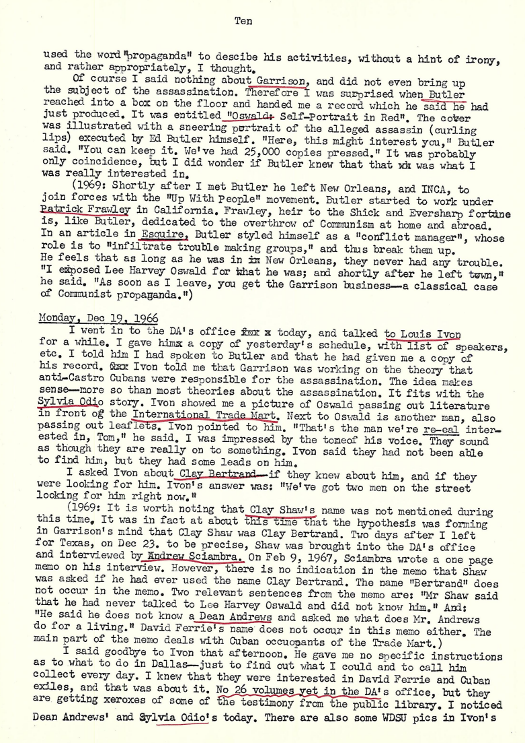
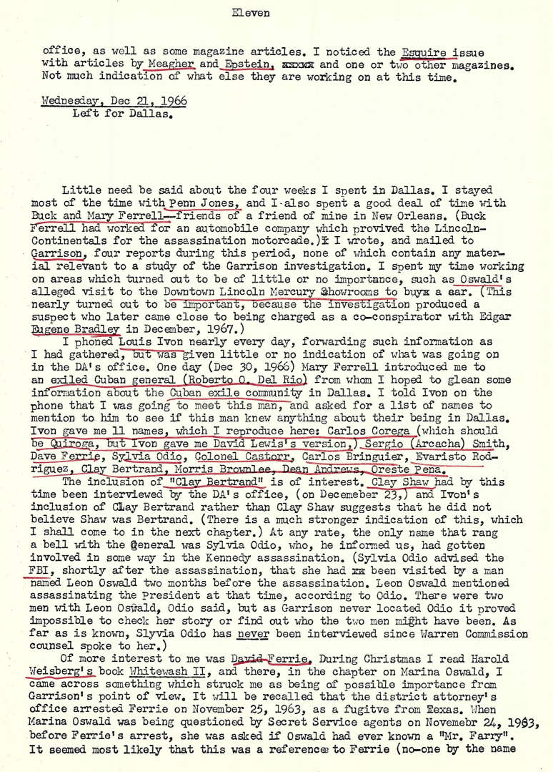
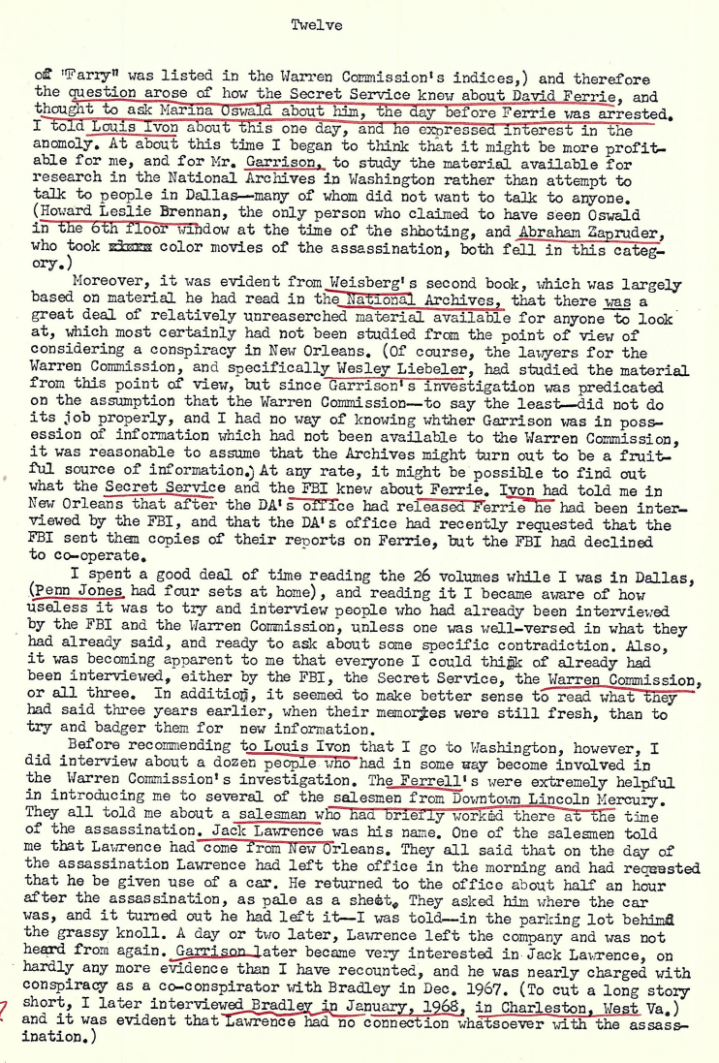
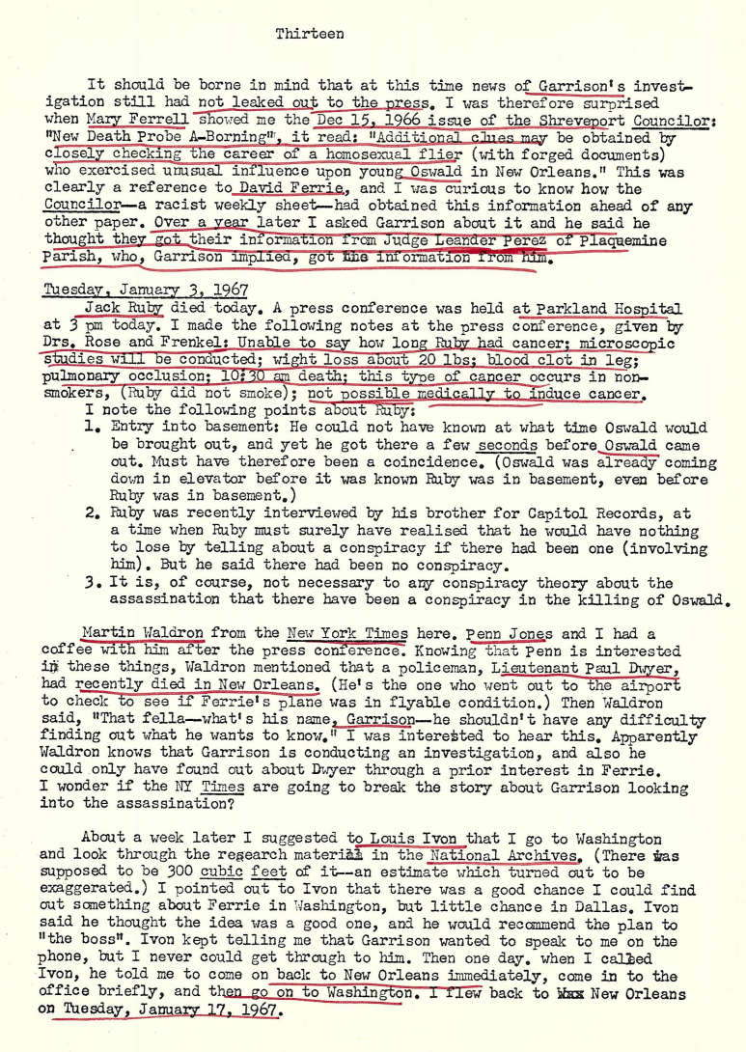
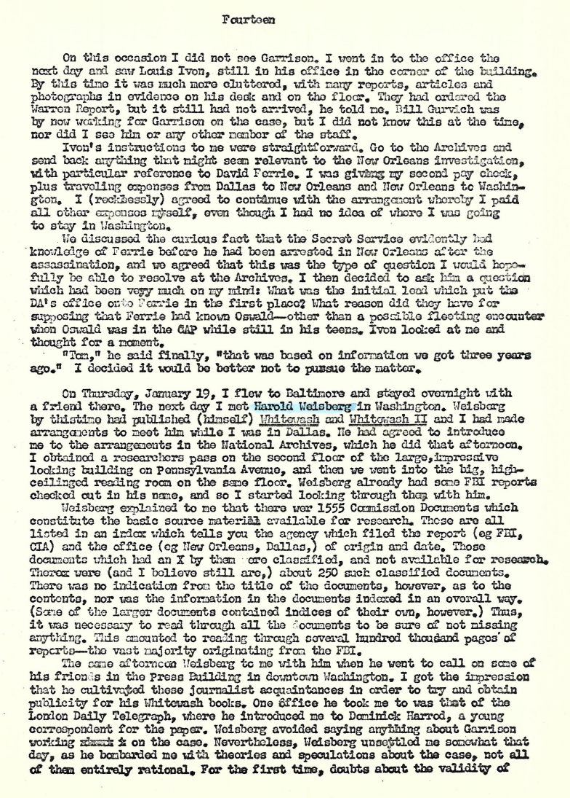
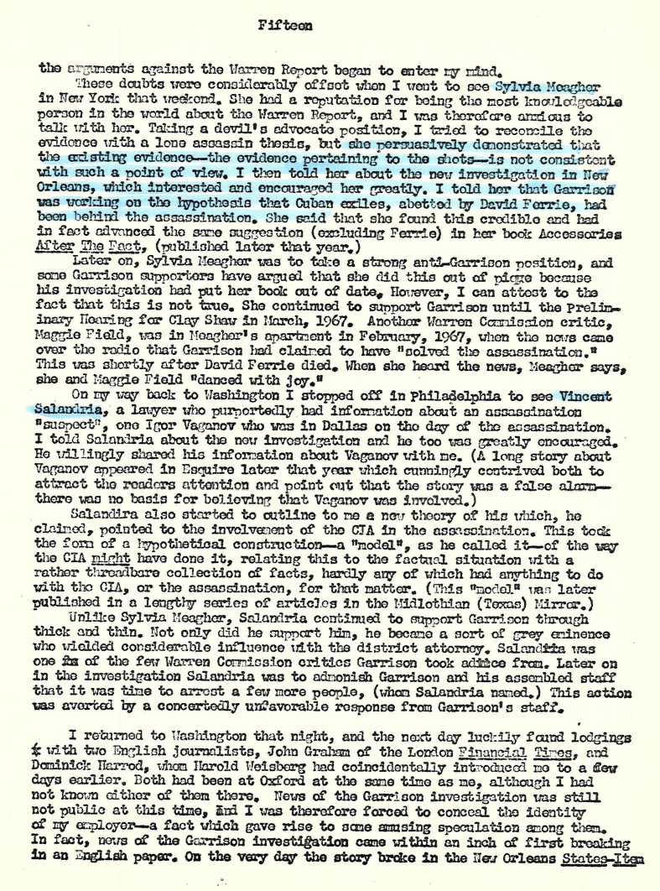
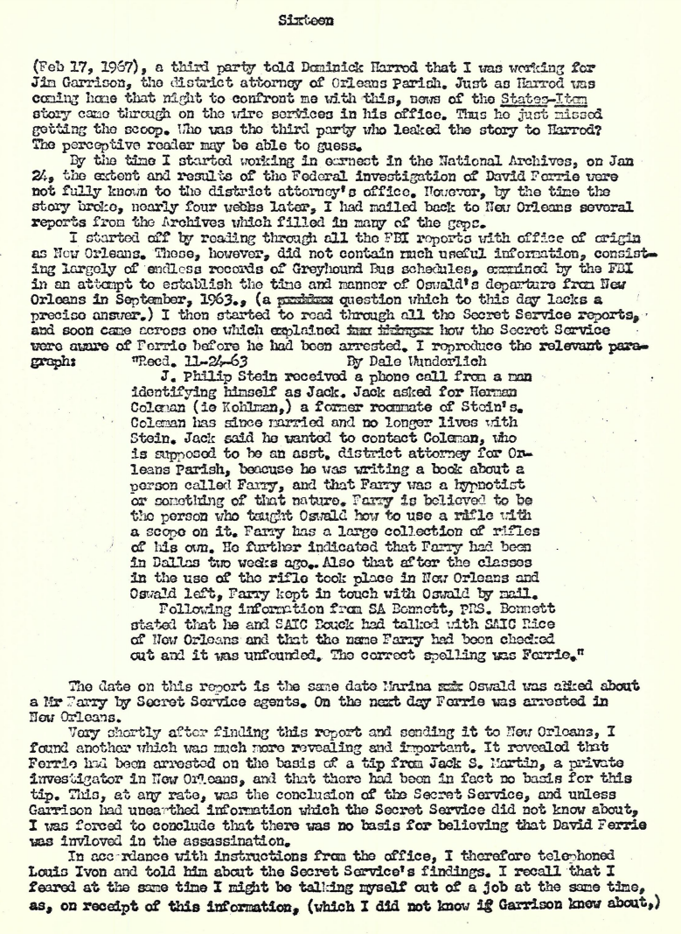
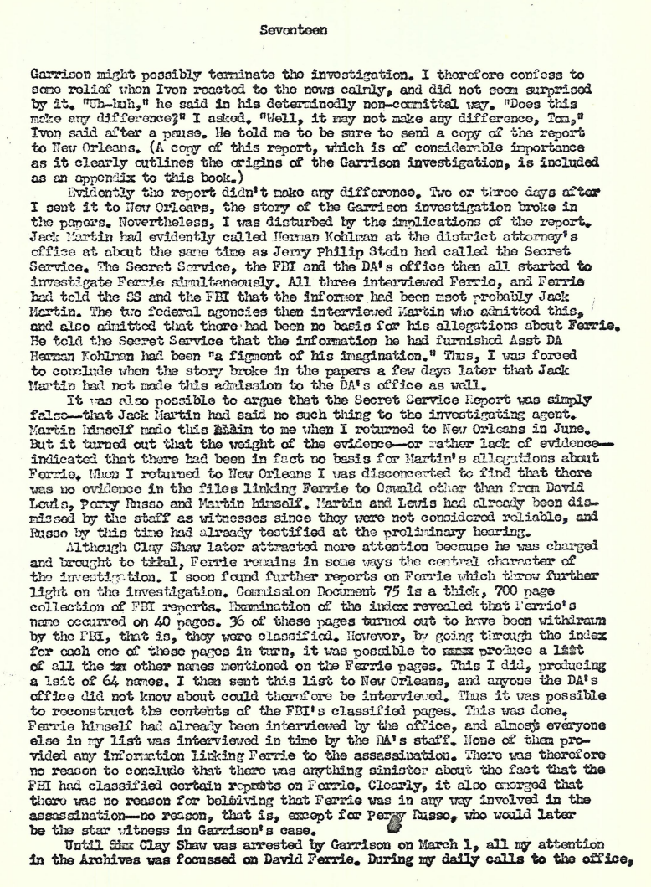
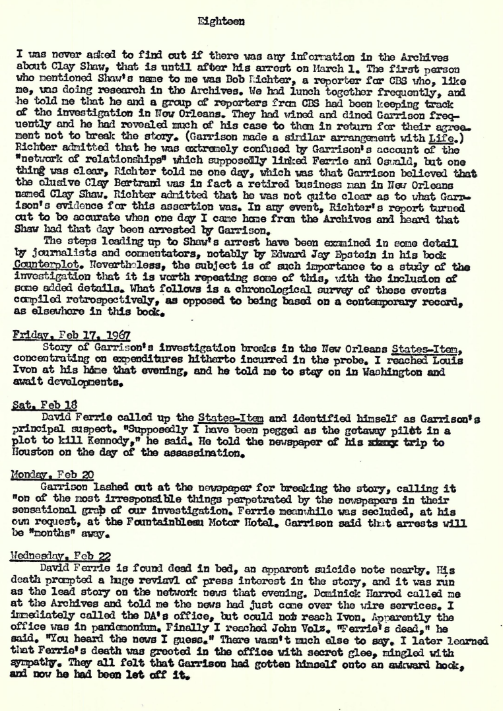
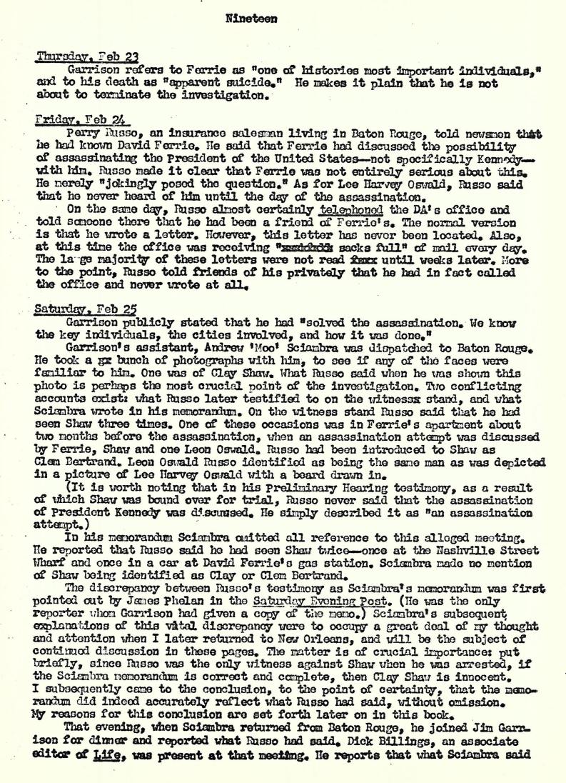
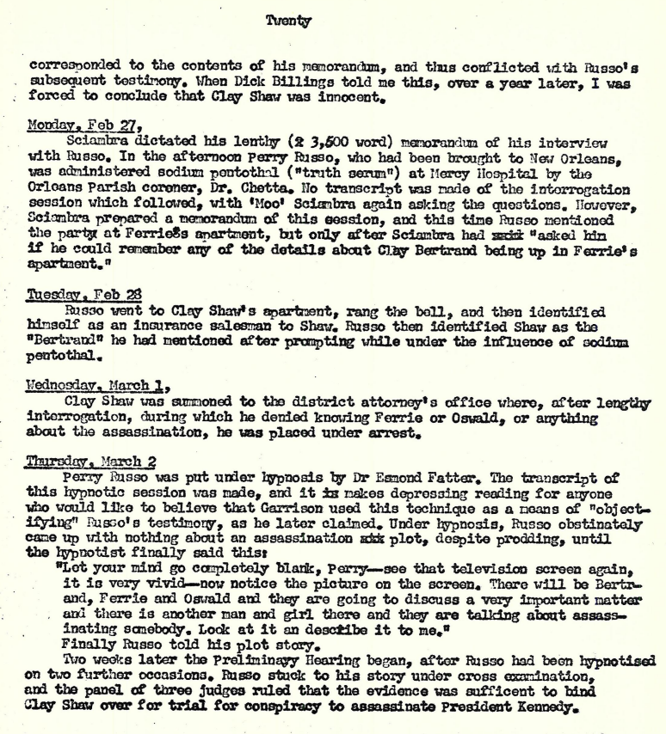

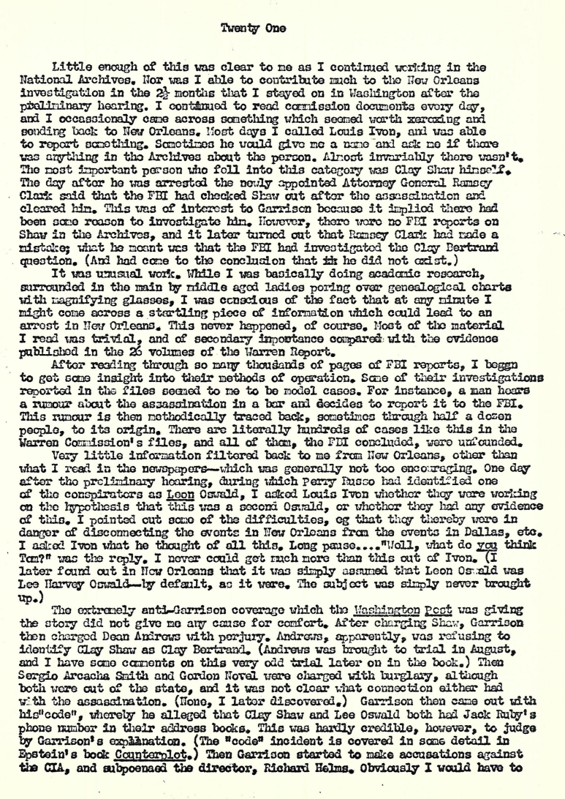
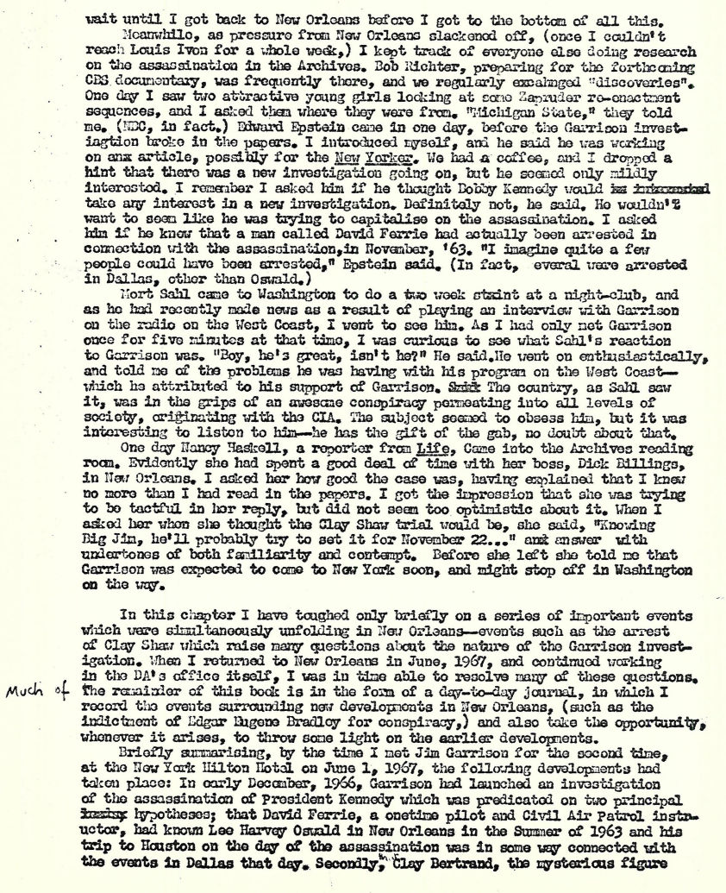
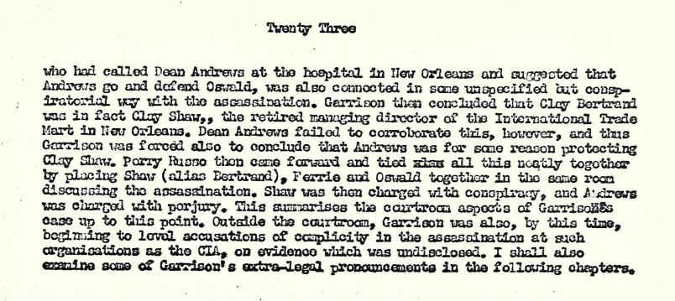
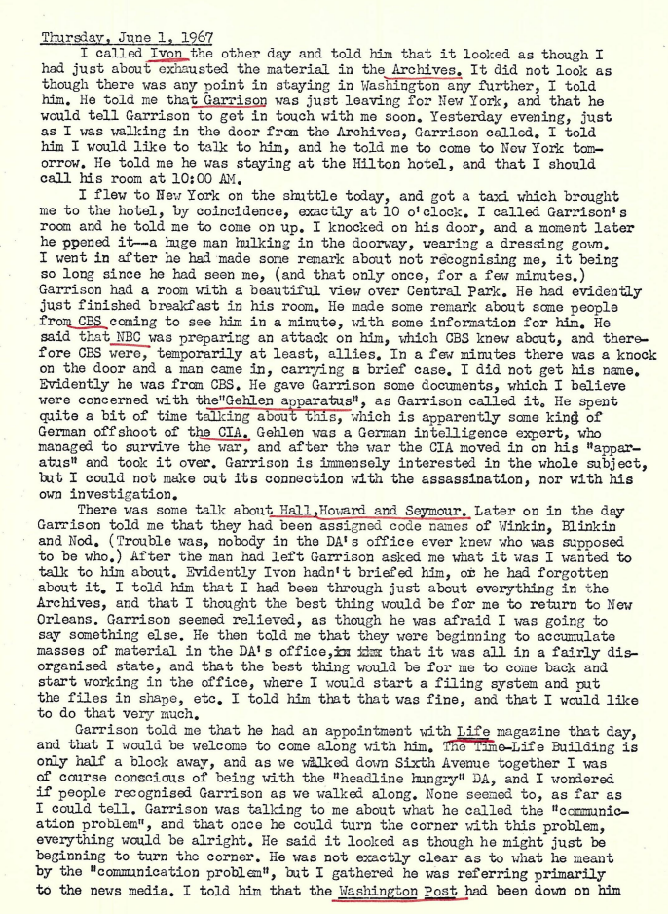
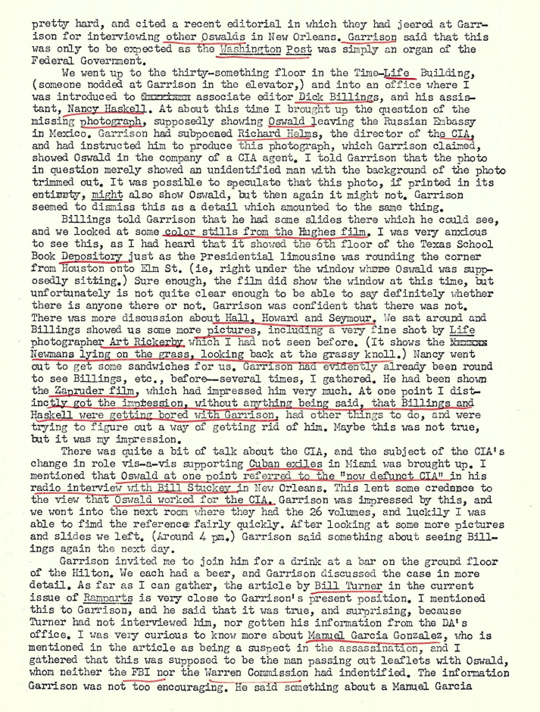
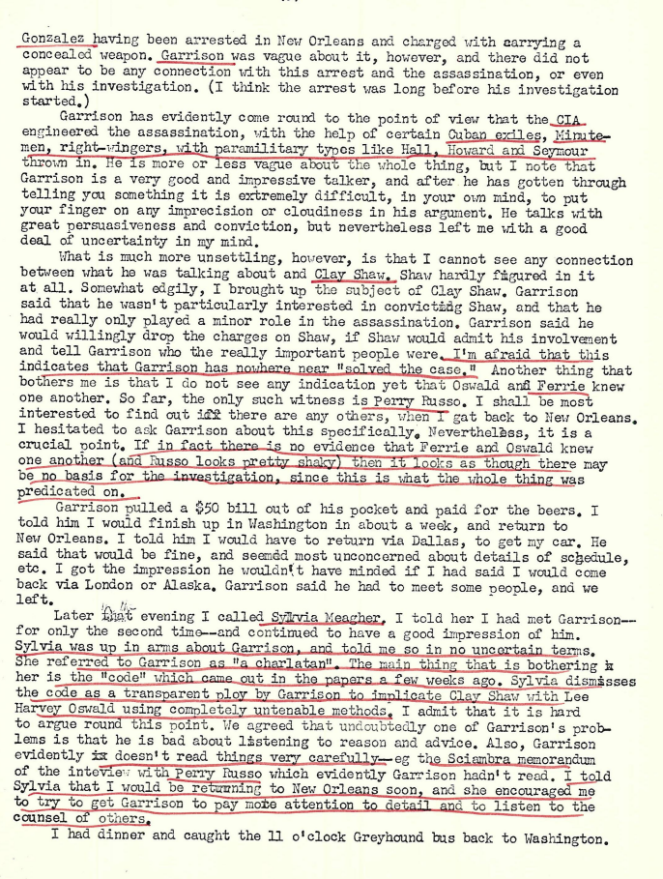
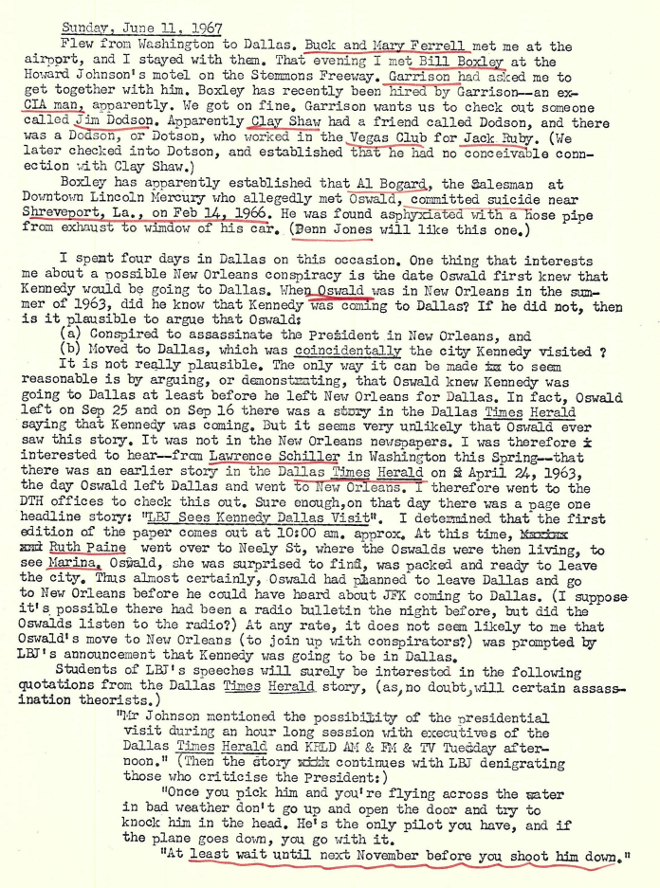
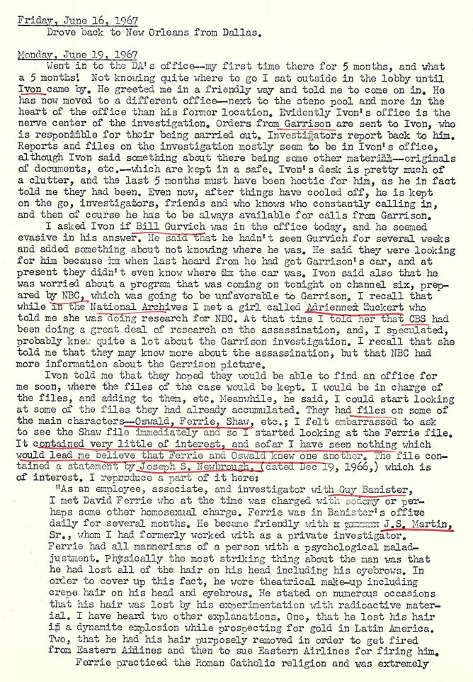
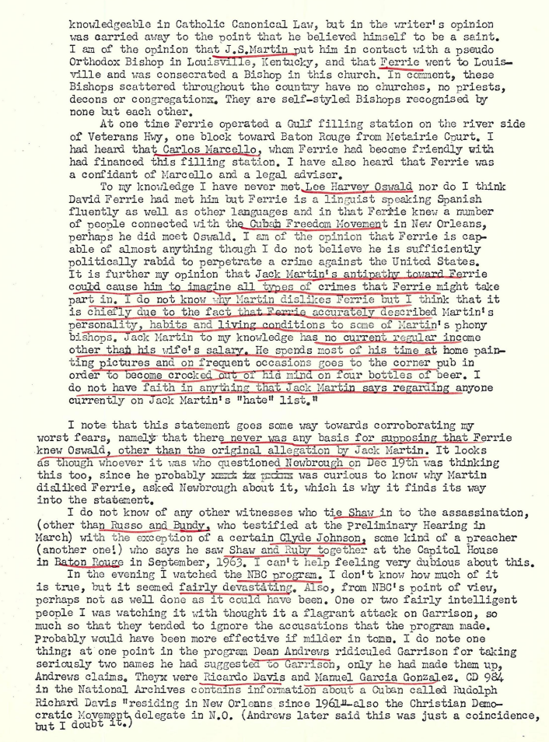
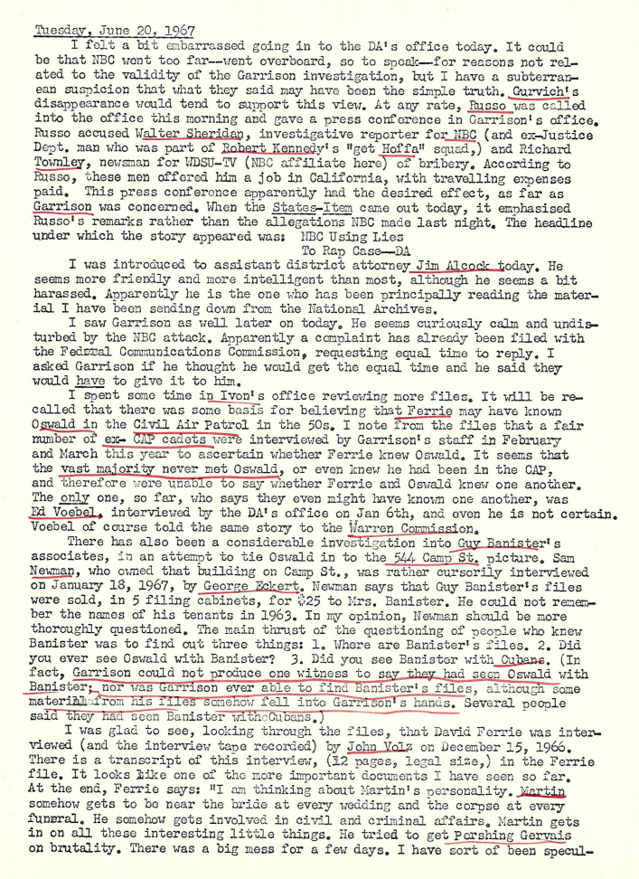
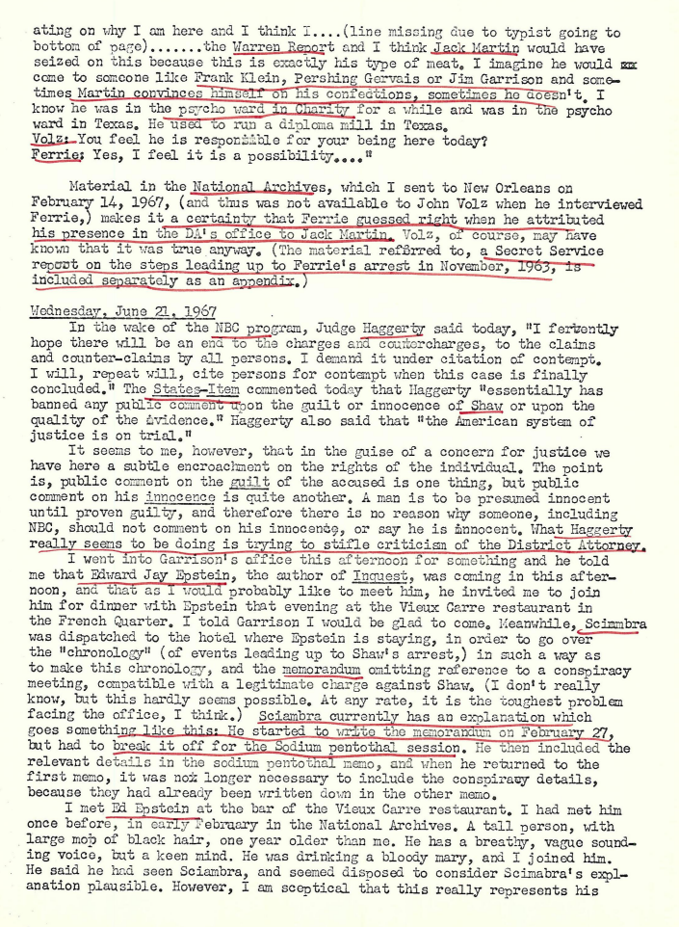
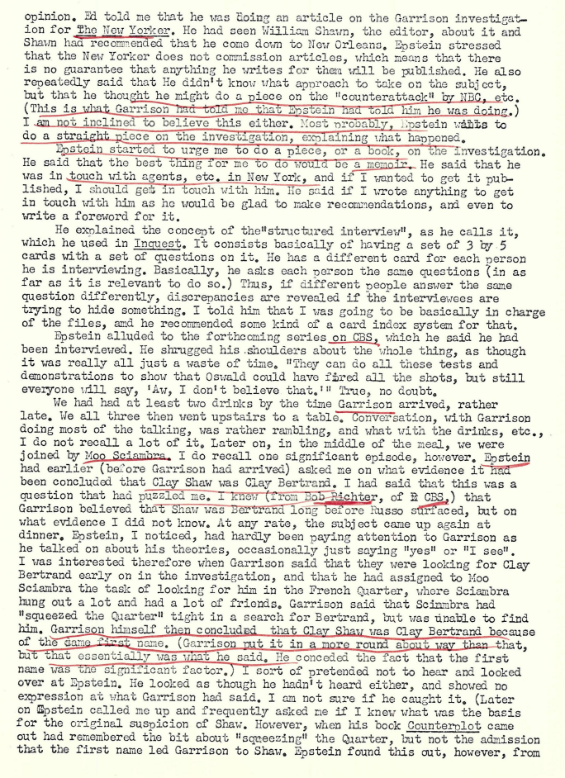
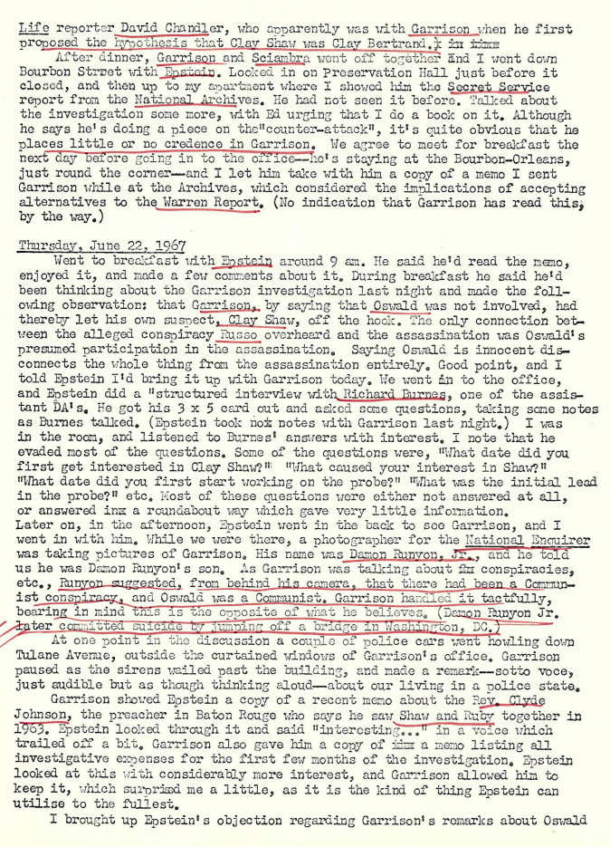
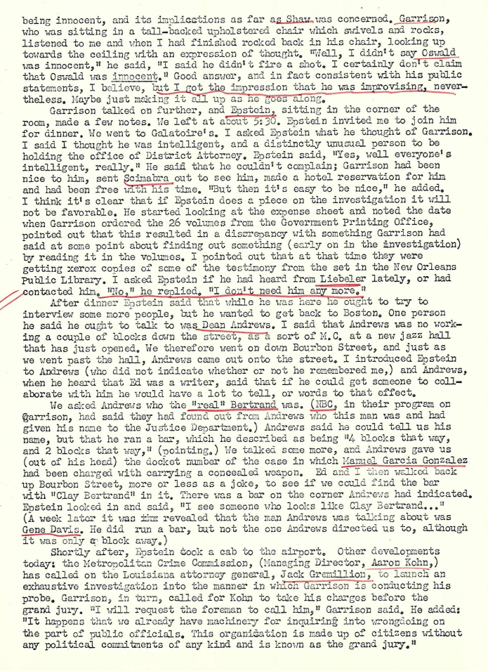
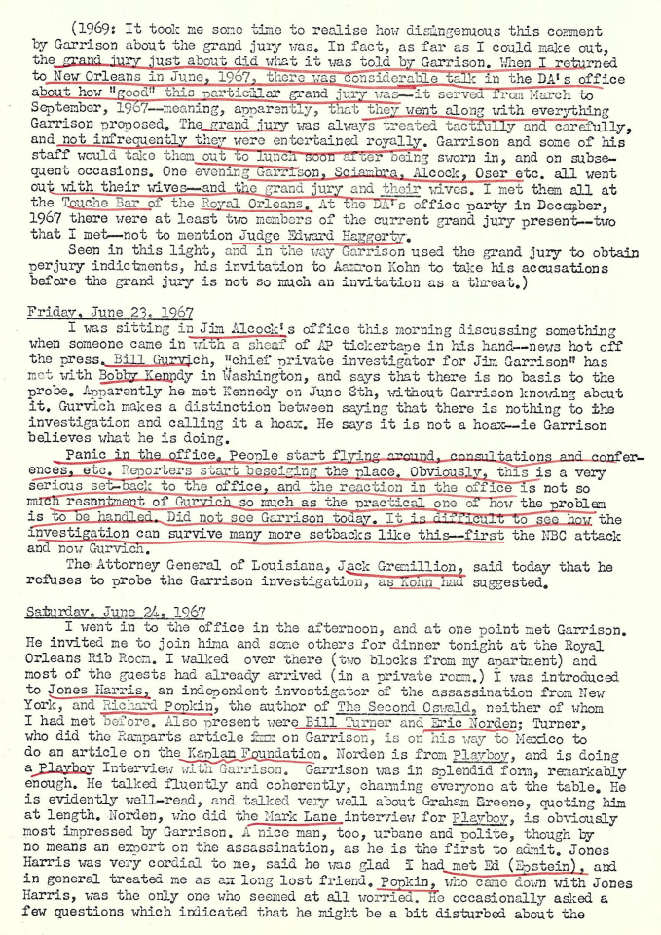
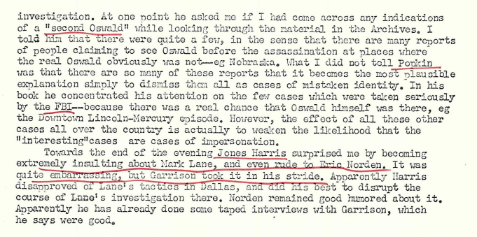
June 25, 1967
Matt Herron, photographer for the Black Star agency in NY, worked with Jim Phelan on the Saturday Evening Post article about the New Orleans investigation. I knew Matt quite well before working on this case and saw him this afternoon at his home, 315 Pine St. There were quite a few people present. He told me that he was favorably disposed towards the investigation, and wants to see it succeed. He thinks there was a conspiracy and is a friend of and thinks along the same lines as Vincent Salandria.
He volunteered the following information regarding Jim Phelan and Perry Russo. Phelan interviewed Perry Russo in Baton Rouge after the Preliminary Hearing. Also present at this meeting was Russo's room-mate and Matt Herron.
Phelan asked Russo twice during this interview if it was true that he, Russo, had not mentioned a meeting between Shaw, Ferrie and Oswald until he came to New Orleans. According to Matt Herron, Russo agreed that he did not mention such a meeting until his arrival in N.O. Herron seemed to remember Russo saying something like "I guess not" in response to Phelan saying was it not true that the meeting didn't come up until he was questioned in New Orleans. Matt Herron also said to me, "I think you've got the wrong man, Tom." He was referring to Clay Shaw, and the group of people with him seemed to be unanimous in believing that Shaw was innocent.
(March, 1969: Herron later changed his mind. I saw him in the court room on the last day of the Shaw trial with Vincent Salandria. At the end of Dymond's closing argument I saw Matt standing alone and I asked him if he believed that Clay Shaw was guilty. He simply said "Yes".)
Herron added (June 25 ‘67) that Phelan is "still working on the case", and that he, Phelan, would submit affidavits at the trial testifying to the above mentioned meeting. I asked Herron why Phelan was still working on the case in view of the fact that his article had been published and he said that Phelan "is interested in detective stories."
Herron also stated that it was his impression from talking to Phelan that Bill Gurvich was now collaborating with Phelan. Matt said that if called upon to testify to this meeting he will do so as he was there; however, he said he was not prepared to "put anything in writing" at this stage. He was passing this information on to me because he wants the assassination probe to be successful in its outcome.
Aug 14, 1967
Dean Andrews trial. Andrews is being charged with making 2 conflicting statements: 1. that he can't say whether or not Shaw is Bertrand, and 2. that Shaw is not Bertand. This means that he is being charged with making a statement with one that is in conflict with one that would lead one to suppose Shaw is not Bertrand. I.e., it looks as though the state is trying to get Dean to corroborate that Clay Shaw is not Clay Bertrand. The whole thrust of the Andrew trial is very injurious to the Clay Shaw case. I pointed this out to Jim Alcock and he said: "I know, it hurts us."
August 19, 1967
I talked to Alcock today; he seems to be the most intelligent, and the most communicative person in the office. He said several things, some of them astonishing. First, he told me that Gene Davis had called Dean Andrews at the Hotel Dieu. I asked him how he knew that and he said that Davis had called him and admitted it. It now begins to look as though Gene Davis really is Clay Bertrand, inasmuch as anyone is. Alcock suggested that Dean might have just made up the name Bertrand. He said there was a rumor that there had been a nurse at the Hotel Dieu while Andrew was there named Clare Bertrand, and that as far as he knew nobody checked this out.
Alcock went on to say that it was the first name "Clay" that was the initial lead as far as Clay Shaw was concerned. I suspected that this was true but this was the first time anyone in the office had admitted it. He said that Shaw had refused to take a lie detector test, and that he feared Shaw's lawyers were soon going to publicise the results of a test which he believed Shaw had taken in Illinois somewhere. He said he would like to subpoena and question Marina Oswald. Mainly he wanted to know if Oswald was ever away at night. Alcock also said he was worried about the business about the beard.
He added that he thought the arrest of Clay Shaw was possible a case of mistaken identity, and that he had qualms about taking the case. I mentioned that we should make a formal request of the FBI that we be allowed to see the classified FBI reports of David Ferrie. I said that otherwise there was a danger that the defense would produce them at the trial, that they would contain nothing of interest, and moreover that the defense would establish that we hadn't even requested to see them. Alcock agreed that we should do this.
Aug 25, 1967
I arrived in Dallas on Aug 24, and was met by Bill Boxley at the airport. We proceeded directly to Marguerite Oswald's house in Fort Worth. Boxley introduced me to her and told her that I represented the DA's office, adding that he hoped we would be able to go though the material pertaining to the assassination which she had been accumulating, and had suggested we might be interested in. (Earlier, to Boxley.) However, Mrs Oswald did not appear to welcome the suggestion, and made it clear that it wasn't going to be that easy to get her to part with her material.
She soon launched into a lengthy discourse about her personal misfortunes, explaining that she had spent a great deal of money on her own investigation, including phone bills as high as $500 a month, and that although she had made about 200 TV appearance[s] she had only been paid $100 on 3 of them. She added that she had recently been wondering where the next meal was coming from and at this point momentarily broke into tears. However, she soon recovered and said, "I hold all the cards, I am the mother, you've got to bring the family into this."
Nevertheless, it was her contention that it would be unwise for ger to reveal any of her significant data to us, as the best way to do it would be in a book, which she seems to want to write, (and later added would be as big as, and considerably more important than, William Manchester's book.) It soon became clear that Mrs Oswald was unable to distinguish between us and newspaper reporters, and although Boxley carefully explained to her that we represented the DA's office in a case which might exonerate her son from having fired any shots, she plainly still regarded us as reporters trying to get a story.
Mrs Oswald showed no interest whatsoever in the New Orleans investigation, and asked no questions about it, as I should have thought she might. In particular, it was striking that she at no stage inquired if we had obtained any evidence which would exonerate Lee Harvey Oswald and it was clear that her interest was not to "clear his name", as she had maintained. She wanted to be at the trial though. "I should be at Shaw's trial, just for the prestige, have the mother there fighting for her son." She just seemed to imagine herself on the witness stand, "with Shaw", in some vague but important capacity. I told her that she could not be a witness unless she had previously told us something of sufficient importance to merit it, but she made no response.
She then went into a diatribe against reporters who had cheated her. Overall, Mrs Oswald gave us no significant information and the whole trip was a waste of time. We also saw Mrs AC Johnson at 1026 N. Beckley, and she showed us the layout and told us that Oswald was quiet and near, and on most days called someone from the payphone in the house, speaking in a foreign language, which she since surmises was Russian. She said he would call twice and sometimes 3 times a day.
Aug 30, 1967
Critics of the Warren Report are nearly always not aware of the extensiveness of the FBI's investigation. I was in the position till I went to Dallas, and more especially the National Archives and read through their voluminous reports. Sciambra has reported the same experience as a result of his trips to Louisiana towns, and certainly Garrison must be in the same position. E.g., early in the investigation he wrote a notation on a memo to get copies of the hotel register where Oswald stayed in Mexico City, and also Dallas YMCA records. Both were published in the 26 volumes.
The NBC program seems to have misfired from a publicity point of view. Quotations from letter to Garrison:
"My heart goes out to you in your fight for justice. . ."
"I ask that you not be discouraged by this horrible unfortunate abomination . . . may God bless you."
"The poor ignorant public (me) is searching for a champion, so don't let us down. I recall Frank McGee solving the Kennedy affair on TV the first day so how could we expect any change out of him."
(Letter to NBC, copy to Garrison:) "It is evident from your recent broadcast on the Garrison investigation that your true purpose was to create a doubt about any activity which might tend to throw light on the assassination of our beloved President Kennedy."
Alcock said something about Santana the other day. Can't remember his exact words but they were to the effect that Santana was just a Cuban fisherman who happened to be in jail at the time, and knew nothing whatsoever about the assassination.
Cynical thought for the day: Ferrie and Oswald are both dead. It's surprising therefore that we don't have a few witnesses who say that they knew one another as neither is around to rebut it. I think that's what Garrison wanted to get out of Brownlee. (Ferrie's godson)
Sep 7, 1967
John Volz indicated how he became involved in the case. Returning from Shreveport with Garrison when G. asked him if he had seen the Esquire article about the assassination. They picked up a copy at the news stand and Garrison told him to read it. He said they only had 2 or 3 people working on the case and they were told not to say anything about it. Volz told me, which I already knew, that precautions were taken in the office not to let this leak out. They were planning to arrest people before there was any publicity about the investigation. Typists were kept in the dark: Oswald was referred to in memos as "Smith" or "Patsy", and Ferrie was known as "Lindberg."
Life was in on the investigation early, as was CBS. Neither was going to break the story until Garrison wanted them to.
Volz made a trip to Dallas in late January to investigate the 3128 Harlendale story mentioned by deputy Sheriff Buddy Walthers. He came back with a negative on it, which he said didn't please Garrison too much. There was a lot of kidding of Volz about this later, and when people saw him in the office they would say, "There's nothing there, chief," which was what Volz apparently had told Garrison. Volz stopped working on the case about a month after his trip to Dallas. Too many of the legal staff were getting tied up, he said.
Sep 8, 1967
Garrison told me in his office that he was sorry I was underpaid, and to make up for it he told me it was alright for me to go ahead and keep xeroxes of anything I wanted. He said he was sure I would want to write a book about my experiences "when I got back to England." Couldn't quite figure this one out. He said he also had a private file at home which he thought would be of interest to me. (March 1969): No doubt it would have been interesting, but I never did see it.)
Sep 9, 1967
Boxley back from Baton Rouge, where he was investigating "Clinton." All top secret. He was talking to Garrison about it in G's office and I got the feeling I was not welcome when I went in. Advance copy of Playboy arrived and Garrison asked me what I thought of the interview. He said: "To me, it's like the taste of water." I told him it was OK because more specific than the later revised drafts he had sent off. (He had said at one point that the great thing about the Playboy interview was that you could write the questions as well as the answers.)
I asked him how Gordon Novel became involved in the case, He thought for a moment and said Novel came in and offered to help with electronic equipment, on the proviso that they didn't implicate him as a result of what he told them. Garrison agreed to this and Novel told about the Houma burglary episode and his connections with Ferrie. Garrison then found out, he said, that Novel had been taking pictures inside the DA's office and selling them to Walter Sheridan. He then reneged on his agreement with Novel.
I asked Garrison what he thought about David Lewis as a witness; he didn't seem to have much of an opinion. I then pointed out that Lewis was one of the few linking Oswald and Ferrie. He didn't know this, or at least pretended not to realize it, and I then pointed out the trouble with the dates. (When David Lewis was originally interviewed in the DA's office, Dec14, 1966, he had been quite positive that the date he saw "Lee Harvey" at Mancuso's restaurant was in 1961, when Oswald was in Russia. I was in Ivon's office with Lewis on that day, the day I was hired.) Garrison then said something about Lewis later correcting the date.
I stressed to Garrison the importance of a Ferrie-Oswald link- in my opinion, I said, the most important connection in the case. He said maybe he would have to "re-evaluate" Lewis as a witness.
Sep 10, 1967 (Sunday)
Went to the office in the afternoon. Sciambra, Alcock and Garrison were there, Ivon also came later, They were discussing the "Clay Bertrand" signature found in the guest book of the VIP lounge at the airport. Also discussing the motion to quash set for tomorrow. All seemed confident as to the outcome; it would take one day and Garrison seemed to know what questions the judge would permit, (especially of Russo.)
There was a discussion of the Pizzo exhibit. I asked Garrison if he had identified the other man passing out leaflets in the picture and he said: "What do you mean, have we identified him? That's Manuel Garcia Gonzalez." He then qualified this in some way.
The role of Life magazine was discussed. Sciambra was in favor of breaking off diplomatic relations. However Garrison and Ivon are evidently in favor of "keeping channels of communications open." I pointed out it seems they must be holding back some information on Hall, Howard, and Seymour, as they seem so interested in them. Sciambra said he got the impression from Boxley that Life weren't giving us everything. Problem with Life, as Sciambra pointed out, and Ivon later confirmed, is that they have a copy of our files whereas they have given us very little.
Note: What leads was Garrison working on when he began his investigation?
- Looking for Ferrie involvement.
- Dean Andrews-Clay Bertrand
- Harlendale Street, (Dallas).
- Mrs Sylvia Odio. (A xerox copy of her Warren Commission testimony was in Ivon's office when I went there mid Dec. 1966.)
- Pizzo exhibit. (Ivon showed me this picture in mid Dec, pointed to the man later known as Manuel Garcia Gonzalez, and said: "That's the man we're real interested in, Tom."
Monday, Sep 11, 1967
Mark Lane arrived, and I met him for the first time. I went into Garrison's office for something, and there was Lane quietly sitting in a corner.
Sep 12, 1967
Shaw motion to quash over. The decision by the judge is next Monday. I went out to dinner in the evening with Mark Land and his wife Anne-Lise. Contrary to the publicized impression, I found Lane quiet, tactful and thoughtful. He told me about his new book, "Mark Lane Replies." At one point I told Lane that there was a certain irony in his supporting Garrison, because he had supposedly been retained by Oswald's mother to defend (posthumously) her son. Garrison's case against Shaw, I reminded Lane, is contingent upon Oswald's guilt since Shaw is accused of conspiring with Oswald. Lane's reply was: "I have never maintained that Oswald is innocent. Nowhere in ‘Rush to Judgement," do I say that Oswald is innocent."
At Felix's, Land and I were discussing the Dean Andrews case and Lane had started to say something about Prentiss Davis when we were advised by someone sitting at the next table (very crowded together) that he was one of Shaw's lawyers -- Panzeca. Had never seen him before.
Lane is playing a quiet game and not asking me any embarrassing questions!
Sep 13, 1967
Bill Turner arrived in town, and I met him at the airport. He is doing an "Award Book" on the Garrison probe. Turner stayed a full week and went through the files in the "Archives" -- my office, xeroxing material and taking notes. He displays particular interest in the "paramilitary" connections in the case -- Minutemen, etc.
Wednesday evening I went out to dinner with him, Boxley, and Mrs Mae Brussell. Mrs B., from Carmel, Calif. has done vast research on the Russian community in Dallas , nearly all of it a complete waste of time it seems to me. She has cross-indexed it to the point where her notes on DeMohrenschildt, for instance, are almost valueless as being more voluminous that his original testimony.
Sep 14, 1967
Mrs Brussell, Mark Lane, Bill Turner, and Bill Boxley all competing with me for a place in my office. In the evening, Turner, Brussell, Boxley and I went out to Garrison's house for what he termed a brainstorming session.
Garrison more or less help the floor and discussed a wide range of topics in his inimitable way. I took the following notes. Dave Ferrie, he said, deposited $7000 in his bank in November, 1963. Garrison added that Ferrie "discontinued his association with Cubans after the assassination." The head of the National States Rights Party was George Soule, and Garrison said they held a convention here in August, 1963, at the Fountainbleau Hotel. This is the same group that was talking about killing Kennedy in Miami and discovered by the Secret Service. (The "Miami tape.") There was then something from G. about this group recently forming the Anglican Old Orthodox Catholic Church, which I couldn't quite follow. Garrison is very interested in these ad hoc church groups, mainly because Ferrie belonged to one. He sees them as covers for espionage and CIA type activity. Garrison believes that the Abundant Light Temple (or some such name) near where Tippit was shot in some way played an important role in the planning and execution of the assassination.
Garrison can sometimes talk extremely amusingly about things like this. You reach a point where, not only do you not believe what he is saying, but you realize he doesn't believe it either. You realize he is just putting on a kind of amusing performance. Often it is difficult to see the dividing line between when he means what he says and when he is joking. I remember once, one Sunday when we were holding staff meetings in the middle of the day, he started to talk to the assembled lawyers about the paramilitary operation in Dealey Plaza. I think everyone was a bit uncomfortable, sensing that Garrison believed what he was saying and that no one else did. Soon, however, he got carried away and was talking about "platoons of National Guardsmen" hiding in churches, "infantry movements", "armored convoys" moving through Dallas, underground canteen facilities in a huge dugout under Dealey Plaza, and so on. Everyone was completely broken up with laughter, which of course Garrison appreciated. He only does this when he is in a good mood.
Tonight, however, he was more serious and concluded about Ferrie: "The lines are gossamer lines, but when you find them they lead from Dave Ferrie to Nazi-ism, Fascism." He added that Ferrie's trip to Houston was "more interesting than if he had gone to Dallas." His phone records for Nov. 1963 were missing too. (Not sure if this is true. I have seen Ferrie's phone records but don't recall.)
"Reily and Monahan were both Directors of the Crime Commission", Garrison said, and added that they worked for the Reily Coffee Co. which employed Oswald. Garrison said that this company "is more that a coffee company."
On July 15, ‘63, there was an Eastern Airlines hearing in Miami regarding Ferrie. Banister testified strongly in Ferrie's favor, and, as Garrison put it, "went way beyond the call of duty." Later that week, G. explained, Oswald says to Adrian Alba: "Pretty soon I'm going to get the pot of gold at the end of the rainbow." Then on Friday he leaves the employ of Reily.
Garrison pointed out that 544 Camp St (which Oswald had on his literature) is the same building as 531 Lafayette, Banister's address. "Guy Banister's office is the key to the case," Garrison said. He may be right. I always feel more comfortable when he talks about Banister because he seems like a good suspect. Garrison then said, "We tunneled (sic) into Dallas from the back." I'm not sure what he meant by this, however.
He said something about there being a statement from a man who says Alba took him to a Minuteman meeting. Conversation turned to the Minutemen type, and the kind of man who is nuts about guns. Garrison's comment: "They ought to get these guys and send them to Vietnam. Give them a physical on the plane." I agree.
Garrison has been doing a great deal of research into the various Ruby or Crafard notebooks published in the 26 vols, and the Oswald address book. He's quite proud of this research, and reckons he's probably the world expert in this sub-topic. (He probably is.) He says the annotation "Midland 2550" occurs in the Crafard book and "Newton 2550" in the Oswald book. Garrison suggest these are "Callsigns" on some radio frequency. (I'm not sure that G is right that both these annotations do occur, but he might be. I checked and could only find one, the Oswald one I think.)
Earlier on, (about a month ago,) a guy called Jim Hicks had come to see Garrison in his office one Saturday afternoon. He said he had been in Dealey Plaza when JFK was shot, although I recall he had 2 versions as to which side of the street he was on. This evening Garrison told us that Hicks has a drunken driving rap hanging over his head. He now wants us to write to the D.A. in Oklahoma to get him off. This is obviously the explanation of Hicks' visit.
Garrison says he is issuing a Grand Jury subpoena for Loran Hall, and then said something about Hall possibly suing him. "He may end up living in this house," Garrison said.
Garrison is more confident these days, since the discovery of the name ‘Clay Bertrand' signed in the airport VIP room guest book, dated Dec 14, 1966.
Sep 15, 1967
‘Plot or Politics' by Rosemary James & Jack Wardlaw published. Can't remember anything else today.
Sep 16, 1967
Went out to dinner in the evening with Boxley and Turner, and we later met Garrison at the Boucherie, with Sciambra and girl friend. Garrison in genial mood, being recognized etc. Being introduced to girls and leaning forward embracing them in a friendly way. I mention the Phelan rumor (to the effect that there is going to be "a break in the case" later this year,) to Garrison, but he does not think the break is likely to be all that important and in this respect he is probably right.
Sep 18, 1967
The judge ruled against the motion to quash today. At lunch with Alcock, Lane, Turner and Boxley, Jim Alcock expressed some concern over the fact that the judge appeared to be rushing to trial, and in particular regarded it as his prerogative to set the trial date because we had filed a motion for speedy trial. In Alcock's view, both the prosecution and the defense would like to have the trial delayed. He is not looking forward to it at all. After the NBC attack on Garrison in June, Alcock expressed amazement at Garrison's behaviour: he now had very good grounds for requesting a continuance in the case, but what does he do? He files a motion for a speedy trial. Alcock shook his head in (slightly amused) disbelief. A. thinks the trial will either have to be late October or January, in view of the Xmas recess and the jury being locked up.
Chandler Brossard, a senior editor of Look magazine is in town. He is a slightly oddball character with unconventional views; apparently a great admirer of Garrison. He is doing a ‘visit piece' for Look. I went to dinner with him, Boxley, Turner, Mark & Anne-Lise Lane, at Antoine's. (The tab was $80.01, paid for by Boxley who was reimbursed by the DA's office.) There was something of an altercation between Brossard and Lane, which was still going on outside Antoine's door as we left. As I recall it, Brossard was saying what a lousy magazine ‘Playboy' is, and Lane, (who had reaped benefit from it in his ‘Playboy interview') disagreed. The argument escalated from then on but I didn't pay much attention.
Brossard said he thought there were only three good magazines in the country: Ramparts, The New York Review of Books, and The Realist: a very odd view for a senior editor of Look.
Today Matt Herron filed a report on his negative investigation in Dallas (last January) in an attempt to establish a phone call link between Ruby and Oswald.) This investigation was predicated on some information he received earlier from Penn Jones, and Herron then got a short assignment from Billings of Life to check it out. Nothing came of it, however.
I finally wrote up a memo on Jerry Hemming's visit. Hemming came to see us last July, and as I had nothing about it in my diary earlier, I will put something here. I quote from a letter I wrote to Edward Epstein, dated July 25, 1967:
"We were recently paid an unannounced visit by two Americans who were intimately connected with Cuban exile groups in the summer of 1963. One, Gerry Patrick Hemming, was even dressed in fatigues. The main purpose of their visit seemed to be to point an authoritative finger of suspicion at Hall, Howard and Seymour, (to an extent that we began to wonder if they knew that others were involved and were trying to protect them.) Gerry Patrick told me the following story which I thought might interest you.
"According to Gerry Patrick, (he usually drops the Hemming,) there were in 1963 numerous "teams" with paramilitary inclinations out to "get" Kennedy. Some of these teams had been approached by wealthy entrepreneurs of the H.L. Hunt type, (though not, I think, in fact H.L. Hunt) who were interested in seeing the job done and even provided financial assistance. Then, on November 22, 1963, Kennedy is shot down on the streets, ("Maybe Oswald got there ahead of them," Patrick commented,) and then for 2 years or so, there the story rests.
"However, since all the mounting controversy of the last 12 months, a startling new development has occurred, according to Patrick. Recently, members of the "teams" have been returning to their sponsors, taking credit for the assassination, and at the same time requesting large additional sums of money so that they won't be tempted to talk about it to anyone. In turn, the sponsors have apparently been hiring Mafia figures to rid themselves of these blackmailers.
"Gerry Patrick admitted that his own association with some of these extremist groups in 1963 has recently been causing him some concern. Incidentally, this may very well be the true story behind the Del Valle murder in Miami, reported this spring in the National Enquirer."
Tuesday Sep 19, 1967
Effect of the Life articles on organised crime, (Life: Sep 1 & Sep 8, 1967): Garrison has instituted a grand jury investigation of organised crime, and has offered to resign if any found. Kohn, he says, also should resign if none is found. On the filing front, a ‘Mob' file was instituted, casually, by Garrison. It contained a memo which G. had evidently just written.
Brossard expatiating in my office about America, which he refers to as "the jerk-off machine." He talks quite amusingly and much of what he says I agree with, eg. the deplorability of accepting the notion of education as a panacea. He says Americans "encapsulate experience" in such a way that the experience does not affect their lives in any way. He have this example: if a conspiracy of top level origin to assassinate JFK was unearthed, this information would be immediately "encapsulated" and no action would result. In a country like Spain, he says, there would be a revolution.
Brossard went out to dinner in the evening at Garrison's home. Boxley and Turner had dinner at the Lanes.
Sep 20, 1967
Turner left in the evening and Garrison left for New York. He has some TV appearances resultant from his Playboy interview.
Sep 22, 1967
I had lunch with Mark Lane alone and we discussed the case more frankly than before. He admitted the uselessness of propinquity as an incriminating factor -- something Garrison has been going on about and apparently sincerely believes in. Lane speculated as to the possible innocence of Clay Shaw: "Wouldn't it be something if he was innocent," or words to that effect. He gave me the impression that it was a thought which had never occurred to him before. I told him I thought Shaw would be acquitted on the evidence I have seen. Lane said he thought there would be a "public investigation" of the probe if Shaw were acquitted. I don't necessarily think so.
Lane is quietly going through the files, (Mancuso, Sheridan, Sandra Moffett, recently,) occasionally xeroxing material. Naturally, I am concerned by Lane's presence as he could be trying to usurp my position. His position is beginning to become clearer to me: he is basically out for himself and would like to see his position vis-a-vis the Warren Commission vindicated by Garrison. I got the feeling today for the first time that he may have realized he might not be backing the right horse. He is definitely a calculator, and I feel may be prepared to take a calculated risk on the outcome of the case. (If I were in his position -- best seller behind me -- I would be strongly tempted to get quickly into another field.) He is clearly in a quandary: an extremely ironical position in view of Shaw's guilt depending on Oswald's.
Wrote to Paul Hoch and Popkin. Reviewed the Nagell file and consider it a complete waste of Bill Martin's time and office money.
Sep 26, 1967
The defense filed a motion for a 6 month delay in the Shaw trial, or alternatively a change in venue. Alcock, Burnes, etc. are obviously pleased with this opportunity to establish a stronger case against Shaw in the interim. Alcock said that as an alternative to the judge actually ruling in their favor -- an unlikely contingency -- the state might file a reply which contained an exasperated preamble alluding to our desire for a speedy trial, and goes on to agree to the defense's request, for purported reason of possible reversal later on if denied. In this event, Alcock said, the judge would have to accede to the united front presented by both sets of lawyers.
Mark Lane on WVUE TV 11 o'clock news, and alleged that Life's organized crime series is in reality part of an "orchestrated attack" on Garrison, and said that they (Life) had photos, etc. which would destroy the Warren Report, but refused to publish them. (What nonsense this is. Presumably he is referring to the Zapruder film, which anyone can see in the National Archives, and segments of which have been published about three times in huge color spreads in the magazine -- most particularly in an article which called for a new investigation and brought Garrison into the fray!) Lane then made an made an indiscreet remark about Aaron Kohn's grand jury statement -- revealing that he knew what Kohn said before the grand jury, which he is not supposed to know -- and also mentioned Billings, Garrison and he having dinner together. I'm afraid Lane sees things purely in terms of public relations, TV appearances, etc.
Sep 27, 1967
Garrison returns with McKeithen from New York. Apparently they were shown additional data by Life, which prompted McKeithen to admit that there was organized crime in Louisiana. Everybody in the DA's office is terribly upset that McKeithen "blew his cool", as they put it. I saw Garrison in the office later on, and a few other people were there. He was really mad at McKeithen. He said, "He's got a wonderful face, he's got the face of a wagon train leader traversing the continent, but when he got back to New Orleans, this BLOB stepped off the plane." He then gave the speech he would have given if he had been Governor. I wish I had had a tape recorder because it was a tour de force. I don't remember how it went except that the first sentence went: "I don't have to APOLOGIZE for the STATE OF LOUISIANA . . . ." After that I was just hypnotized, like everyone else in the room. I remember thinking that he would only have to make a few speeches like that and he could get elected Governor wherever he likes. I never saw Huey Long, of course, but I imagine Garrison could have made him look like an amateur.
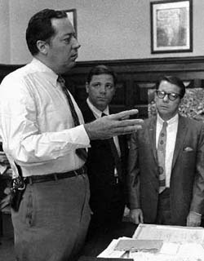
Garrison with assistant DAs Andrew
Sciambra (middle) and James Alcock (right).
Monday Oct 2, 1967
In the morning my phone was put in and I arrived at work at noon. Garrison was there and he was in one of those moods when he wanted me in his office. He discussed various things. Penn Jones' new book had arrived and he was amused by the chapter headings: ‘Deaths,' ‘More Deaths,' ‘Still More Deaths.' He also went over my memo on Oswald in Mexico, (he has some theory that Oswald's brother went to Mexico.) He then complained that people call him all the time and he has to "absorb their energies," as he put it, and meanwhile gets nothing done. He also wanted me to call Jones Harris re "Helms", and John Hall (a lawyer) in Tulsa re Jim Hicks.
I spoke to Jim Alcock later in the day, and he started out be expressing pessimism about the case; he complained that no-one was working on the Shaw case and we were really going to have to get down to it. He said his reply to the defense motion was such that a compromise would be arrived at as to the trial date, and he implied it had already been arranged with the judge that the trial would be in January or thereabouts.
A lead which has developed is that Tommy Cox (listed in Shaw's address book) is supposed to have admitted something about Shaw's alleged involvement to a third party, and we are now trying to find Cox, so far without success. Alcock then discussed the case in general and said he was not at all looking forward to the trial. He said Shaw may in fact have used the name Bertrand, and Russo's meeting may have taken place, but he said that he doubted Shaw was really responsible for any overt act.
He repeated to me that Eugene Davis had admitted calling Dean Andrews at the Hotel Dieu, and he said he would like to question Davis further. (No development re ‘Clare Bertrand' at the hospital.)
Alcock discussed Ferrie and pointed out he saw no reason to believe Ferrie was involved. I asked him if we had any witnesses other than Jack Martin or David Lewis who linked Ferrie and Oswald. He said no, and then added that Lewis was "a liar", and that anyway Martin didn't ever claim seeing Oswald and Ferrie together. (Not so. At one point, Martin did make such a claim. He might have added that it was surely more than coincidence that Martin and Lewis both came into the DA's office with matching stories on the same day, Dec 14, 1966, incidentally the date in the guest book at the VIP Lounge. Also, later on Matin and Lewis were sharing an apartment together.)
Also, Alcock pointed out that right after Ferrie was released on Nov. 25, 1963, he went straight to Oswald's apartment on Magazine Street which was, as Alcock described it, "swarming with FBI, Secret Service, police, etc." trying to find out how anyone could think he was involved with Oswald. Later on he went all over the city discussing his case, trying to find the answer to the same question. As Alcock said, a guilty man would probably have quietly left town. Maybe he was, as Garrison would put it, "disassociating," (by this he means someone who is supposedly guilty deliberately acting in an innocent manner,) but it seems awfully unlikely. I agree with Alcock's position on all of these points.
Alcock said he did not believe the defense's request for a 6 month delay indicated that they knew, or thought, that Clay Shaw was guilty, but simply that they didn't want the hassle of the trial, with witnesses to be called, the expense involved, possible homosexual disclosures, and generally the length and exhausting nature of the proceedings. He said he wasn't looking forward to it either, mainly because we had such a slim case, and were going to be hard put to it to link Shaw to any of those supposedly involved -- according to Garrison's statements: Minutemen etc. Alcock said the Clinton angle "wasn't working out," and that he entirely disagreed with Garrison's interpretation of the Tankersley episode, (Holmes exhibit in 26 volumes, which suggests that Oswald may have had a friend in New Orleans who filled out a change of address form at the Post Office.)
Alcock repeated what Garrison had already said to Epstein and myself in June–that Shaw became the suspect because they were looking for Clay Bertrand and Clay Shaw had the same first name; also Clay Bertrand was presumed to be a homosexual. Thus Shaw came to light. Garrison had said earlier to Epstein and myself that Sciambra had "squeezed the quarter" looking for Clay Bertrand, but that he could not be found.
Alcock said that we should call Marina Oswald before the grand jury, and that it would look bad if we didn't. Even now it would look a bit remiss to call her at such a late date. Alcock said he thought a "buff" such as Garrison is would be only too pleased to have the opportunity to talk to the wife of the alleged assassin. Mainly, Alcock is interested in asking her if Oswald spent nights away from home.
Regarding the Thornley affidavit, prepared for Garrison at the urging of David Lifton, Alcock said he talked to John Rene Heindel the other day, and if he speaks Russian, Alcock said, "he fooled me."
Tuesday, October 3, 1967
State's reply filed re continuance and change of venue. January trial now seems likely. Garrison requests McKeithen to appear before the Grand Jury, and then subpoenas him! Alcock and Lorraine Schuler (Garrison's secretary) amazed at this, and obviously somewhat dismayed. Alcock again referred to the Playboy interview and said how wild it was. Lorraine Schuler said she wouldn't even read it. Then Alcock said that by saying outright that Oswald didn't fire a gun that day, Garrison had "pulled our overt act out from underneath us." He told Garrison this, but Garrison casually replied that: "That's just my opinion. You can argue differently in court if you want to." (Garrison is consistently and openly contemptuous of lawyers and law. I once heard him say that lawyers should be called liars. On another occasion Garrison explained that when he was in law school he learned that any case can be argued either way, according to whichever set of precedents you care to select from the law books, and that therefore the establishment of truth has got little to do with law. Ever since he realized this, he said, he lost interest in law.) As Alcock said, the one thing we could have proved was that Oswald owned the gun etc.
It is worth noting that if it is a question of either strengthening his case against Clay Shaw, or arguing against the Warren Report, the latter always has a prior claim in Garrison's mind.
To dinner in the evening at the NOAC with Garrison, Boxley, Burnes and Sciambra, later joined by Ivon and Loisel. (Alcock always does his best to avoid these gatherings.) Garrison even more confident than ever, and soon after I arrived made a startling remark to the effect that so far he had been playing it cautiously, but now he was really going to start swinging out onto the offensive. Idea of the dinner was to get us to concentrate our attention onto crucial areas -- before we had been spread out "like two infantry battalions," Garrison said -- but in fact not much was achieved in the course of the evening.
Garrison seems certain that General Walker and H.L.Hunt are involved in the assassination, although I am not clear on what evidence. I was agreed to give them the code names Harry and Eddie Blue (i.e. "True Blue") It was pointed out by Boxley, (real name, it emerged, is Bill Wood) that Lifelost interest in us when we lost interest in the Cuban exiles -- good point.
Garrison is evidently proud of the fact that he doesn't smell a Communist conspiracy in the assassination. He repeatedly says how "we found out after two days the Communists weren't involved." His assistants look about them with deadpan expressions when he makes remarks like this, not giving anything away.
Walker's "involvement" is supposed to have something to do with the fact that he was in New Orleans on the day of the assassination, and then traveled from here to Shreveport. H.L.Hunt also has a home in Shreveport. Movements to Shreveport -- Cody, Walker, Bruce Ray Carlin to N.O. and back to Fort Worth all seen as passing messages to avoid records of long distance phone calls -- this is the way Garrison likes to speculate. He gets fairly far from reality at times like this, and regards it as completely obvious that if there were such a widespread and all-embracing conspiracy, no one else but him would ever have stumbled across it.
Marilyn Murret has not been checked out in New Orleans, nor has Sam Newman been asked to identify the 5'9" brown hair Spanish accent person at 544 Camp Street. (Mentioned by him in one of the Secret Service reports in the 26 volumes.) On Monday Alcock repeated how amazing it was that the other person in the Pizzo exhibit--"Manuel Garcia Gonzalez"-- has never been identified.
Thursday, October 5, 1967
Marcello brothers and Governor McKeithen appeared before the grand jury. Lunch with Matt Herron and Marta Calleja. Matt is taking pictures for Life. I spoke to Martin Waldron in the afternoon, and he told me that the New York Times had been given a lead for a possible Shaw-Ferrie link, which, he said, had not been checked out, and so he gave it to me. This concerned a man called Shaw who rented an airport somewhere with plans to fly bombing missions over Cuba. The information was dug up by some history professor called Sadler in South Carolina while doing a thesis or something like that. Alcock reached Sadler by phone but concluded that there was nothing to the lead.
(1969: this is an illustration of the kind of dishonest reporting that has been going on in the Los Angeles Free Press. In their March 21, 1969, issue they refer to (ie Art Kunkin refers to) Shaw's "possible involvement, according to information in Garrison's files, with other people from New Orleans Trade Mart in a plot to bomb Cuba in 1947 from a Florida airport rented by a "Shaw"." The "information in Garrison's files" is simply a lead provided by a reporter from the New York Times, which was checked out and found to have no substance.)
In the evening Garrison left for Los Angeles.
Friday, October 6, 1967
Went with Boxley to check out lead that Oswald was employed by St. Charles (Sheraton Charles) Hotel in 1963. No Oswald or Hidell in employee files of hotel though. The story evidently derives from one Fred Willis, now employed at the Pancake House on Bourbon Street, to whom we spoke. I doubt if there is anything to it. Apparently the FBI had already checked into the possibility and no doubt would have made it known if Oswald had worked there.
As Boxley and I were driving back towards Tulane Avenue I told him about the Claire Bertrand rumor, and we discussed going into the Hotel Dieu and looking at their employee files. Decided against it though. I think we both felt that it would be somewhat embarrassing to unearth such information!
Had a call from Matt Herron and that evening we went to have drinks with David Chandler and his wife. Chandler extremely critical of Garrison, and said he hoped to see him in jail as a result of his activity. Chandler said that Garrison was a criminal and he could prove it.
Chandler said that Life was going to come out with another ‘mob' story soon, which would specifically single Garrison out for attack. Then, probably after the Shaw trial, there would be another story about the assassination investigation. (1969: neither of these articles came out.) Chandler wanted to know (a) what I thought of Garrison, and (b) why I was working for him.
We asked Chandler what Billings thought about the assassination and Chandler said Billings thought there was a conspiracy. Chandler said he was writing an article for Esquire, for which the deadline as in 9 days, although he hadn't started it yet, and also a book about "the whole picture" (ie Louisiana politics) which was supposed to coincide with the Shaw trial.
I asked him why he seemed to have so much animosity towards Garrison, and he said he didn't have any personal animosity towards him, as he did towards Charles Ward, whom he described ironically as "gutsy Ward." Chandler asked me what I thought of Garrison's methods, and I asked him in respect to whom. He listed Beaubouef, Layton Martens, Sheridan, Townley etc. He said that what he objected to in the case of Beaubouef was that he was subpoenaed, and the power of the subpoena was used to interrogate him in the DA's office. Same was true of Ferrie, he said. (Not so, I believe. Ferrie was interrogated in the DA's office, but I am sure he was not subpoenaed.) I replied that it seemed to me more important to concentrate on the substance -- or lack or it -- in the investigation than to harp continually on methods. That was why the Phelan article was so damaging, I conceded, because it attacked the substance of the case.
I asked him why Life seemed to be singling out Louisiana for attack–wasn't the situation bad anywhere else? He admitted the situation was bad in New Jersey, also in Mass. He said that the 3rd article on La. was provoked as much as anything by the response of McKeithen & Garrison of an offer to resign if Life's charges were true. This resignation offer made it a good news story.
I said that if you legislate against certain activities, which are only marginally, if at all, "malum in se," such as gambling, then you are always going to create a breed of men who are criminals by virtue of their catering to this activity, as happened also in the case of prohibition. Chandler replied that it was not the gambling that he objected to, but the bribery and corruption which permitted it to exist, and the subsequent degeneration of officials who allow themselves to be corrupted in this way. (Which, I now agree (1969) is the whole point, although at the time I argued further with Chandler about it.)
Thursday, October 19, 1967
Garrison returned from West Coast. Little has happened during his absence. He returned determined to charge Heindel with some crime, but prudence has, I hope, prevailed. He was urged not to by, at least, Loisel, Boxley, Alcock, David Lifton and Steve Jaffe.
I completed memo on Oswald's movements while he was unemployed in New Orleans. Boxley away in Houston -- doing heavens knows what, I never see any memos from Boxley. The other day I had lunch with Boxley and he told me how he came to be hired by Garrison. It was on May 1, 1967. I think he had been doing some work for the Wakenhut organisation before working for Garrison. He came right out and told Garrison that he had been employed by the CIA in the ‘50s -- early ‘50s I think. Boxley also worked for a fairly covert part of the agency -- maybe Plans Division or something like that. He is quite discreet about the CIA–it wouldn't pay him to be otherwise, he allows -- but he insists that assassination of the President is not something that he would outright dismiss as unthinkable as far as the CIA is concerned. In any event, Garrison accepted that Boxley was no longer working for the CIA, etc., and hired Boxley immediately. Boxley was of course grateful, and impressed by Garrison. They spent quite a bit of time talking about the CIA, and the kind of operations it gets into. Boxley began to introduce him to the espionage argot -- talk about "cut-offs, safe houses" etc., and no doubt was largely responsible for getting Garrison to believe what he evidently wanted to believe: that the assassination was engineered by the CIA. The next day Boxley picked up a copy of the local paper and read in it headlines about Garrison's latest allegation, about the CIA. He was so startled that at first he thought the story was about him, and that Garrison was going to pounce on him.
I think Boxley lacks judgement, but he is a likeable and friendly person. I think he would do just about anything for Garrison.
We determined the whereabouts of Herrera, a State Department interpreter who might have been at the airport on Dec 14, 1966 -- date of the signature in the VIP lounge book. He lives in Arlington, Va. Questioning him could be crucial, one way or the other.
Garrison met with Melvin Belli while on the West Coast, and I think impressed him, although Belli was previously committed to the point of view -- having defended Ruby -- that there was no conspiracy.
Saturday, October 26, 1967
Garrison's intention to do something about Heindel was warded off by a concentrated effort in the office, and Alcock said he would resign if Garrison charged Heindel with perjury. Burnes continues to create the impression that he does what he is told by Garrison, merely looking for the legal means without consideration for truth or validity. Ivon and Loisel are also opposed to any action. Garrison told Loisel that he was afraid the Federal Government was looking for means to remove him from office, and he wanted to produce something new -- ie Heindel -- to forestall them. Alcock, Ivon and Lorraine Schuler took the view that this would be just the kind of move the Federal Govt. would be hoping Garrison would make. Also David Lifton called from L.A. and urged prudence. Garrison received an unfriendly letter from Kerry Thornley, now living in Tampa, Fla., saying he regretted his original affidavit and didn't want to have anything more to do with the case.
Further arrivals from the Mark Lane coterie: first Gary Sanders, a young engineer from San Francisco who attended Lane's class at Stanford. Gary trots around with Lane, and has even re-located. Now looking for job and apartment. Meanwhile he seems to think it is his right and his business to know what is going on in the office, under the aegis of Lane, who has the entree to office for Lane and Sanders, and that this is liable to create bad feelings in the office. I told Lane this last night, and he told me he didn't intend to move into my office, or that of any assistant DA.
The latest arrival is Steve Jaffe, from Los Angeles. He is currently Garrison's blue eyed boy, but he is unlikely to remain in that position for long as he is nothing more than a star-struck hanger-oner to famous people, majoring in movie making at UCLA. He started out as a friend of Mort Sahl, but increasingly used his friendship as a means of meeting important people. Sahl and Lane are both now unenthusiastic about him. He left today for Chicago, paving the way for Garrison's arrival there tomorrow in the ‘Playboy' Mansion.
We have received visits in the last week from: Roger Craig, ex-deputy sheriff in Dallas; Al Chapman, whom Penn Jones now informs Mark Lane is a member of the Klan, and furnishes nothing but useless information; a Mr. Eddows from England, and Dr. John Nichols from Kansas City.
Craig wrote to us and told us to contact him immediately. Garrison, Boxley and Lane spoke to him on Tuesday night, but so far no memos have appeared. I gather from Lane that he did not materially add to his testimony before the Warren Commission, which he was surprised we had read. He still sticks to it, and expressed surprise that Capt. Fritz does not recall Craig talking to Oswald. I spoke to Craig briefly in Garrison's office, and he had nothing to add about Oswald's testimony.
Chapman had nothing to offer, as far as I could see, but Garrison spent the whole of Thursday afternoon and Friday morning talking to him. Chapman took some man-hole pictures behind the picket fence in Dealey Plaza in August, 1967. He said he thought the "Illuminati" were responsible for the assassination, and seemed to be trying to tie "niggers" in too, citing Euins, and Negro man on wall, reported to him by Hudson, the Dealey Plaza ground-keeper.
On Friday afternoon Dr. Nichols finally saw Garrison, and in presence of Garrison, myself, Sciambra, Boxley, Lane, Jaffe and Sanders, showed us his color slides. His thesis is that Kennedy could not have been shot in the neck from an angle between directly behind to 28° to right hand side of the neck. This conclusion derives from anatomical data re. Bone structure of the neck, position of tracheotomy wound, angle up to TSBD thus giving entry height in back of neck, diagram of cross section of neck and size of neck bone, which CE 399 could not have penetrated. His point is that at angle of 28° position the wound would have been detected at Parkland Hospital and reported. Thus Nichols leaves us with the probability that the wound was a back wound, and leaves a big ? mark as to the origin of the throat wound.
Nichols cites as proof that autopsy doctors did not look at autopsy photos and x-rays the fact that they spent considerable time looking for a bullet in the body, which would have showed up readily in the x-rays!
Eddows, a retired English barrister who wrote a book about the Timothy Evans case, believes that the Kennedy assassination, like the Christine Keeler case, was engineered by the Russians. He regards the Denning Report in England as a whitewash, ditto the Warren Report. He believes that Clay Shaw was linked to the Steven Ward crowd in London.
On Monday had dinner with Garrison and his mother, Mark Lane and his wife Anne Lise, and Gary Sanders. Lane persuaded Garrison that it would be a good idea to go on a college lecture tour. Garrison thought the idea a good one, and said he would put the money into ‘Truth & Consequences'. Apparently an engagement at New Mexico University has been tentatively arranged. Lane said that at one college he was scheduled to speak at, Rep. Gerald Ford was due to speak the week after him. Garrison said he would speak the week after Ford at the same college, and thus make a "Ford Sandwich".
Not much emerged in a rambling evening's discussion. Both Garrison and Lane were putting Sylvia Meagher down for being critical of Garrison. Expectations were high for Craig the next day, and Garrison said that if he had his pick of all the witnesses in the Dealey Plaza area to speak to, he would choose Craig. Garrison said he never finished reading Epstein's book Inquest; when he discovered that there was no "analysis" by the Warren Commission, that was enough for him. (I do not recall this being a finding of the book, nor do I quite understand what Garrison means.)
Garrison seems to regard the Warren Report as completely defunct, and tends to be impatient when further discrepancies are pointed out. Seems to think it is a waste of time and that it is now imperative to move forward constructively by pointing finger at party or parties allegedly guilty.
Mrs Garrison had little to say, but she became animated when the subject of Walter Jenkins came up, towards the end of the evening. Garrison was talking about what an impression it would make if Walter Jenkins were suddenly arrested in connection with the assassination. It would link LBJ in neatly, suggest connections with Shaw etc. Garrison's mother became really interested at this point, and joined enthusiastically into the conversation. She started to egg Garrison on, and encouraged him to charge Jenkins in some way. "Oh, do do that Jim, I think that would be a wonderful idea." For her, as for Garrison, the dividing line between joking about something and seriously contemplating action on it seemed to be precious thin.
On Saturday (28th) Garrison talked to Eddows in my office. Eddows was inordinately impressed by the 'code.' For me it was a bizarre experience. After going through the P.O. 19106 ‘code', he branched out into several other variants supposedly employed by Oswald, eg a code which gives you the CIA phone number in New Orleans. Garrison's method of working this out is as follows: first he finds a series of digits or numbers in Oswald's address book (several pages are filled with scrawled figures, so there is plenty of choice) and selects a group which strikes his fancy as being encoded. He then looks up the CIA phone number in the phone book. Then, using an arbitrary method which is uniquely suited for that purpose, he translates one set of digits into the other. He also did this with the FBI phone number, but needless to say he had to use a different decoding procedure. Of course, this is not quite the way he explains it. He starts out by showing you the digits in Oswald's book, and persuades you that it is in code. Then comes the decoding ‘key', which he makes sound as plausible, logical and as easy to remember as he can, (Garrison can be surprisingly persuasive on occasions like this.) Using the key, he translates the digits into a different set, and writes out the new number for you. Then, with the air of a conjuror arriving at the climax of his trick, he opens the phone book and shows you the CIA phone number. The same number!
Eddows seemed to be completely hoodwinked by this, and was tremendously impressed by the whole performance. Garrison had complete confidence in Eddows after this, and even let him keep the sheets of legal paper he had been demonstrating the variants of the code on, which I should have thought could almost have been regarded as an incriminating document of some kind. Garrison also let Eddows take away a copy of Clay Shaw's address book.
Friday, November 3, 1967
I had been boiling up for a row with Mark Lane and his lieutenant Gary Sanders, and it burst today. I confronted Lane with his right to read and xerox our files–he was in the process of reading the Ferrie file when this occurred. I asked him how he felt that xeroxing the files contributed to the investigation. He kept quite calm and replied that Garrison set policy in the office, not me, and that therefore he could xerox them if he wanted to, which was I suppose a reasonable answer. I also told Lane that it was my belief he had lied to me about some information provided him by David Lifton. Lifton, a friend of Wesley Liebeler in Los Angeles, had managed to get some information from Liebeler about the classified pages on David Ferrie in the National Archives. Liebeler worked on this area for the Warren Commission and had copies of the classified pages, which he read out to Lifton one evening. (He would not let Lifton have copies of them.) Lifton ran home and wrote down all he could remember. He then later met Lane and told him he had this material written down. Lane told him that he had to have it because he was on his way to New Orleans and Garrison would like to see it. Lifton gave him the material, as well as some info from some columnist. Lane says he only got the columnist material, not the other. Lifton was quite surprised to hear this, and surprised to hear that we did not have the Ferrie material in the office by now. Their stories are in flat contradiction, and there is no doubt in my mind that Lane is lying. The fact is the Ferrie material is worse than useless to Garrison, because it indicates that the FBI is not hiding anything significant about Ferrie, and thus deprives Garrison of an excuse to talk about governmental secrecy, etc. Lane is smart enough to realize this, and no doubt decided that the best thing would be simply not to show the Lifton material to Garrison at all.
Saturday, November 4, 1967
Thought it best to tell Garrison that I had had an argument with Lane, and he treated it with vast diplomacy. He ensured, first of all, that I was alone in his office with him, to ensure that he was not confronted by any kind of consensus from the office. Garrison advised me that it was OK for Lane to xerox the files etc., because he was writing a book about the investigation. Two people had been authorized to write books about the subject; and Mark Lane, who would be doing a more leisurely "history" book on it.
I saw Lane later in the afternoon, and we more or less agreed to stop the feud. I told him, however, what it was that concerned me more than anything: some of the files, which I was supposed to be in charge of, were something of an embarrassment to me. The Ferrie file contains no evidence that Ferrie knew Oswald, which is the relationship which the investigation was originally predicated on. The Ferrie file is, in fact, simply a report on a negative investigation. Under the circumstances then, it was somewhat embarrassing to have outsiders like Gary Sanders coming round reading the file. Lane reacted as though he appreciated my problem and then said: "Well, in future, if anyone looks at the Ferrie file, just tell them that the important material from it has been put into a confidential file somewhere." By saying this, of course, Mark Lane was acknowledging the lack of basis for the investigation.
In late afternoon Harold Weisberg arrived, and I went out to see him with Loisel, Ivon and Eckert at the Fountainbleau. We spent the afternoon bugging the next door room to Harold's, for the purpose of deciding once and for all whether people really are going through the baggage of our guests, as Harold Weisberg has claimed in the past, as also did Steve Jaffe.
In the evening met Layton Martens at the "Seven Seas". He seems like quite a nice guy, just majored in cello at USL and wants to leave state to join an orchestra in New York, but is not allowed to leave because of his perjury indictment. He does not know, he says, the basis for the indictment.
Saturday, November 11, 1967
Garrison supposedly leaving again for West Coast on Monday. Jaffe and Sanders off to Dallas filming for Steve's UCLA project.
Saturday November 18, 1967
Garrison left on Monday, to give an unspecified speech in Los Angeles–some group Maggie Field has rounded up. Not much happened this week: Garrison away, and Mark Lane didn't come in at all.
Saturday Evening Post advance copy (with article by Tink Thompson) arrived and caused a pleasant surprise in the office. "Boy, that's beautiful," said Lorraine Schuler, looking at the diagram showing crossfire possibility, "it makes Russo look a little bit better." Alcock commented: "Garrison will come out of this smelling like a rose. That guy has more luck than anyone I know. And I'll tell you something else about him: he's not afraid of anyone."
Gary Sanders had brought with him a copy of the complete Texas AG report on the assassination, consisting of about 20 bound volumes of reports etc. Much of it–in fact the majority–is duplicated in the 26 volumes. However, I sent Sylvia Meagher some of the new material for her appraisal. She received it and called up mystified. Agreed to look through it, but this did not commit her in any way to support of Garrison, she stressed.
Epstein, I sense, is trying to push me for details of the case he badly needs, via an ms. He hopes I'm going to submit to his publishers. He writes me friendly letters, and calls up quite frequently.
Monday, Dec 4, 1967
Last Thursday, a lawyer from Playboy was here, and I happened to be in Garrison's office when he asked Garrison some blunt questions about Gordon Novel and his involvement in the case. He pointed out to Garrison that he had read the Novel files, but was unable to make any headway in understanding how Novel became involved. I had found the same thing myself; the 2 Novel files are in a state of chaos, and there are no interviews with Novel in them, or really any material directly relating to Novel's connection with the office or with the probe or with the assassination. Merely contains previous offenses -- eg attempt to derail railroad train, throwing rocks at cars, etc (as a minor), and many telegrams to Marlene Mancuso which date back to the ‘50s. Therefore I awaited Garrison's reply with interest.
Garrison said he only saw Novel three times, the first being when he was approached by Novel with the offer to be some kind of de-bugging officer for the office. He was introduced to Garrison by Willard Robertson. Subsequently Garrison discovered, he said, that Novel had sold a photograph to NBC ( of a truck or something) and then had no further dealings with him. Novel also volunteered information about the Houma burglary, and his knowledge of Ferrie and Arcacha. Novel was due to appear before the grand jury, but fled to Ohio before he did so.
Garrison admitted to the lawyer -- in response to questioning -- that Novel had no connection, as far as he knew, with the assassination. That the office never was too concerned about him or interested in him, thus accounting for the paucity of information about him in the files.
The lawyer told Garrison that, in his view, there was enough discreditable material in Novel's background to make it unlikely that Novel could ever win his suit against Playboy and Garrison.
On Saturday, Garrison made statement to channel 12 TV about Warren, Johnson etc., affirming that they knowingly covered up an assassination plot.
Thursday, Dec 7, 1967
They want to start a trial file in the office, which collates the evidence to be used against Shaw at the trial. Evidently, it should be broken down into different areas: giving evidence that:
- Shaw discussed or plotted assassination.
- Shaw knew Oswald.
- Shaw knew Ferrie.
- Oswald knew Ferrie.
- Shaw used name Clay or Clem Bertrand.
- there was an overt act by either Shaw, Ferrie, or Oswald.
- shots were fired from 2 or more directions, in accord with Russo's testimony.
It cannot be stressed too strongly that proving Oswald innocent and proving Shaw guilty are antithetical aims. If Oswald is proven innocent, Shaw is virtually exonerated.
If Shaw is guilty of conspiracy, then Oswald must be either an actual assassin or have concurred in his own frame-up, by allowing his rifle to be taken into the TSBD etc. Moreover, the argument that Oswald should have (a) discussed assassinating the President with Shaw and Ferrie, and (b) be innocent, when he was in the building from which the shots were fired, when his gun was also in the building, and when the bullet fragments ballistically matched to that gun were found in the car of the dead President, lacks plausibility to say the least.
In fact, nobody seems to have remarked on the fact that Russo's testimony, if it is true, actually increases the likelihood that Oswald was an assassin, since, in addition to the prior evidence against him, he is now involved in a prior discussion about the assassination.
The only way to make Shaw's guilt compatible with Oswald's innocence is to shirt the overt act to Ferrie, since in that event Oswald could have been unknowingly framed, and the Shaw-Ferrie-Oswald conspiracy could still have come to fruition without Oswald knowing anything about it. However, none of Ferrie's actions seem as though they can be interpreted as an overt act, not even his trip to Texas (which did not start until after the assassination), and therefore the burden seems to fall back on Oswald.
Monday, January 15, 1968
Returned from Washington D.C. after approx 3 weeks visit -- partly vacation partly business. The day before I left Edgar Eugene Bradley was charged with conspiracy by Garrison. The original lead on Bradley was a letter we were sent by one Thomas Thornhill, alleging that Bradley had been involved in the assassination, including a photograph of Bradley. The letter was dated in April, 1967, but nobody took any notice of it until Bill Turner found it in the files during his visit in September. Bradley was then investigated in L.A. by Turner, Boxley, and Garrison, during one of his visits to the West Coast. Garrison became persuaded that a photograph, taken in Dealey Plaza shortly after the assassination of two tramps being led away by Dallas policemen depicted Bradley. Nobody in the DA's office was prepared to fill out the Bill of Information charging Bradley, especially Alcock, but Garrison talked them into it over the phone. Garrison assured them that the case against Bradley was solid, and that we had jurisdiction in the case. Then, with extreme misgivings, charges were filed while Garrison was still away. He returned almost immediately, and was back in time to be present for the DA's office party.
One of the co-conspirators named with Bradley in the original Bill of Information was Jack Lawrence, a car salesman at Downtown Lincoln Mercury during the assassination. His name was later withdrawn, however, and no co-conspirators were actually specified. I had planned to travel to Washington on Dec 21 anyway, and so when I left I suggested to Louis Ivon that while I was there I check through the National Archives for any mention of Edgar Eugene Bradley, and also try to get to see Jack Lawrence, who was last heard of in Charleston, West Virginia. Garrison apparently remained convinced that Lawrence was "involved", and Ivon agreed it would be a good idea to get more information on him in an effort to forestall Garrison from again acting rashly.
I went to the Archives while in Washington, and requested any information they may have on Bradley from their name index file, but Marion Johnson told me they had nothing. Knowing that they sometimes have reports on people which do not get listed in the name index, I then requested to see all commission Documents originating in California, ie. FBI reports with office of origin San Francisco, Los Angeles, etc. I also checked through the El Paso files. However there was no mention of Bradley anywhere. (I did find some FBI reports on Richard Case Nagell, however, which strongly suggest that he had nothing whatsoever to do with the assassination.)
I also traveled to Charleston, West Virginia, with Lady Jean Campbell (daughter of Lord Beaverbrook and ex-husband of Norman Mailer), a correspondent for the London Evening Standard now living in New York. She had been introduced to me by Jones Harris. We visited Jack Lawrence in his house in Charleston, to cut a long story short. He persuaded both of us that he had absolutely nothing to do with the assassination.
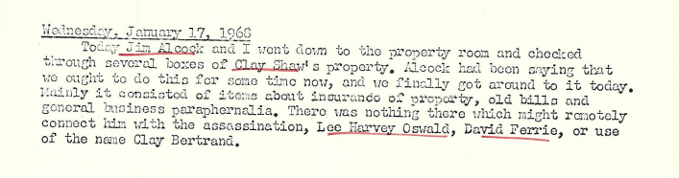
Thursday, January 25, 1968
Marina Oswald subpoenaed yesterday. Mort Sahl arrived today and gets D.A. credentials. He was recently on the Johnny Carson show and suggested to Carson that Garrison appear on his show. When Alcock head this he said, "Is he serious?!" When Sahl commented that he was now working as an investigator for Garrison, Alcock, who had been unaware of the fact, commented to me later, "We'll have jugglers and fire-breathers working for us soon."
Sahl looks rather weary and under the weather, haggard, lined face, from what I remember of him in Washington last May.
Saturday, January 27, 1968
Barbara Reid gave a party this evening, attended by Garrison, Mark Lane, Mort Sahl, Vince Salandria, Matt and Janine Herron, among others. Morris Brownlee and John George also there.
Sunday, January 28, 1968
This afternoon there was a rather extraordinary meeting on the NOAC. It was attended by just about everybody from the DA's office who is working on the investigation -- Sciambra, Alcock, Burnes, myself, Ivon, Loisel and even Charlie Ward. We sat around a large table in a back room for some time, and then Garrison came in with Vince Salandria. Garrison said that Salandria had some remarks to address us, and introduced Salandria as an expert on the assassination etc.
Salandria started off by telling us that we were in much better shape now than on the occasion of his earlier visit, in July. I had accompanied him around at that time, and I recall he was shown the Shaw file. He looked through it, and was rather rueful about it to me. He admitted to me that there wasn't much there. Now, however, it was a different story, or so he seemed to think. He could tell by the expressions on our faces. The case against Shaw was now looking much more solid, he told us, and we were beginning to work as a team.
He then started to urge us that the only trouble was we weren't going far enough, and he then started to work himself up into a harangue about Michael and Ruth Paine. "They're agents," he said, "I know they're agents. I've got the proof." He went on at some length about how he had met the Paines, and he produced some quasi-evidence suggesting they were agents etc. Then he told us to go ahead and charge the Paines -- "You've got all the evidence you need." He exhorted us to charge some others too, Marina Oswald, and Allan Dulles. Don't worry about anything, just go ahead and charge them, "the evidence is THERE!"
Garrison sat next to Salandria through all this, calmly smoking his pipe. Salandria was getting really worked up by this time, and was actually shouting at us. Someone asked him to tell us some of the evidence, and then he pulled out a few card indexes -- seemingly a little annoyed at being distracted by such trivia -- and then started off on his stuff about troop increases in Vietnam, the radio message to Airforce One, the same stuff he had shown me earlier on when he was working on the manuscript on WHY Kennedy was killed with his friend Tom Katen.
When he finished he was fairly attacked by several members of the staff, notably Jim Alcock and Charlie Ward. He was told that he just didn't have sufficient evidence to warrant any of his conclusions, that he didn't seem to realize that we, as a DA's office must be concerned with the law and other such niceties, etc. Garrison began to get upset at these attacks, and came to Salandria's defense. Salandria even tried to tell us that Oswald was innocent, and I pointed out to him that if you believe Russo, you have just about got to believe that Oswald is guilty. I pointed out that the evidence adduced by our investigation made it more, and not less likely, that Oswald was involved. I remember Garrison gave me a look as though to say -- 'What on earth is he talking about, he still doesn't understand,' but I knew the whole office, apart from Garrison, was solidly behind me.
Garrison was beginning to smart by this time, and he ended the meeting with an attempt to wrest back the initiative. He gave us a lecture about all having to pull together, that we couldn't afford to work against one another, etc. However, it was obvious that his major objective had not been accomplished. Evidently he had been trying to use Salandria to persuade us of a course of action which he wanted to take himself but knew that we would not endorse. Therefore he was hoping that we might accept it if it came from someone else, namely Salandria. But the ruse had not worked. It was evident that everyone there, with the possible exception of Sciambra -- who does not stick his neck out at all when he sees it means going against what Garrison wants -- thought that Salandria was something of a nut.
Wednesday, January 31, 1968
Garrison on Johnny Carson show tonight. Watched it at Matt & Janine's.
Thursday, Feb 1, 1968
Charlie Ward's comment on Garrison's appearance on TV: "He makes a good appearance of course, and he's photogenic, but what he said was a disaster."
Friday, Feb 2, 1968
Huge volume of mail beginning to descend on office in response to Garrison's appearance on the 禅onight' show. Nearly all of it looks favorable.
Saturday, Feb 3, 1968
Thought For the Day: Why the fraternization between the judges and the DA's office? I don't see why a judge, once elected, (for a much longer term than the district attorney) should be in any way dependent upon the DA for his political survival. In any event, this fraternization is no doubt one of the worst aspects of the so-called system of justice here. I recall Judge Haggerty at the DA's office party: smiling, talking to everyone, shaking hands with anyone he didn't know and introducing himself. He reminded me more of a politician at election time than a judge at a party. I went with a French girl I had met recently, and when I told her he was the judge who was going to try the Shaw case I think she thought I was kidding her.
Monday, Feb 5, 1968
Ivon told me when I came in that Gary Sanders is to be put on the payroll @ $400 a month. Lorraine Schuler on the vast amount of mail now arriving in the office: "All my education and training on this garbage. That isn't one tenth of it," dumping a great pile on my desk. There is no adverse mail re the Carson show. All favorable to Garrison.
Mort Sahl came in waving newspaper with Herman Deutsch favorable comment on the Carson show. No doubt about it, Sahl sees the investigation purely as a publicity struggle, and not at all in terms of the facts or truth -- exactly contrary to what you would suppose. Mark Lane is the same. This would be OK if we were running, say, a TV station.
Alcock said he got a call from the California Attorney General regarding the extradition papers on Bradley. "Looks like you've got some pretty good papers," the AG said.
"Holy Mackerel!" said Alcock, "that guy ought to go back to law school. I think they're going to extradite him!"
Gungho Gary Sanders accused me of being "bad for morale" and "working against the office" when I said that I did not believe that Craig saw Oswald, and that it did not fit with other facts. I told him you cannot go into a courtroom with nothing but morale.
Tuesday, Feb 6, 1968
Motion filed by defense for Change of Venue today. Hearing for this March 5th. Alcock says trial won't be till April at least. "Good in some ways, not in others," he says.
Garrison not in office today. Called me regarding my memo on Oswald in Mexico. He still believes Oswald never went there, apparently. Strange letter from Gene Wilson on Downtown Lincoln-Mercury stationery. He possibly puts Shaw in Dallas in Dec. 1963.
Replying to letters re 禅onight' Show. Just about all favorable to Garrison. An interesting point re "limits of the investigation" raised by Garrison's statement on the program that only 5 are working on the case, (which has prompted many offers of assistance. We are now limited not by manpower shortage but by physical (office size) and financial considerations.
Fourteen letters to high school/college students writing term papers and wanting information. I note they nearly all type their letters neatly, double spaced. Their overall grasp of the facts in the case tends to be poor, however. Thought: the most interesting thing about the investigation now is not the substance of it, but the public reaction to it.
Wed Feb 7, 1968
Today had row with Gary Sanders and Jody Duek. She has ensconced herself in my tiny office without so much as consulting me, and now practically gives me orders. The less said about her the better.
Garrison not in office Monday through Wednesday. Ivon says he is still smarting from the opposition he got from the rest of the DA's staff after the Salandria talk.
Thursday, Feb 8, 1968
Today Marina Oswald Porter and Kerry Thornley were before the grand jury. I spoke to Marina briefly in Alcock's office before she went up to the GJ room. Here husband Kenneth Porter was with her. Marina seemed scared, timid, unwilling, unco-operative, answering in quiet monosyllables. She seems intelligent though. We did not discuss the case at all, just pleasantries. Alcock remarked to her that he had been to the same high school in Fort Worth as Oswald's brother Robert. Garrison came in and shook hands, reassured her and told her not to worry about anything. Garrison is basically not interested in Marina, but appears to be considering indicting Thornley.
In his office after the grand jury session was completed, Garrison remarked that it had been "a good day". Sciambra and others were laughing at some of the questions some members of the jury had asked. The first question the grand jury foreman asked Marina was: "Is this your first visit to New Orleans?" They also asked her some questions about what Oswald talked about at night. She said he hardly said anything. "Not even pillow talk?" she was asked.
Marina made one remark that pleased Garrison. She said the Secret Service had told her to beware of Ruth Paine "because she was a member of the CIA." However, Alcock told me later that by the way she answered -- "that organization you join..." it was evident she meant something other than the CIA, namely the ACLU. As far as the substance of our case was concerned, Alcock said that she contributed nothing of value, and could only be a defense witness when it came to the trial. Oswald did not stay away at night, neither he nor she drove a car, she had never been to Clinton, not had he, as far as she knew.
Alcock pointed out why Garrison had been reluctant to call Marina before the grand jury: because her testimony would undoubtedly be in opposition to any conspiracy theory involving Oswald. It would be hard for the Grand Jury to believe that there had been a conspiracy after talking to her, and Garrison did not want to run the risk of exposing the GJ to this point of view. That was why he was pleased by her comment about Ruth Paine -- it suggested that events may in fact have been as Garrison had portrayed them.
(1969: I never saw a transcript of Marina Oswald's testimony. Of course, Grand Jury testimony is technically secret, but the fact that Garrison largely conducted his investigation in the secrecy of the Grand Jury raises some questions about the validity of his criticisms of the Warren Commission. This would be analogous to the Warren Commission having heard testimony in closed session. It seems that Marina's testimony before the Warren Commission will go down to posterity -- albeit under a great deal of criticism -- but her testimony before the "Garrison Commission" will not even see the light of day. It will be analogous to one of the Commission's classified documents, which Garrison got so much mileage out of. As far as I know, nobody has ever raised this criticism of Garrison. When is he going to publish his 26 volumes?)
Friday, Feb 9, 1968
Garrison in the office today, in one of his talkative, performing moods. He kept calling me, and others, into his office on pretexts. He is also considering charging Kerry Thornley, who was also in the office today. Alcock said "He'd better not," (charge Thornley) as there was no evidence against him, with which I agree. But Garrison is hynotised by the fact that Thornley (a) admits having met Clay Shaw. (b) showed the ms of his (first) book to Martin McCauliffe, professor at LSU who helped found Friends of Democratic Cuba紡n anti-Castro outfit including Sergio Arcacha Smith, "who was involved with Oswald," according to Garrison. (c) Picked up unemployment checks at Julia St., near Camp St. (d) met Guy Banister. (e) Moved to Arlington, Va. soon after the assassination. (f) Lived at one point on Dauphine St, a couple of blocks from Clay Shaw, and one or two other points.
Thornley consistently denies having met Oswald in New Orleans in the summer of 1963. I spoke to Kerry Thornley briefly in my office late in the afternoon. He looked as though he had been in tears. He said, "Where have I met you before?" I did no recognize him from anywhere, but I knew that an English friend of mine, Warwick Reynolds, had been here in �62 and �63 and had at one point shared an apartment with Thornley on Barracks St. I had been here on and off during that period too (on vacation from school I was teaching at in Virginia,) and I told Thornley I might have met him with Warwick Reynolds. He immediately recalled Warwick, and thought it probable that that was how he recognised me. He said the publishers had printed 81,000 copies of his book, but had only sold 17,000 of them. Apparently they haven't even been trying to sell them lately, although we both agree this would be a good time. He gave us his only copy.
Garrison in rare form today. "Sooner or later, because people are lazy, you catch them out on propinquity," he said while thumbing through the city directory. What a classic remark! (Little or no attention has been given to Garrison's "Propinquity Factor" theories. However, on Feb 10 and April 7, 1967 he wrote "Part I" and "Part II" of a memorandum entitled "Time and Propinquity: Factors in Phase One" which, if the Garrison investigation is to have any historic value, will certainly be valuable documents. They are predicated on the supposition that if people live anywhere near one another, they are therefore to be suspected of being associated in some way. I need hardly say that nobody in the office takes "the propinquity factor" seriously except for Garrison himself.)
Another Garrison comment today: "I don't mind that the Government turned out to be involved, it makes the fight all the more fun!" He then started to talk about "the need to move more audaciously," as he put it. Everyone in the office starts to wince when he talks like this. Garrison started to talk very amusingly about Communists. "They're like unicorns. Nobody has ever seen one! J. Edgar Hoover might just as well start talking about unicorns. 禅hey're out there in the woods, more unicorns than ever, we're being surrounded by them. Mr. President, we need 200 extra agents this year and a million dollar increase in our budget to control the increasing unicorn menace in this country.'" After a good performance like this紡nd on such occasions Garrison can be astonishingly good, brilliant one might say, he plays his part well. Does not harp on his joke, and pretends not to notice that everyone is rolling about laughing. On this occasion he just made some remark to the effect that America had gone insane worrying about Communists all the time, and then changed the subject.
He started talking about CIA "involvement", referring to his suspects as "players" � meaning Novel, Thornley, etc. Garrison said: "They get three one hundred dollar bills in the mail every week, with orders not to pay income tax. If there's ever a question raised, there's a phone call and that's the end of it."
When he picked up the phone at one point, part of the receiver fell off so he just threw it into the waste paper basket. He also came round and smashed up a chair in his office which was beginning to break. I told him about the Wall St. Journal story, (船A on the Griddle') but it did not seem to bother him very much. He started to talk about how the CIA controls Life magazine "in sensitive areas."
Garrison observed that one day he would probably be on the cover of Time, with a group of other people under the caption "The Arrogance of Dissent". He suggested that the others would be Rap Brown, Martin Luther King, Stokeley Charmichael and Dr. Spock. He said "the arrogance of dissent" was a phrase which had been used by a Senator recently and quoted with approval in magazines.
Mort Sahl in office, and I have good rapport with him. He told me he had had [a] run in with Jody Duek too穆he telling him what to do etc. He's leaving Monday for TV show (his) in Los Angeles, with GM sponsorship. Mort is unbalanced on assassination, does not have it in proportion, and is weak, to say the least, on the facts (which do not really interest him). I like him though, he's sensitive, observant, and quick. He talked very well about the "cocktail party buffs" in Los Angeles congregating round Maggie Field, associating with show biz people etc.
Saturday, Feb 10, 1968
Went to the office in the afternoon, and Garrison was there with Dick Burnes and Louis Ivon. Garrison is planning to subpoena Allen Dulles and Gordon Novel simultaneously, with pictures in the paper of both of them smoking pipes. Question of relevance regarding Dulles raised. He left CIA long before the assassination. However it was determined that he was in CIA at the time of the Houma bunker burglary, (he left about a month after it.)
Garrison starting talking about "getting our napalm on them,"(those he is fighting and accusing.) He made motions with his hands and arms as though trying to cast something away from him. "They can't get it off them," he said, laughing.
Regarding President Johnson, Garrison said: "I'm probably only a cloud on the horizon for him at the moment, but if I keep on getting access to national microphones like this, I'm going to become a real thorn in his side."
I asked him what he had been about to say on the 禅onight' Show about Robert Kennedy -- the subject was changed before he got around to it. He said it would have been to the effect that John Kennedy had been our President, and what RFK has to say about it is irrelevant, especially as he says he has not read the Report. Garrison concedes that RFK is probably not as opposed to him as he has said in public statements. He agrees that RFK probably couldn't become overtly involved in the case, even if he wanted to.
Sunday Feb 11, 1968
Went to the office in the afternoon. Garrison interviewed on film by Willem Oltmans for Dutch TV. Garrison made his usual speech about the CIA and FBI etc., and Oltmans accepted it uncritically. Oltmans has spent some time with George DeMohrenschildt and is trying to get Garrison and DeM. together. Garrison seems to be convinced that DeM. is involved in some way, and refers to him as the "project manager". However he refuses to meet him. Garrison received a friendly letter from DeM. offering to meet him either in Dallas or New Orleans, I believe. Both Billings and myself urged Garrison to see him, but he has consistently refused. I think G. is afraid that if he meets DeM. in the flesh, he will become persuaded that he is not involved, and thereby lose a suspect.
Garrison said that during the 禅onight' Show, he turned to Carson during one of the commercial breaks and said: "I'll sing and dance for you if you like." Carson, not at all amused, didn't take it as a joke and said: "You're not going to do any singing on this show."
Ivon more communicative than usual today. He said that three weeks ago Governor McKeithen gave $5,000 to Garrison for the investigation. He was sort of talked into it by Willard Robertson, Rault and Garrison. Ivon said that Willard Robertson has practically underwritten the investigation, and has personally donated $25,000 or $30,000 of his own money to "Truth or Consequences". However, Ivon does not think Robertson intends to give any more, or is unlikely to.
Ivon, like Alcock, is afraid Reagan is going to extradite Bradley. "I hope he doesn't," was Ivon's terse comment. Trouble is, Bradley's return would make the investigation open-ended, and it might be another year before Bradley's trial would come up.
Ivon talked about the power of the D.A., especially to subpoena people before the grand jury. "It's a lot of power he's got," Ivon said. "If all the D.A.'s in the country were like Garrison, things would be in chaos." Ivon is in a state of consternation, as he has been for some time, about Garrison's evidently self-destructive path. "I can't see why he would want to lay his whole career on the line like that," he said. Ivon expressed the fear that Garrison would ultimately become identified in people's minds with nuts like George Lincoln Rockwell. I told him Senator Joe McCarthy was a better analogy, except that Garrison is in far more exposed position than McCarthy, because Garrison has a trial pending, at which he will be expected to produce his evidence, whereas McCarthy did not have that threat. Garrison these days confidently asserts that the trial is not going to take place, because the Government will block it or Shaw will be killed. But no-one in the office shares this view, which is little more than whistling in the dark. That's the difference between Alcock and Garrison; Garrison will say in a loud, confident voice, "The trial will never take place," and really sound as though he believes it. Alcock will say, "Man, I hope he's right, but frankly, I see no reason to suppose there won't be a trial."
Today Garrison has decided to renew interest in Emilio Santana, for no apparent reason. He walked around in the afternoon carrying an 8 x 11 picture of Santana, showing it to people. Ivon told Garrison: "I wish you wouldn't," (get interested in Santana again,) "We really questioned him thoroughly for three days and couldn't get anything out of him" (Ivon's polite way of telling Garrison that he doesn't believe the man is involved.) When Ivon says something like this to Garrison, Garrison will pretend to take no notice of, or ignore what Ivon says. But it probably has its effect. In a day or two, in most cases, Garrison will have dropped the matter.
Garrison gave a copy of Santana's picture to Willem Oltmans, who is going to show it to this Dutch magician-type guy who solves crimes etc. by handling the photograph and telling you things about the person -- where he is etc. Apparently he has on occasion been of value to the police. But it is just wasting time to show him Santana's picture.
Ivon said that in the very early days of the investigation, the few who were then working on the case would stay up "in the old grand jury room" till 2 or 3 in the morning, going through files and photographs." They were especially trying to find the unidentified man in the WDSU picture, handing out leaflets with Oswald. They looked through thousands of mug shots, in hope he had an arrest record. No luck though.
Ivon said that Garrison does not react well to criticism in the press, citing the recent Wall St Journal attack. Ivon said that Garrison should expect these attacks, but he says they always seem to come as an unpleasant surprise to him.
Schweggman, "biggest money man in the state," according to Ivon, had an ad in the paper today, expressing support for Garrison.
Monday, Feb 12, 1968
Nothing much happened today. Garrison did not come in. (Garrison's attendance record at the office is rather peculiar. He is nearly always there on Saturday and Sunday, but during th week he will stay away if at all possible. He spends a great deal of time napping at the NOAC. I have also heard he takes Sauna baths there.) I attended part of a trial in section F in the afternoon. A narcotics case with the defendant Perry (or Terry?) Baker. Despite the fact that when the narcotics informer was asked to point out the defendant, he pointed to the law clerk siting next to the assistant DA, Baker was found guilty by the preponderantly blue collar, red-neck, jury, and sentenced to 7 years, I believe. Horrifying. I can't help feeling that Baker made a bad tactical error when he had a bunch of attractive girls from Newcomb in the courtroom, rooting for him. Also his lawyer made a mistake when in his closing argument, he started talking about a "new morality." Hardly likely to appeal to that jury.
Answered more letters re Carson show. Many letters are from law students, all over the country, wanting to work here in the summer. I note they all assume the investigation will still be going on then. Letters from high school and college students writing term papers and wanting information. Evidently the 'Tonight' show was a huge success for Garrison, the biggest yet in the publicity struggle. Most people who write take the position: "I seen through it. NBC is trying to discredit you again, Jim, but they didn't fool me.
Tuesday, Feb 13, 1968
Bill Turner came into the office, and an interesting conference was held in Garrison's office, attended by: Charles Ward, Jim Alcock, Dick Burnes, Moo Sciambra, Numa Bertel, Lynn Loisel, and myself. We were addressed by Bill Turner. Garrison was supposed to come, but called up 15 minutes beforehand to day he would not be there. Anyway, he wanted Turner to outline "CIA involvement" for us, having failed to make much impression on us with Salandria. However, once the meeting was started it was diverted from Garrison's intentions by Ward and Alcock to the much more interesting question of why Bradley was charged with conspiracy.
Since Bradley was charged no-one in the office has been able to get a very clear picture of what the evidence against Bradley is. The general feeling has been that it is very weak, but no one knows for sure. It would be impossible for Garrison to be anything but vague on the subject, and Turner, who principally worked on the case, had not been back to the office until today. Thus Charlie Ward and Jim Alcock were understandably interested in what Turner had to say, since they are in the position of having to assume a kind of legal responsibility for Garrison's actions.
Turner was obviously very much ill-at-ease at this sudden confrontation, and tried at the outset to revert to cozy speculation about the CIA. However Ward and Alcock were insistent. Basically the steps leading up to Bradley's being charged were:
1. Discovery of letter in our files by Bill Turner in September, 1967. This letter had been sent to Mike Karmazin on April 10, 1967, by Thomas L. Thornhill. "My information concerns a man named Edgar Eugene Bradley," Thornhill wrote. "One of my witnesses will testify to the fact that Mr Bradley tried to hire him to assassinate Mr Kennedy during his 1961 campaign in Calif."
2. On Dec 18, 1967, Turner and Bill Boxley went to 6543 Fulton Ave., Van Nuys, Calif. to interview Thornhill. They found a Mrs Carol Aydelotte living there. She lived there with her husband and Thornhill, and was familiar with Thornhill's allegations about Bradley. Bill Turner wrote in a memorandum addressed to Mr Garrison (dated Feb 16, 1968) that "her acquaintance with Bradley covered the span of the assassination; and that he was constantly harping on the fact that someone should kill Kennedy. She believes that as a result of her knowledge of these remarks, Bradley has launched a campaign of intimidation and harassment against her, and the matter is currently pending in a civil suit in the local courts."
3. Carol Aydelotte gave Turner and Boxley the names of two people who would corroborate her story against Bradley. They were Dennis Mower of Lancaster, Calif., and the Rev. Wesley Brice, Pastor of the Hollywood Bible Presbyterian Church in North Hollywood. Turner and Boxley then interviewed Mower in Lancaster on Dec 19th. According to a memo which Boxley addressed to Mr. Garrison on the subject, "Mower confirmed that Bradley had attempted to recruit him to assassinate President Kennedy and he stated that he had reported the attempt to FBI agents Holbrook and Quinn.
4. Boxley then interviewed Rev Brice on Dec 20th, but the results of this interview were not known to Turner at the time he addressed the members of the DA's office. On the results of this interview depended whether or not there was any New Orleans jurisdiction in the matter, Turner said. (When the results of the Brice interview became known, it turned out that Brice had said nothing about New Orleans in connection with Bradley.)
As Turner explained it to us, the allegations against Bradley are as follows:
1. He attempted to get Mower to shoot at Senator Kennedy, (as he then was,) from a storm drain system in Los Angeles. Aydelotte said that at this time Bradley had the blue prints of the storm drain system of the Sears Department Store Complex and Shopping Center on Laurel Canyon Road in Van Nuys. Bradley tried to induce Mower to hide in part of this system and take a shot at Kennedy as he came by.
2. Dennis Mower corroborates this.
3. Mrs Aydelotte further alleges that later, when JFK was President, Bradley rented a hotel room in L.A. on the occasion of JFK's visit, with a good sniper's vantage point. Turner reports that Mrs Aydelotte's mother can corroborate this in some way, but apparently her mother was not interviewed.
4. Mrs Aydelotte says that Bradley is a close friend of a man named Lorenzo Pascillo, who from pictures has been identified as Loran Hall -- at one time suspected of having visited Sylvia Odio with "Leon Oswald". Garrison is very interested in Hall, as is Dick Billings incidentally.
5. Aydelotte says that Bradley has sadistic tendencies. Turner noted that Bradley "beats his daughter, Jeanine Bradley, frequently and viciously."
6. A Fort Worth Star-Telegram photograph showing two men in front of the School Book Depository apparently under arrest following the assassination was shown to Mrs Aydelotte. According to Turner, "without hesitation, she pointed to the lead man and said: ‘That's Gene Bradley.'"
7. Some unspecified information from Rev. Brice. Mrs Aydelotte did not know of any connections Bradley may have had with New Orleans, but according to her, "Dr. Brice may be able to help on this score." (It later turned out that Bradley had told Brice before the assassination that he had to "take a swing through the South." Brice added that on the evening of the assassination he was at Mrs Bradley's home when Bradley called her, apparently from Dallas, but there does not seem to be any evidence for this either.
The office staff listening quietly through these explanations by Turner. When he had finished, Charlie Ward showed him the Dallas Morning News pictures of the same two tramps being led away. The facial angle is different, and the lead man obviously is not Bradley (though clearly the same man as in the other picture.) I don't think Turner had seen this picture before, and he was undoubtedly very embarrassed by it. He hummed and hawed, but wouldn't positively say that it wasn't Bradley.
Dick Burnes then immediately pointed out that even if we had jurisdiction over Bradley, which we appeared not to, he said, there is not even any allegation of conspiracy at all in the statements of any of the witnesses Turner had mentioned. There was in fact, Burnes said, only a solicitation which was rejected. (Bradley solicited Mower.) Turner was obviously slightly put out by these virtual attacks, which must have seemed very different to him from the genial company of Garrison. I'm not surprised that Garrison didn't show up for the meeting. He probably knew something like this would happen.
In any event, it appears that -- pending disclosures from Brice -- we have, on the evidence as a result of which Bradley was charged:
- No evidence that Bradley was in New Orleans.
- Therefore no jurisdiction.
- No evidence that Bradley was in Dallas, (disregarding photo.)
- No evidence that Bradley conspired (legally) to assassinate JFK.
- No evidence linking Bradley to the Dealey Plaza outcome.
Therefore there is not the slightest basis for Bradley having been charged. Everyone in the office was well aware of this after the meeting, and Bradley's arrest was universally regarded as a disaster for the office. Everything depends on Bradley not being extradited.
Since Bradley was charged I note that the following two statements have appeared in the Bradley file--which has now been re-located in Ivon's office, and is not easy to lay one's hands on:
1. A statement by Perry Russo(!), dated Dec 26, 1967, in which Russo states that he saw Bradley with David Ferrie sometime between March and October of 1963, in New Orleans.
2. A statement by Roger Craig, dated Dec 29, 1967, in which he says he either saw or apprehended Bradley in front of the Book Depository after the assassination. This information (from Craig) was included in the extradition papers re Bradley. (Note, later: Richard Sprague, one of Garrison's most ardent and uncritical admirers whose specialty has been collecting photographs of the assassination, later found a picture of Craig talking to a man in front of the TSBD who looked like Bradley, but definitely was not him, according to Sprague. Sprague, who believes that the tramp picture depicts Bradley, no doubt appreciates that Bradley cannot both be the tramp being led away, and the non-tramp conversing with Craig.)
Alcock pointed out that charging Bradley with the same crime as Shaw, and at the same time not being able to demonstrate any connection between the two conspiracies, looked really bad even if it was legally a possibility. He said he thought it would form the basis for some justifiable motions by the defense (Shaw's defense), demanding to know more details of the Bradley "conspiracy." No doubt he would be able to skirt around any such demands. What does worry him, however, is the thought that Bradley might be extradited. "Let's keep our fingers crossed," he said.
Then there is the confusion about Leslie Bradley. It turns out that there is also a Leslie Bradley, who was a pilot, and who is believed to have been in New Orleans on the day of the assassination. Also something about him having known Ferrie. But at least this is not a case of mistaken identity, as some journalists seem to think. We knew nothing of Leslie Bradley until E.E. Bradley had been charged. All the Leslie Bradley material was dug up by journalists, and it is their hypothesis that this is a case of mistaken identity.
Wednesday, Feb 14, 1968
I asked Bill Turner when he came in if he had spoken to Garrison last night about what Rev. Brice reputedly said to Boxley on the subject of placing Bradley in New Orleans jurisdiction. Turner said he had not, and then made the following admission: that Garrison had told him the reason he was charging Bradley was a gambit in the publicity struggle than anything else. Apparently, according to Turner, Garrison does not really believe that Bradley is guilty. Alcock unfortunately removed from the Bradley file the yellow legal sheet with Garrison's handwritten instructions re. Bradley charge, (sent by Garrison via the mails to Alcock, from L.A.) I saw it once. It began: "We've closed the circle on Bradley. He's involved, all the way... We have witnesses who place him in New Orleans too, so don't worry about jurisdiction..." (Unfortunately I did not get a copy of this.
There is now considerable consternation in the office about Bradley, and fear lest Reagan extradite him.
Garrison not in the office today.
Jody Duek in again, trying to get the Shaw file from me. She sure has got nerve, I'll say that for her. I'm not about to give her the Shaw file, however. (Not that it's kept in my office now. It's kept in a special filing cabinet (lockable) in Louis Ivon's office. I can see it whenever I want to though.
Martin McAuliffe came in and told us how he met Thornley at the Bourbon House -- innocently, it was obvious. McAuliffe had helped found Friends of Democratic Cuba. Loisel and I interviewed him. Obviously quite an intelligent man, now teaching English I believe, or maybe was at the time he met Thornley. He described how Thurnley told him he had literary ambitions, and so McAuliffe asked him to show him something. Thornley showed him his "novel" - in fact it was not quite a novel, I think - and McAuliffe said it was pretty bad. Not much other contact with Thornley, nor did McAuliffe see Oswald in the Bourbon House or anywhere else. McAuliffe clearly worried that if says the wrong thing, he's liable to get charged himself!
Thursday, Feb 15, 1968
Thomas Edward Beckham before the grand jury today, all day. Garrison is full of high hopes, talking about "a break in the case," etc., and hopefully points to a blurry picture in front of the TSBD.
David Lewis came in and gave us some further information regarding the United Cuban Missionary Force Beckham attempted to found, and Beckham's self-styled (to Lewis) membership in the CIA. I wrote up memo on Lewis' remarks. After Beckham emerged from the grand jury, Alcock was mocking the idea that anyone could believe (as Garrison does) that "a bum like that" would be working for the CIA.
Turner related that Garrison intends to delay the Dulles subpoena until the Thornley perjury charge is issued. Turner apparently pointed out to Garrison that there was little basis for such a charge.
We discussed the leak of Garrison's medical records, the Bolden case, and the anonymous letter from the Los Angeles FBI office to Ramsey Clark, (the latter was subsequently printing in the LA Free Press.) I told Turner that Bud Fensterwald had told me in Washington over Xmas that the medical records affair was an FBI leak. Turner was interested and said he would like to "pin it down real tight" and do a story on it. The leak came out in the Chicago Tribute 3 days after the Turner-Garrison press conference in which Garrison mentioned the William Walter story. (To the effect that a telegram was sent to the FBI a few days before the assassination, or an inter-office TWX, containing a warning about the assassination. This story about William Walter originated from a guy who came up to Mark Lane either before or after his talk at the Tulane campus. Lane got the guy's name -- Walter -- and his story, that he had been working as a clerk in the local FBI bureau when this TWX came through, but that is all. In other words, no one ever saw a copy of the TWX. In any event, Garrison used it as an opportunity to attack the FBI–one of the rare occasions when he has attacked them, incidentally. If Fensterwald is right, the FBI immediately retaliated with the medical records. Seems plausible. Turner, who worked for the FBI, says the Chicago Tribune is frequently used by the Bureau as a "leak" organ.
Turner mentioned what is in some ways Garrison's least explicable fault: his refusal to accept help when it is offered. In some instances these offers come from a direction which Garrison has specifically indicated interest in, and therefore ought to be interested in getting help from that quarter. Turner gave the example of Robert De Pugh, the Minuteman leader. De Pugh has indicated to Turner in an interview that he accepts Garrison's thesis that renegade Minutemen are "involved" in the assassination. He would like to see Garrison, and even has names to give him. Garrison is well aware of this offer of help, but, to date at least, refuses to see De Pugh.
I told Turner of another obvious example -- that of George DeMohrenschildt. Although he was Oswald's closest and virtually only friend in Dallas, and from his background might quite reasonably be suspected of having been a CIA agent, and has written to Garrison expressing a desire to talk to him, Garrison (till now) won't even answer his letter.
Another person Garrison could probably have gotten help from, if he had approached the matter tactfully, was Henry Wade, the Dallas D.A. (who, like Garrison, is a former FBI agent.) However, instead, Garrison took the first opportunity to attack Wade, and the Dallas police Dept.
A consistent pattern in this investigation has been the failure to talk to people thought to be involved before issuing a warrant for them. This is true of Shaw (only briefly interviewed by Sciambra on Dec 23, 1966) Gordon Novel, Edgar Eugene Bradley, Sergio Arcacha, Loran Hall and Lawrence Howard, (the latter two were subpoenaed as material witnesses. My interview with Jack Lawrence was one of the few instances where we knew what the person under suspicion had to say about what he was doing, etc. Garrison fears, of course, that if you talk to these people you alert them and they somehow vanish off the map, destroy the evidence etc. I think Garrison also believes that it is a waste of time to talk to suspects, because if they are involved, they obviously aren't going to admit it, which is still not a very good argument for not talking to them.
Friday, February 16, 1968
Bill Boxley arrived back, apparently now convinced of the involvement of Jack Lawrence. Why? Because of Boxley's conversations recently with two Downtown-Lincoln Mercury ex-employees named Rozelle and Falzone. Rozelle points out that Lawrence was hired by one Lorenz, a German (CIA etc., according to Boxley,) who is also "involved". I pointed out to Boxley that the only way we can get anything solid on Lawrence is to find the actual person who retrieved the car in Dealey plaza. Boxley thinks it was Lorenz.
Alcock still appears outraged by the Bradley business and said he would refuse to try to case if Bradley is extradited. I get the feeling that Alcock will be leaving the office fairly soon. Dulles and Novel were subpoenaed today, and story in papers. Dulled reportedly laughed when told on phone by a reporter that Garrison had subpoenaed him.
The FBI replied to Sciambra's letter of Jan 22 regarding Reeves Morgan and the Clinton episode. Sciambra was trying to get confirmation from the FBI that Reeves Morgan had contacted the FBI in ‘63. The FBI reply was guarded, and gave no indication whether or not they had prior warning of the Clinton episode.
Saturday, February 17, 1968
Briefly went into office in afternoon and talked to Ivon, who has been away all week. Garrison just leaving when I arrived, with Sciambra, Mark Lane, and Gary Sanders. No developments.
Monday, February 19, 1968
Garrison in the office bright and early today. Jim Alcock says he has papers drawn up for a perjury charge against Thornley.
I detected a distinctly cool wind today from Ivon and Steve Bordelon. What's up? Very odd reaction from Garrison regarding the statement Sanders got from Augustinovich. He is some guy Sanders has dug up from the Miami area and he apparently is prepared to testify that Oswald's somehow connected with the CIA. When Sanders' memo to Garrison on this was returned by Garrison, it had "irrelevant area" written across the front page in Garrison's hand. Although I am not exactly Sanders' best friend, I sympathize with his chagrin at this strange response. Here he is, the poor guy, doing his best to please the boss, comes up with something one would surely have predicted would have pleased Garrison, and he gets slapped down for it. My feeling is -- and Alcock shares it -- that even if this is unreliable information (and I have not had a chance to talk to Augustinovich) at least it is an attempt to link Oswald with the CIA, which is more than we've had before. Now that there is some evidence for Garrison's pronunciamentos, he promptly rejects it. I can't figure it out, except that I sense something strange: Garrison doesn't like Sanders, for some reason. I'm not sure, but I sense that Sanders comes on too strong for Garrison. Sanders turns him off in some way, and it doesn't matter what Sanders comes up with -- a picture of the assassin behind the picket fence -- I'm not sure G. wouldn't disregard it just to snub him.
Another oddity: Alcock is very nonchalant about the Thornley charge, whereas before he was threatening to resign if Thornley should be charged. Seems like, for some reason, he's decided to reconcile himself to it.
Barbara Reid in the office today, and Boxley spent most of the day in Garrison's office with her. Louis Ivon told Sanders to tell Jody Duek not to come in any more. Garrison came into my office in the afternoon, and politely asked if I would mind leaving for a short while, while he talked to Willard Robertson alone there. Trying to squeeze more money out of him, apparently.
Boxley being put onto the 544 Camp St -- Information Council of the Americas (INCA) angle. Not a bad idea, but I doubt if we'll see much action.
Tuesday, Feb 20, 1968
Another quiet day. Worked on correspondence. Reflected that the mail is the most interesting thing coming into the office these days. I imagine it would fascinate a social scientist, and a detailed analysis of it would be book length.
Papers being drawn up on Kerry Thornley, which both Alcock and Burnes refuse to sign. There is no doubt in my mind that Thornley is completely innocent of perjury and everything else.
Ivon and Bordelon working on material for Gordon Novel suit, and I transcribed Novel's original ‘Mr. Weiss' note. Not much today.
Boxley id being put on regular assistant D.A. payroll, which will therefore allow "special investigation funds" to run further. I.e., plan is to get Boxley's salary paid by City funds. I'm paid, as usual, out of the Fines and Fees fund. (As I have been all along, with the exception of a couple of pay checks when I was in Washington, which were drawn on the J.G. Safi account -- Truth or Consequences. I also got one pay check apparently drawn on Garrison's personal checking account.) Garrison says he's going to have Boxley working here from now on. "I'm not going to do Henry Wade's work for him any more," Garrison said.
Going through Oswald's note book, Garrison said: "You see, he had Chandler's name in there, but he spelled it Crawford." This sounds like a typical piece of Garrison wishful thinking, but in this instance it might be true. Chandler admits that he did meet Oswald in N.O. when he was working for the States-Item, and Oswald very likely would have written down his name in his book, and was quite capable of writing David Crawford instead of David Chandler.
Wednesday, February 21, 1968
Thornley charged with perjury today. Garrison issued a footnoted press release, with addendum, like a miniature term paper or something. He showed it to me with evident pride.
The basis for the perjury charge is straightforward. Barbara Reid says that she saw Thornley with Oswald in the Bourbon House in the summer of 1963. Thornley says he was not with Oswald at that time, and did not see him in the Bourbon House. I gather that Garrison has one other witness -- Pete Diagno (sp?) but I have not seen a copy of his statement. However I note that Diagno is a friend of Moo Sciambra. I used to hang out quite often in the Bourbon House myself in the summer of 1963. I was there for parts of June, July, August and September. I recall that I used to see Diagno in there almost every day, and Barbara Reid would be there quite often too, generally with a camera slung around her neck. Sciambra would often be there as well, generally hanging around with the Diagno crowd -- a rather unattractive bunch whose main topic of conversation seemed to be "broads" and betting. I would go there quite often with my English friend Warwick Reynolds. Warwick knew Thornley quite well, although I did not know that at the time, and I never saw Thornley until he was in the office the other day, as far as I can recollect. I certainly cannot recall seeing Oswald there. The Bourbon House clientele was large and varied -- most of the people who actually lived in the French Quarter within a several block radius would go there at one time or another. Part of its charm was that, although it was in the center of the tourist section, tourists would almost never go in. They would poke their heads round the door, take one look and leave. I would say that if one had never known Oswald before, it would be impossible to remember him going there unless he went there regularly. And regulars would remember him. As it is, my feeling is that Oswald probably never went there, and there are scarcely any other reports that he was ever in the French Quarter, which did not seem to attract him particularly.
Actually, it is inconceivable that Thornley saw Oswald at the Bourbon House, unless you are prepared to believe that he saw him, spoke to him, and did not recognize him. Because if he had seen him and recognized him, he would undoubtedly have recounted the episode before the Warren Commission, and put it in his book about Oswald. As Epstein points out, Thornley wrote a book about Oswald, which as it was, was extremely short of material about the alleged assassin.
I note that Lifton has been doing quite a bit of research on the Thornley matter.
Thursday, Feb 22, 1968
Office closed for George Washington's birthday. I went in to the office in the afternoon. As usual when the office is closed, Garrison was there. I talked to him for close to an house in his office. Unusually, he outlined the future possibilities for the investigation. For the first time, he seems to be seeing an end to it, and he talked about the thing being over by the summer time, and talked about everyone taking vacations, etc., which he said there had not been time for up till now. Before that, however, he seems to want to charge Ed Butler (INCA -- now with Patrick "Up With People" Frawley of Schick) and Carlos Bringuier. Garrison says that the conspirators -- generally referred to as "they" -- performed two functions with Oswald in New Orleans: 1) "Custodial", and 2) "Image-creating." By custodial he refers to "baby-sitting", generally looking after, and making sure that he behaves properly. By image creating he means preparing the ground-work for later representing Oswald as a Communist. According to Garrison, this latter role was performed largely by Thornley, Butler and Bringuier. The custodial work was done by Shaw and Ferrie, and I think Garrison regards this part of the mystery as cleared up and dealt with. The common link to all of these people is -- Garrison says -- the CIA.
Alcock had a confrontation with Garrison today -- alone in his office. I asked Alcock what had happened when he came out. He said that he had told Garrison that he didn't believe anything Garrison was saying about the CIA etc., and that none of it could be proved in court. Alcock added, for good measure, what no-one else in the office (except Boxley) believed it either. Then Alcock said :You know, Jim, we get disturbed when we see you listening to Boxley, giving you all that bull..."
"I've learned one thing about Boxley," Garrison replied. "He's right."
Alcock told me this as though he was exasperated by Garrison, but also as though he was amused by him. "That guy," says Alcock, shaking his head and grinning slightly, "he's something, isn't he?" Alcock went on again about "all these bums" like Beckham and Jack Martin supposedly working for the CIA.
Friday, Feb 23. 1968
Garrison did not come in. Ivon told me that Lawrence Howard was coming in to the office tomorrow with Steve Burton from the West Coast. Mark Lane in office today. He's not been in for some time.
Sunday, Feb 25, 1968
Howard in office with Steve Burton. Steve had persuaded him to come to New Orleans voluntarily, without an attorney, etc., and talk to Garrison. Howard is an immensely powerful looking man, with a great barrel chest, but is surprisingly mild in voice and manner. He also seemed quite intelligent. During the course of the afternoon (tape recorded by Louis Ivon) he persuaded Garrison that he had nothing to do with the assassination. He answered questions tactfully, and gave in to Garrison's expectation whenever it was feasible and didn't actually incriminate anyone. E.g. he would agree that the CIA undoubtedly had connections in the Miami area during the summer of 1963, but did not give us any names. He handled Garrison cleverly, I thought, and I'm sure he could have told us more, although I was also persuaded that he knew nothing whatever about the assassination. But Howard was smart enough to flatter Garrison.
Steve Burton seems an intelligent young man, definitely above the average "Assassination Inquiry Committee" type. Even Louis Ivon, who generally despises these people (too often, he has to end up giving them DA's investigator credentials), approves of Burton.
Monday, February 26, 1968
When I arrived in the office in the morning, Steve Burton was already there, going through some of the files in my office. Evidently Ivon had let him in. Of course, most of the sensitive files (Shaw, Bradley, Thornley) are not there, but in Louis Ivon's office. Burton had, however, made a bee line for the next most interesting file -- Ferrie (actually two files on Ferrie.) He had looked through them already and was looking at something else. I started to talk to him a bout something and then he said: "I think it's a good idea not keeping the Shaw file here where people could see it. I notice you have got all the important material withdrawn from the Ferrie file as well." I said nothing, just vaguely nodded. Of course, he had seen the Ferrie file in its entirety.
Tuesday, Feb 27, 1968
Office closed for Mardi Gras. I later learned from Louis Ivon that Garrison came in, as usual when no one else is there.
Wednesday, February 28, 1968
Nothing much. Answered letters. Garrison not in.
Thursday, Feb 29, 1968
Ditto.
Friday, March 1, 1968
Lane came in and asked for material on Mays which I had previously shown to Garrison. Garrison had ben unimpressed at the time, but was later persuaded otherwise by Lane, and Boxley was then sent to Miami to meet Mays. He carried a copy of Rush to Judgement in his hand to act as an identification signal. Mays originally contacted Tink Thompson, who sent Mays' letter to me. Mays also had contacted Ed Horsey in Michigan (a low grade assassination buff) and Horsey passed the information on to Lane. Mays claims to have been approached to take part in the assassination, and now wants $25,000 to tell all.
Sunday March 3, 1968
Did not go in to office, and Garrison is briefly out of town, but I received an alarm call from Sylvia Meagher who had heard (I think) from Tink Thompson that Garrison "no longer trusted me." I then called Thompson, and learned that this information came from Horsey, via Mark Lane.
Monday, March 4, 1968
Garrison still away. Did memo on "4900 Block, Magazine Street", at Garrison's request. Garrison believes that the 4900 block of Magazine Street is a "safe block", ie owned by the CIA, and used as a sort of parking place for agents awaiting assignments.
Tuesday, March 5, 1968
Change of Venue hearing opened. I spoke to Hoke May in the corridor of the Criminal Court Building and I expressed some interest in the 544 Camp St. affair. He told me about bill Nitsehke, an ex-FBI agent who used to hand around with Guy Banister. He said that Nitsehke had been shown the WDSU picture of the unidentified man passing out the leaflets with Oswald and had identified him as having been up in Banister's office at one time. I had not heard this before, but it is of interest as it connects two of the unresolved problems about Oswald in New Orleans -- the unidentified man and 544 Camp St.
Hoke May said that he and Ross Yockey had written a book about the Garrison investigation, but that he had just recently received a rejection slip from his agent in New York, saying that it would be impossible to get it published because there was basically no interest in the case among publishers. He and Yockey are now handing their material over to Mark Lane, May informs me. Very generous of them. I also briefly spoke to David Chandler, covering the hearing for Life.
In the evening Matt Herron came in and spoke to Sciambra in my office re the Phelan story. "Going over the chronology for them again, Moo?" Alcock remarked as he walked by, grinning all over his face. Sciambra now has an interesting addition to his story, which I had not heard before. That Russo, when he initially talked to Sciambra in Baton Rouge, (Feb 25, 1967) referred to the "meeting" as a political meeting and not as a party. It was only in the sodium pentothal sessions with Chetta the the word "party" was used. Thus, Sciambra did not refer to a party in his memo. The trouble is, as Sciambra still does not seem to understand, this still does not explain why he did not refer to a political meeting in his memo. The point of the discussion with Herron was to go over -- with Russo at a later date -- the substance of Phelan's discussion with Russo in Baton Rouge after the Preliminary Hearing. Herron was present at this discussion.
Sciambra also said, and Herron corroborated, that when Phelan spoke to Russo in BR after the Prelim Hearing, Phelan told Russo that he had only mentioned seeing Shaw twice, and was quoted thus is Sciambra's memo. To this Russo replied. "I should have said three times." Sciambra doesn't seem to realise how damaging this reply is, if it really is what Russo said. Because if so, it means that Russo is admitting that he didn't mention the conspiracy meeting to Sciambra in Baton Rouge. If he had in fact mentioned it, and Sciambra had omitted it, Russo's logical answer to Phelan would have been "He should have said three times."
It really seems to me that Russo did not mention the conspiracy meeting to Sciambra at Baton Rouge -- all the evidence points to that conclusion. Sciambra says that the reason he did not include it in his memo was that he was so anxious to tell Garrison about it that he told him verbally at a restaurant the night he came back from Baton Rouge. I must say that is pretty hard to believe. If Phelan is right--as it looks as though he is--Sciambra would have done much better to have admitted as much. As it is, he is in a real jam, which will no doubt be evaded in legal proceedings. Of course, if Russo did not mention the conspiracy meeting the first time, then Shaw is innocent. Because Russo was the only witness they had when Shaw was arrested. All the other evidence that has been accumulated comes either after the arrest (Bundy) or after the widely publicized Preliminary Hearing (everything else.) None of this later evidence can have any validity if there was no basis for the initial arrest.
Which brings me to today's hearing. One point strongly emerged: the blatant way in which the judge continually sided with the state. If the trial itself goes this way, things do not auger too well for Shaw. I wish I knew why criminal judges apparently find it necessary to reside in the pocket of the D.A. Garrison was on the stand for hours, but little was accomplished as Haggerty sustained nearly all of the states objections. Specifically, he was not permitted to respond to the question: did the Shaw conspiracy come to fruition in Dallas? The defenses point is that Garrison, by talking publicly so much about a conspiracy, has prejudiced potential jurors' minds on an issue which remains to be proved--that there was in fact a conspiracy. The state objects to most questions on the ground that the question is only relevant if it can be shown that a potential juror has been prejudiced, and Garrison is not a potential juror.
Wednesday, March 6, 1968
Second day of hearing, which I did not attend. Defense has subpoenaed 1300 potential jurors. Mark Lane was on the stand today, and he came back and glowingly told Garrison of his replies to Dymond.
Garrison in a good mood today, full of ideas about 4900 block, Magazine. I am now starting to make duplicate files for Garrison -- at his request. He believes that one day we will come into the office and find that the files have been ransacked by the CIA or whoever. Ivon concedes that this is a ridiculous idea, and reluctantly told me to go ahead and start making duplicate files. He's afraid that Garrison will show them to everyone. Ivon tipped me off to start off with unimportant files, in the hope that by the time we get to the important files, Garrison will have forgotten about it.
Garrison said he had raised some money from an ‘industrialist' in Miami, enough to last four or five months, and says that he will give me a raise and hire someone else in Florida to work on the case.
I'm working on the Guy Banister angle of 544 Camp St., and told Garrison about it. I found that there was a memo in the files of an interview with Bill Nitsehke, and he discussed various people in the WDSU picture, but according to a numbered system, and the picture with the numbers on the figures is not there. I told Garrison of the possible importance of Bill Nitsehke and he said maybe he would talk to him again. Garrison seemed to have forgotten about him.
Thursday, March 7, 1968
A letter arrived from a lady in Ohio who had bought a $750 "teletrap" from Gordon Novel -- a device which is supposed to prevent phones being bugged. She complains to us that it does not work. (How does she know?) Ivon told me that the D.A. in Columbus, Ohio -- Howard Johnson -- is now helping us. Why? Because Gordon Novel's attorney there, Weiner, is running against him in the next D.A. election.
Bill Turner in town again, and in the evening I had dinner with him and 5 very old friends he met through Warren Hinckle of Ramparts. Also present were Jim Garrison, and Harold Weisberg. At the end of the evening (a private room in the Rib Room of the Royal Orleans Hotel) Mark Lane also showed up. The five friends were a young English couple (not married) Mark Pepplo and Caroline X (didn't get all the last names), a young American couple, Bill Y and Ellen Z, and another young bearded American. All were dressed more or less as beatniks. However they appeared to have unlimited money. One, Bill Y gave Garrison $2000 cash, in $100 bills. However that was by no means the whole story. They were talking in terms of much larger sums in an apparently serious attempt to get Garrison to run for President! They are also interested in doing a movie about Garrison, although they do not seem to have a very clear idea of what they want to do with it or how to do it. In addition, they want Jim Garrison to write a book for something called Chelsea House publishers, which I believe one of them -- maybe the English girl -- worked for. Garrison has been expressing interest in the idea of writing a book about the case, which I gather will be on the order of the Salandria-Katen piece: Why Kennedy was killed.
Weisberg dominated the conversation to an unpleasant extent at dinner. He hardly stopped talking or attempting to inflate his ego in some way. Sparrow, for instance -- the Warden of All Souls who recently came out with a pro-Warren piece, is "afraid to debate" Weisberg. How many times have we heard this drivel from Weisberg! He annoys me more and more, he is so stupid and besides he is a compulsive collaborator with newsmen -- a weakness which resulted in his suspension as a Senate investigator, as I believe Joe Pyne alleged.
The three young Americans we had dinner with (and who footed the $100 bill) have reached the outer limits of paranoia -- far worse than anything I have encountered before. They routinely book airline tickets to Europe every week -- are on constant stand-by, so to speak -- so that they can leave suddenly before "the tanks are on the streets." Ellen, a very glum and depressing girl, told me with perfect seriousness that she hardily ever reads the papers any more, but when she does she assumes the exact opposite of what she reads to be true. Garrison is sympathetic to this kind of orientation, and he made a great impression on them, listening to them politely and agreeing with them, then adding something of his own about the CIA, etc in weighty, definitive tones. They obviously assumed everything he said was gospel truth. Most of the time Weisberg kept butting in, however, going on about Bringuier, Pena, etc. What really characterizes these paranoid people, of course, is their total ignorance of the facts. None knew anything whatever about the case, admitted as much, and assumed that everything Garrison said was literally true. Paranoia, it seems is the perfect excuse for intellectual laziness: what's the point of reading about it anyway because all we are ever told is lies.
It was curious that such scruffy and young looking people should have so much money, and at one point I asked one of them, Bill Y, I believe, a question along those lines. He gave some rather vague answer about striking very lucky on the stock market.
Friday, March 8, 1968
In the morning a large body of the DA's office watched Mark Lane's "Rush to Judgement" at the Paris [?] Theater on Elysian Fields. Not much to say about it except that it was a surprisingly dull film, and amateurish. We then returned to the DA's office where some of us saw rushes of Mark Lane's currently-being-made film about the Garrison investigation. We saw one part, which consisted of Garrison talking, at home, the usual stuff. Another segment consisted of Dago Garner being interviewed by Lane. Garner calmly sat there and told a story about seeing Clay Shaw with Oswald somewhere–obviously a blatant lie. In fact is was so brazen that I involuntarily laughed out loud. This was in Garrison's office, with Garrison, Lane etc., there. I don't imagine Lane was too pleased, but honestly, using Dago Garner is going too far. Alcock has said that if it ever comes to trial he will refuse to put Garner on the stand, or if Garrison insists, he will refuse to question him.
The paranoid group was also in the office, to the consternation of everyone else -- beatniks with leather jackets walking about the DA's office as though they owned the place.
Turner told me a rumor that Epstein's piece will not be published in the New Yorker because it was "too bitter". I don't believe this for one minute. Steve Jaffe called with some non-believable news about RFK running for President on a pro-Garrison ticket!! He also had some believable news: that Billings and Life are about to do an unfavorable story on the investigation.
Had supper in the evening with Bill Turner at Felix's. He's on some kind of expense account paid for the paranoid group. They had flown him to New York, and then come down with him to New Orleans, paying all his expenses. So Turner paid the bill. He admitted that they had turned out to be something of an embarrassment to him. He thought they really were serious about trying to get Garrison to run for President. He agreed that there seemed to be some kind of a puzzle about where they got their money from, and said he did not believe the stock market story. It amused me that Turner said that they had apparently become convinced, in the course of last nights dinner, that Weisberg worked for the CIA. They had confided this in Turner today, apparently. To them, it was simply "obvious" that Weisberg was a CIA agent. Turner laughed at this, and conceded that that was going too far. Turner said he thought that Lane's second film would be better than the first, "because it contains the central character of Garrison."
Saturday, March 9, 1968
Went to office in the afternoon. Bill Boxley -- who returned from Miami yesterday, and Bill Turner were there. Garrison gave Turner $300 cash to give to one Jim Rose in California to come back to New Orleans and be hired as an investigator. Turner highly recommends Rose, a youngish guy with flying experience and paramilitary connections who is a fairly agressive investigator, according to Turner. He told us some story about Rose simply burgling some guy's house when he wanted to get some information (one of the California right wingers Garrison is interesting in -- may have been Stanley Drennan or someone like that.) Anyway this guy came back when Rose was right in the act of going through his house. Rose had some kind of gun which squirts a disabling gas or fluid, fired it at the guy and escaped.
Boxley, at Garrison's request, had put a WANTED picture of the "Frenchman" in the ‘Bingo' picture (the two tramps in Dealey Plaza) with an offer of a thousand dollar reward if he is found. The picture was put in the Miami News, together with a sizeable front page story. This is pretty silly of Garrison. If the guy sees his own picture all he has to do is come in and collect the money. Moreover, he would kill two of Garrison's birds with one stone, because at the same time he would be able to reveal the identity of ‘Bingo', and prove that it was not Bradley. If someone from the Dallas police Dept. sees the picture, he might also be able to get the reward. Because 'Bingo' and ‘Frenchman' were presumably both booked on November 22, 1963, and it ought to be possible ti find out their names if you are in the Department.
I had mistakenly thought that they had put the 'Manuel Garcia Gonzales' picture in the paper, which would have been a much better idea. I suggested this to Garrison and he thought it might be worth doing.
Boxley and Turner left, and then there was an embarrassing moment when I made some remark about "those people" being pretty crazy, referring to the paranoid group. Garrison, thinking I was referring to Boxley and Turner, disagreed. I then clarified who I was referring to, and he admitted that they had been a bit too much for him.
Garrison's outlook regarding the investigation has definitely taken a change in the last two or three weeks. He is now sick of "new leads," and doesn't want leads checked out which are not already "a part of the existing structure." I think he realizes the thing could go on proliferating for ever, and he apparently sees an end to it after, say, another 4 or 5 months. He seems to think that we have "made our point". It looks like Garrison is, at last, getting bored with the whole business. As for Clay Shaw, he is supremely confident that it will never come to trial. I drove him back to the N.O.A.C., where he said he would make some calls.
Sunday, March 10, 1968
Did not go in to office.
Monday, March 11, 1968
Garrison not in office. Not much happened that I recall. Chandler judgement reached in Federal Court.
Tuesday, March 12, 1968
Garrison in briefly with Gary Schoener from Minneapolis, and Mark Lane. Schoener has been collaborating with Salandria and Katen. Talked to him briefly in my office. In afternoon I read the transcript of a v. interesting interview Garrison had with Jack Martin, on Dec 14, 1966. It lays down much of the subsequent case, as he links Oswald with Ferrie, and also, obscurely, Sergio Arcacha Smith, whom Garrison evidently had not heard of until Martin mentioned him. The interview was tape recorded.
In the evening, 7-9 pm., there was a cocktail party at the Monteleone Hotel for the DA's convention being held in New Orleans this year. Arlen Specter and Garrison were both there, but they did not speak to each other, despite efforts by a New York Times reporter to get them together. Garrison stood near the center of the room, surrounded by the likes of Bordelon, and Lynn Loisel, receiving people rather grandly. I spoke to a guy from Oskaloosa, Iowa, quite young. I asked him who the DA was and he said he was. I asked him how many worked in the office and he said "I'm the only one." No sign of anyone from the Dallas office, incidentally. Specter left without even looking in Garrison's direction.
Wednesday, March 13, 1968
I located a copy of the Corliss Lamont pamphlet which Oswald had on his person when arrested here in August, 1963. It was in the N.O.P.D. Intelligence Division files. Frederick O'Sullivan brought it up from the Police Department. (He was questioned by the Warren Commission about his knowledge of Oswald, and was one of two witnesses Liebeler asked about Ferrie.) O'Sullivan showed it to Garrison -- who said we would be able to use it at the trial. It has the "FPCC, 544 Camp St., N.O. LA" stamp on the 39th page. I sent a xerox copy to Paul Hoch at Berkeley. He has been doing a lot of detailed research on this one point, and had tried to track down all existing copies of this pamphlet. Hoch makes an interesting point about it: the FBI got a copy from Oswald in August, 1963, and thus knew about his presumed connections with 544 Camp St three months before the assassination. There appears to have been no investigation of 544 Camp St by the FBI, despite their claim (to the Secret Service) that they had "checked this angle out thoroughly".
Weisberg still hanging around the office, driving everyone crazy. Garrison not in. Boxley has gone back to Texas.
Thursday, March 14, 1968
Today Dick Billings, associate editor of Life magazine arrived in New Orleans, having received a letter from Jim Garrison assuring him of immunity from subpoena or any other legal entanglement. In the morning Garrison came into my office and told me that Billings was arriving that afternoon, and was planning to stay for three months. I asked him what I was supposed to do if Billings came into my office. Was I to co-operate with him, as we had in the past, and show him the files? Garrison said emphatically not, and that he was now convinced that Life was now working with the Federal Govt, and that he himself wasn't even going to talk to Billings. He said he would prefer it if I didn't see Billings socially outside the office, although he added that he wasn't exactly ordering me not to.
It should be noted that a week ago we received word from the West Coast that Life was preparing an article about the case which would be published at the time of the Shaw trial, and which would cast the investigation in a derogatory light. Also, on March 11, Federal District judge James Comiskey rules that Life stringer David Chandler did not have to testify before the Orleans Parish grand jury as to his alleged knowledge of organized crime in Orleans Parish. Also today, Jim Garrison addressed the National District Attorneys Convention, and he attacked the judge's decision on the grounds that there was a collusion between the Federal District court, Life magazine and the Federal Government. He added that they were engaged in a conspiracy to suppress the Zapruder film, among other things.
By way of retaliation, Garrison decided to subpoena the Zapruder film today. The subpoena was drawn up by Dick Burnes, and he requested my assistance in including some details about the actual film itself. I considered it important to clarify whether we were subpoenaing the original film, or a copy. I advised Burnes that it would be better to subpoena a first generation copy, as I was quite sure that the magazine wasn't going to take the original out of their safe for anyone, and that we would therefore have a better chance of success if we subpoenaed a copy. The matter was referred to Garrison. I went into his office, (Harold Weisberg and Moo Sciambra were in there at the time,) and again recommended that we subpoena a copy. However, Garrison was adamant that we subpoena the original. I got the impression that he hadn't thought about which copy to subpoena until I raised the question. I also got the impression that he was less concerned about getting a copy of the film to show at the trial than he was about making trouble for Life. In any event, the subpoena was drawn up in the afternoon. I discussed the matter with Jim Alcock, and he agreed that it would be better to request a copy. I pointed out that, from the point of view of the trial, it would presumably be effective to show the film, and that we were therefore presumably concerned about the outcome of the subpoena -- unlike the Dulles subpoena, for example. Alcock said it would be even better simply to ask for the film, without subpoenaing it at all, especially as Billings was coming in that very afternoon.
At 3:00 pm. Billings arrived in the office, and sat outside in the lobby, waiting to be invited in. Eventually he spoke to Jim Alcock in Alcock's office. Billings at that time advised that Life was outraged by Garrison's recent statements about them in front of a large proportion of the D.A.'s in the country, and that Life's lawyers were instituting contempt proceedings against Garrison as a result. Alcock told him of the new office policy with regard to Billings, and that they had been told not to provide him with any more information.
Friday, March 15, 1968
Billings had still failed to reach Garrison, and he therefore come into the office again. (Garrison not in office, of course.) He spoke to Alcock and Louis Ivon on this occasion, and they told him of the subpoena of the Zapruder film, which was in fact issued today. I saw Billings briefly soon after he had met with Alcock and Ivon. He seemed depressed by his failure to make any headway; he told me he was leaving Life on April 1, 1968, with plans to be a freelance writer. We agreed to meet that evening to discuss the whole matter further.
I met Billings at 7 pm. And we discussed the whole subject of the assassination and the Garrison investigation for several hours. Clearly, he position is that he wants to write a book about the subject, and he has already approached about six publishers in New York, without receiving any encouragement. He feels that his problem is that he is unable to reach any conclusion on the subject. I am not too clear exactly what he means by this, but my guess is that he does not feel that he can make any positive statements about the validity of Garrison's case. (Later, 1969: Billings' position is clearer to me now. His problem at that time was that he was trying to justify -- both to himself and to his employers -- the position he had taken with regard to the Garrison investigation; ie. He had failed to advise his editors of the weakness of the Garrison case, and oversight which was, I believe, the cause of his losing his job with the magazine. Billings held off and held off blowing the whistle on Garrison for reasons which are probably complex. Although this is speculation, my guess would be that billings did this (a) because he thought there were genuine doubts about the assassination problem, and that Garrison might eventually hit on the solution. (b) Billings evidently had a great deal of information about Cuban exile-type plots in Miami -- I mean solid evidence that such plots existed, and was hoping to see Garrison tie in these plots to the Dealey Plaza outcome. He had half the story and he was hoping Garrison would provide the other -- vital -- half. Boxley's remark -- Life lost interest in us when we lost interest in the Cuban exiles -- makes sense in this context. (c) and this is probably by no means least -- Billings undoubtedly liked and admired Garrison in many ways, and probably thought that it would constitute betrayal if he informed his editors of some of the realities of the Garrison investigation. And by the end of the evening, he had convinced me that he was very well aware of the realities, probably more so than any other journalist who has worked on the case.)
In general, I feel that Billings and I share a similar position about the Warren Report. He does not believe that there was a conspiracy on the part of the government, the Warren Commission or the FBI to conceal the truth, but that a probability exists that they simply did not uncover the whole truth. When it came to the investigation of sensitive areas, such as Oswald's possible alliance with anti-Castro Cubans, he feels that the FBI tended to side-step the problem by not investigating it very thoroughly, for fear that it might upset their sole-assassin preconceptions. In corroboration of this, one need only point to the absence of any trace of an FBI investigation of the 544 Camp St problem. Billings argues that some of the classified FBI reports, if declassified, probably would reveal some interesting information, and he cited CD 1085, the FBI report on Cuban exile groups. Billings does not feel that the FBI knowingly would have filed any reports which indicated conspiracy without making it known, merely that these reports might inadvertently contain such information. I agree with this position.
As for the Garrison investigation, Billings was more guarded, but I sense that he believes that, 1. Shaw is completely innocent. 2. Garrison sincerely believes everything that he says. 3. Garrison is not motivated by political ambition, but that his motives are much more complex, or, maybe, much more simple. 4. Garrison, regrettably, has too much of a butterfly approach, and instead of concentrating on a few important areas, such as Oswald's Cuban connections, hops around from storm drain theories to the Minutemen, without ever really exhausting one line of inquiry. I agree with all these assessments, including the first, in the light of what Billings told me later on in the evening.
We discussed Life's position at some length. I said that I thought it was absurd to say that the magazine was a tool of the government in view of their Nov. 1966, article ("A Matter of Reasonable Doubt") and it was also unfair to accuse them of suppressing the Zapruder film. They have made it available for viewing in the National Archives (without restriction, as is the case with some of the other film in the Archives, eg. the Nix film,) they have published articles based on its contents criticizing the Commission and calling for a new investigation, and, above all, they are a magazine and not a TV station or a Movie company. The only decision which they made about the film which cannot easily be interpreted as simple commercial vested interest was their refusal to let CBS show it on their "Special" on the Warren Report. Such a showing would almost certainly have enhanced rather than diminished the value of the film. I asked Billings about this and he said it was one of those rather mysterious calculations made by the businessmen in the upper echelons, which, he agreed, did not seem to make good sense.
He then said that Life has in fact been dickering with the project of making a film, utilizing Zapruder and other footage which they possess, such as DCA, Dorman, Hughes, etc. However the problem has been to find a producer for it. As Billings said you cannot just splice the footage together and then shot it. You have to analyze it and come to conclusions, etc., and this is precisely what no-one in the magazine wants to do, not because anyone there knows there was a conspiracy and is trying to hide it, but because it would represent a controversial entanglement which they would rather avoid. As he said, if you showed the Zapruder film to 100,000 people, 95,000 would immediately conclude that Kennedy was shot from the front. If they made such a film it would be sold to a TV station.
Billings emphasized that he had no Federal government connections. He worked closely with Garrison during the early stages of the investigation, and was sincerely hoping for some solid proof of conspiracy, which the magazine would have published if it had existed. As he said, this would have been a considerable embarrassment to the FBI and the government, and he observed that the present rift between Garrison and Life must be a source of pleasure to the FBI. Billings said that he had suspicions about the New York Times aborted investigation, and in particular their peculiar attitude towards Garrison. He feels that many of the news media had adopted a negative attitude toward Garrison before they had had a chance to come to a valid conclusion about his evidence. I recall that this was my impression, too. I told Billings what I knew about the New York Times story. In November, 1966, before I was working for Garrison, and, I believe, almost before the Garrison investigation began, I was in Dallas with Penn Jones. To be precise, this was on November 22, 1966, at the assassination site. At that time I met Martin Waldron of the NY Times, and, he had a four or five page questionnaire of problems about the assassination he was looking into, as a part of the NY Times investigation. Most of these questions were about New Orleans, and specifically about David Ferrie. I did not see the list, but he showed it to Penn Jones. Thus, it should be emphasized, the NY Times was investigating Ferrie independently of Garrison, and possibly actually earlier than Garrison.
The next time I saw Waldron was on the day Jack Ruby died, Jan 3, 1967. Once again I was with Penn Jones, and at that time I asked him if he had made any headway with his list of questions. He told me that he had taken it to N.O. police chief Giarrusso, who had given him hardly any information. This was confirmed by Billings, who had seen a list, and I believe he said had obtained a copy of it. It had Giarrusso's answers written against the questions. Most were either "don't known", or "see Garrison" or "Garrison investigating". The odd thing is, Waldron never did go and see Garrison, not once. Garrison himself told me that he had never met Waldron, and Billings, who was obviously at that time alert to the possibility of rival papers getting onto the Garrison investigation, says that as far as he knows, Waldron never tried to see Garrison.
In addition, there is no doubt that Waldron knew a full 6 weeks before the story broke in the States-Item that Garrison was conducting an investigation of the assassination. But the NY Times never broke the story. When I met Waldron on the day Ruby died, I asked him about a remark he had made earlier to Penn Jones about a policeman who had died in New Orleans. (Penn Jones' hobby is collecting "assassination deaths".) I asked him on this occasion who this policeman was. He said, "Oh, Lieutenant Dwyer, some name like that. You ask your D.A., I'm sure he knows about it." (Dwyer is mentioned in Frederick O' Sullivan's testimony.) The fact that I was working for Garrison was a big secret at the time, or was supposed to be. I had said nothing about it to Waldron, nor, I am sure, had Penn Jones. In any event, it is curious that Waldron showed no interest in seeing Garrison, and the NY Times showed no interest in breaking the story.
(1969: At the time of the Shaw trial I asked Waldron about this. He said that, in the first place, he did try to get to see Garrison but was unable to get past his secretary, or words to that effect. Secondly, he admits that the NY Times had the story and could have broken it, but it just didn't seem that big a deal. As to how he got onto the story in the first place -- and Ferrie in particular -- Waldron was vague.)
Billings feels there is a possibility that Waldron has "Federal connections" of some kind, sources who supply him with information, but at the same time place him under certain constraints. I have noticed that Waldron never sets foot inside the DA's office, even though I invited him in once or twice.
Billings says he first saw Garrison on December 14, 1966, (a date which keeps cropping up.) He was alerted to the fact that Garrison was up to something by David Chandler, who in turn had been alerted by me. I had called Chandler, at the suggestion of Matt Herron, who is a friend of Chandler, and knew that Chandler knew more than most people about Garrison. (In fact he had just written a story about him for New Orleans magazine.) I wanted to know a bit more about Garrison before committing myself to working for him. (Ironically, I was worried specifically by the possibility that Garrison might be scared off the subject if he stumbled into CIA involvement!) Chandler was alerted by my call, made a few inquiries and called Billings. I asked Billings when the investigation really began, and he replied that that was, to him, one of the big mysteries of the case. He thinks it might be earlier than is realized. Garrison once told me that one of the things that got him going was the Esquire issue with articles by Sylvia Meagher and Ed Epstein. I note that no investigative report in Garrison's files is dated earlier than December, 1966, and so I conclude that the investigation did not seriously get under way until early December, although there may have been some unrecorded investigation before that. Billings feels that Garrison was in possession of important and convincing information implicating Ferrie early on in the investigation–information which he has never made available to anyone. Billings feels this because Garrison was so positive, so sure, so convincing, about Ferrie. I do not believe this is true for a minute. Garrison has a way of being very sure and very convincing about things on precious little evidence.
We discussed some aspects of the New Orleans investigation in more detail. I said that it was important to place oneself in the position of being about to start a hypothetical investigation of the assassination in the New Orleans area, as Garrison did. What are the important things to investigate? They are, I think: 1. Who is "Clay Bertrand"? 2. Who is the unidentified man passing out leaflets with Oswald in front of the International Trade Mart? 3. How did "544 Camp St." appear on some of Oswald's literature? 4. In general, did the FBI conduct an honest and thorough investigation into Oswald's activities in New Orleans, or did they leave big gaps?
All of these points have been looked into by Garrison. The net result of his investigation has been that: 1. Clay Bertrand has been identified by Garrison as Clay Shaw, and by Dean Andrews as Gene Davis. Gene Davis seems like a better candidate as Andrews is the only person in the world who ever knew who Bertrand was, and Gene Davis admits he called Andrews at the Hotel Dieu, (although I did not tell Billings this at this time.) 2. The unidentified man with the leaflets remains unidentified, although at one point Garrison claimed that his name was "Manuel Garcia Gonzalez" -- on no evidence whatsoever, apparently. 3. No explanation has been provided as to how the Camp St address was on Oswald's literature, if we discount merely assuming that people like Guy Banister are "involved". 4. It has been concluded that the FBI's investigation was, on the whole, very thorough indeed. (Exception: Guy Banister and 544 Camp St. really do seem to have been overlooked, which, as I have remarked before, is curious when you consider that the FBI knew about this 3 months before the assassination, and of course Banister was an ex FBI man.
This does not add up to a very productive investigation, although in many ways this was not Garrison's fault. A serious and quite considerable investigation was conducted into these areas, (although I'm afraid the less said about the "Bertrand" investigation the better.) Also, Alcock, Ivon and Sciambra have all attested at different times to the efficiency of the FBI's investigation. It is hard to think of anyone of any relevance who was not interviewed by them within a week or two of the assassination. (In fact, most were interviewed within a few days.) This has been, I am sure, a source of great disappointment to the DA's office, although Garrison himself has never admitted as much. When all the books and articles came out criticizing the Commission, I think many people in the office thought they were exploring virgin territory when they looked into Oswald's background, because these books had tended to over-emphasize the short-comings of the FBI. They gave no indication of how extensive their investigation had been. Far from finding virgin territory, they found that the FBI had been there ahead of them every time -- three years ahead of them. I don't think anyone was expecting this. I know I wasn't; it was clear that many of the people working on the investigation, such as Louis Ivon, acquired a certain sneaking respect for the FBI, as I did too.
Billings still considers the Sylvia Odio lead one of the most important in the case, and recently checked out the rumor that she is now living in Chicago with her husband. He concluded that she is not. He has spoken to Annie Odio, who promised to forward a letter from Billings to Odio, but she will not give him her address. In fact, no one has succeeded in interviewing Odio yet, or showing her pictures of possible suspects. Billings wants to talk to Odio's father, who may still be in jail, to find out if he still has the letter she wrote him before the assassination (?) referring to the alleged visit of "Leon Oswald". Billings feels that Castro may well co-operate in this project, and might even be able to furnish him with some valuable information. I gather he is toying with the idea of approaching Castro about this.
Billings and I then began to discuss the case of Clay Shaw. He told me he thought it was a bum rap, after I had broken to ice on the subject by telling him that, to me, the most serious criticism of the case that I had seen was the Phelan article. I told him that it was difficult to see any way around the problems created by that article. I said that Sciambra's latest position was to say that he omitted the conspiracy meeting from the memorandum because he told Garrison about it verbally when he returned from Baton Rouge. Garrison was having dinner in a restaurant, and Sciambra told him there. Billings then startled me by telling me that he was present at that meeting between Garrison and Sciambra. I think Billings said it was at Broussards. Billings related that Sciambra joined them later in the evening. He came in excited and told them that he had just interviewed Perry Russo in Baton Rouge. He was excited because Russo had said he had seen Shaw and Ferrie together on one occasion -- in a car at Ferrie's gas station, and he claimed he had seen Shaw on one other occasion -- at the Nashville Street wharf on the occasion of President Kennedy's visit.
Thus Billings' description of what Sciambra told Garrison on the night of Feb 25, 1967, is consistent with the controversial memorandum which Phelan attacked. No mention was made of a third meeting at which the assassination was allegedly discussed, no mention was made of Lee Harvey Oswald, nor of Clay Bertrand.
When Billings had finished telling me this, I started to say, "Well, that means that Sciambra..." when he interrupted me: "Sciambra's a liar," he said. He added that he considered that Sciambra was the most dangerous person in the office, because he was, among other things, stupid. I am forced to agree. It now looks as though there is no alternative to the clear cut conclusion that Clay Shaw is completely innocent. It is now clear that the sodium pentothal and hypnotism sessions which intervened between the meeting in Baton Rouge and Russo's testimony at the Preliminary Hearing were used not to "objectify" Russo's testimony, as Garrison claims, but to elicit it.
It is of course still conceivable to argue that the hypnotism, etc. was necessary to get Russo to recall what did in fact happen, and that he was unable to recall events through the unaided use of his memory, but this is clearly grasping at straws. The simpler hypothesis (Occam's Razor) is that his testimony was suggested to him. The transcripts of the hypnotism sessions very much bear this out, incidentally. Billings remarked that he was appalled at the extent to which Russo was "prepared" as a witness before testifying. As he said, it ought not to have been necessary, if only because Russo's original story -- seeing Ferrie and Shaw together once -- was by itself interesting enough. But he was finally so prepared by hypnosis, etc., that he reached a point where he was no doubt unable to distinguish between what he had originally recalled and what had been suggested to him. (I am prepared to believe that by now Russo is genuinely unable to make this distinction.)
Billings pointed out a further conflict. When Russo first said he saw Shaw and Ferrie together at the gas station he said it was before the assassination. When Billings later interviewed Russo he had changed this to after the assassination, which was more in harmony with the facts, because Ferrie did not get the gas station (from Carlos Marcello) until ‘64 or ‘65. Billings also said that he was having dinner with Garrison, Sciambra, and Russo on the night of Feb 26th, I think, and at one point the name Bertrand came up. The name meant nothing to Russo because he said, "Bertrand, who is that?" or words to that effect.
Shaw was arrested on Wednesday, March 1, 1967. Billings has a clear record of the events which led up to this arrest, and he briefly outlined them to me. (Billings evidently has a very good memory, because he was able to rattle off exact times and dates without looking anything up.) Basically, the sodium pentothal session and the hypnotism sessions intervened between the Sciambra interview and the arrest. Billings said that after Garrison heard of Russo's amplified testimony by these means, he demanded the immediate arrest of Shaw, right on the street as he came out of his house. (Shaw's house was being staked out at the time.) Garrison's assistants demurred at this, however, especially in view of the presence of a Life reporter. They insisted that Shaw be brought in to the office. Garrison acquiesced, Shaw came to the office and requested an attorney when they started talking about taking a lie detector test or sodium pentothal, or undergoing hypnotism. The lawyer arrived and he requested a delay of one day before taking the lie-detector test. At this point Garrison ordered the arrest of Shaw. I had been told earlier by someone in the office that Shaw's somewhat precipitate arrest was motivated by this consideration: that if he had been allowed to return to his apartment he would undoubtedly have destroyed whatever incriminating evidence there may have been there. (Snag is, Shaw had already been brought in to the DA's office for questioning on Dec 23, 1966, and asked if he had ever used the name Clay Bertrand. Presumably he would have destroyed the evidence at that time, if there had been any.)
Thus, Billings leaves me with no alternative but to conclude that there was no basis for Shaw's arrest. I note the following three points: 1. At the time of Shaw's arrest there was only one witness against him -- Perry Russo. 2. Russo's testimony is not credible when considered in the light of Phelan's and Billing's criticisms. 3. Dean Andrews, the only person who ever claimed to know who Bertrand was, says Shaw is not Bertrand, and there is no reason to assume that Andrews is "protecting" Shaw other than by making an ad hoc assumption to that effect. (I notice that people who want to believe that Shaw is guilty do make this assumption.)
In a series of articles for the Chicago Daily News, Richard Billings outlined the story of the Garrison investigation. He confirmed that Sciambra failed to mention any "assassination party" in Russo's testimony in Baton Rouge. Billings also told author Edward Jay Epstein that Sciambra's oral account to Garrison matched the Sciambra Memo, but failed to mention the "assassination party" that later became the key part of Russo's testimony. See Epstein's The Assassination Chronicles (New York, 1992), p. 281.

It seems to me important to realize that Garrison is mainly guilty of bad judgement rather than bad faith. He seems to believe sincerely that Shaw is guilty, Thornley a conspirator, the CIA planned and carried out the assassination, and that the Federal government covered it up. I once told Alcock that this was my impression of Garrison -- that in mitigation one had to concede that he believed what he said. "Positively," said Alcock. "If I didn't think that I would have quit long ago."
(Later, 1969: Much of what Billings told me he repeated to Ed Epstein shortly before his article came out in the New Yorker. He had shown the galleys to Billings, as he had heard that Billings was familiar with the case, and he wanted Billings to check the facts. Billings went further, and wrote a great deal of additional information in the margins, including much of what he told me. Shortly after he got this information from Billings, Epstein called me up. He wanted to know if I knew about it, and if I considered it important. I said yes I did to both questions. Epstein was quite excited to be able to include this material at the last minute. Somehow, before the New Yorker piece came out, Sciambra had gotten word of Billings' corroboration of Phelan. (In fact, Billings wrote 5 articles for the Chicago Daily News which included some of this in a very compressed form.) I was curious to see what Sciambra's reaction was going to be. It turned out to be straightforward: Billings is a liar. Billings was not having supper with Garrison when I returned from Baton Rouge.
Thus Billings calls Sciambra a liar, and Sciambra calls Billings a liar. I don't think I need bother to say which of the two I believe.
Saturday, March 16, 1968
Went in to office very briefly in the afternoon and saw Dick Burnes. I heard at that time that the DA's banquet that evening had been canceled by Garrison.
Monday, March 18, 1968
Dick Burnes left the office today, for position in a law firm in Alexandria or somewhere like that. As far as I know there was no undisclosed reason for his departure, although I noticed that relations between him and Garrison were never really cordial. This may just have been because Garrison knew he was leaving, however.
Andy Sciambra left for Washington to check on the VIP Room matter. He is going to interview three or four people there whose names appeared in the book. They nearly got me to do it when I was in Washington at Christmas, but I think they figured it was too likely I would come back with a "negative." Apparently Sciambra is the man they put on the job when there is any chance that a potential witness may be wavering.
Change of venue hearing proceeded. Garrison not in office.
Tuesday, March 19, 1968
On Monday the change of venue hearing was resumed, and 80 potential jurors have been called in the last two days. Dick Burnes has now left the office, and today his place in the court room was taken by Numa Bertel. Alcock had to prepare for tomorrow's Federal Court contempt proceedings against Garrison. Alcock says that Garrison is uninterested in the whole affair, but, as he said, unless he did something about preparing a defense, Garrison is liable to end up in jail. (Which is probably what Garrison half wants. He would then be a martyr.)
After the proceedings were over today, Bertel and Alcock and Ivon were talking about the potential jurors. Bertel made the point that you can tell in a minute what kind of a juror you have got, and what his attitude is likely to be in the case. This was my impression after a short visit to the courtroom this afternoon. Then Bertel made the remark: "Once you get into the upper economic and intellectual level, you know you've got problems." This had been my impression too, looking at it from the point of view of the prosecution.
It is a depressing reflection on the system of justice here that it is to the DA's advantage to get as stupid a jury as possible. Depressing, but no doubt true. The DA's office would be likely to adhere to this adage in all cases and (and I have no doubt this applies to all DA's offices) but it is particularly true in the Shaw case. As I came out of the court room today I reflected that the best hope for Shaw is for him to get a smart jury. But he probably won't, because not too many of the people on the jury panels seem to be bright, and the state will undoubtedly object when the bright ones come up.
The advantage ought to lie with the defense, because a man is presumed innocent until proven guilty, and thus the burden is on the state to prove its case. However, a dumb jury will tend not to notice when the state in fact has not proved its case, and therefore will be liable to find an innocent man guilty. Theoretically, the reverse problem ought also to crop up with a stupid jury -- that of failing to detect that a guilty man is in fact guilty. But this would seem to be a fairly unlikely occurrence because there really is such a tremendous presumption of guilt when a man is brought to trial. (As F. Lee Bailey pointed out on TV the other day. If a man is brought to trial, he said, possibly as much as 90% of the people thereby believe that he is guilty.)
In this case an unintelligent jury will be particularly to Shaw's disadvantage. The case is unusually complex, and if the all-important evidentiary issues are clouded by such emotional events as the showing of the Zapruder film, I would estimate that Shaw is indeed likely to be convicted. Also, the overall subject of the assassination, and in particular the fact that Oswald was shot before coming to trial, makes it more likely that Shaw will be convicted. Judging from the reaction to the books on the Warren Report, etc., the American public feels that it has been deprived of something in not having an Oswald trial, and there may be a desire to make up for this loss -- with a vengeance -- at the Shaw trial.
Some of the Warren Commission critics, and particularly Mark Lane, have from the start adopted the notion that the proper place to arrive at the truth about the assassination is in the court-room. Now that I am beginning to learn that the Warren Commission established far more of the truth than a court of law trying Oswald would have done, (that is assuming, of course, that Oswald's own testimony did not materially aid to what he had already told in the Dallas police station.) All you can get into the court-room is material relevant to the guilt or innocence of the accused -- Garrison certainly is not going to be able to use the court to air a whole body of information about the assassination that the Warren Commission did not utilize -- unless it is relevant to Shaw's guilt.
It is worth noting that all of Garrison's anti-Warren Commission ammunition is taken from the 26 volumes of the Warren Report. I cannot think of any witnesses he has dug up himself who know anything about the assassination.
There is something ironical about the Zapruder film, and the uses it may be and might have been put to. Apparently it will be used at the Shaw trial to prove that Shaw was guilty. It might also very well have been used at the Oswald trial to prove that Oswald was innocent -- and Oswald and Shaw are alleged to be co-conspirators. The Shaw trial: Zapruder film -- shots from the front, therefore conspiracy, therefore (!) Shaw part of it. Oswald trial: Zapruder film: shots from the front, Oswald not in front, therefore Oswald innocent. For Oswald to have been acquitted by this line of argument, however, one must presume that Oswald was not a part of a conspiracy. I don't know whether this would appeal to the Warren Commission critics or not. They all want a conspiracy, but they are uncertain -- or seem to be -- as to whether they want Oswald to be a part of it. In fact, surely this much is certain: if there was a conspiracy, Oswald was very much a part of it.
It occurred to me today, in the aftermath of the change of venue hearing and after reflecting on the dangers of the jury system, that in one way to publicity which Shaw's lawyers have complained about may be ultimately what will save him. The press will be there in force at the trial, and ready to yell "foul" at the first opportunity. (Except the Times Picayune, no doubt.) Their presence will thereby create a certain amount of pressure in the direction of justice. Judge, jury, and in fact everyone will tend to be on their best behavior. I think Haggerty will just about have to be more objective at the trial that he has been recently. If Shaw is unfairly convicted (ie., convicted) the he will no doubt be glad to have the press around at that point, because at that stage accurate reporting etc. would tend to protect his interests. The press have given Garrison a great deal of free publicity, but ultimately Shaw will be much better off with the press than without one at all. I'm sure that Garrison has already been considerably inhibited by the press–he realizes there is a limit to what he can get away with.
Wednesday, March 20, 1968
Not much. Went to try and get brake tag, but without success.
Thursday, March 21, 1968
Garrison in not very good mood apparently, although he was not in office. A note was delivered from Garrison to Jim Alcock requesting:
(a) Subpoena of Ruth Paine.
(b) that Bill Gurvich be charged with theft of $19 for taking some DA's files when he left the office last June.
(c) Subpoena of David Chandler to testify before the grand jury as to his knowledge of the assassination, (not organized crime.)
The report from Lynn Loisel was that Garrison was annoyed about the "communication problem" in the office, and was beginning to hope that he would be removed from office. By "communication problem" he means that he is encountering some difficulty in getting members of his staff to do exactly what he wants and to agree with what he says.
Nobody in the office seems to think that charging Gurvich with theft is a good idea, and that it will just come across publicly as a piece of vindictiveness. Alcock says he will not sign the charge sheet. He said not as much as he would have if Garrison had had his way. Ivon said that there was a regular distribution of office memos, and that Gurvich was on that distribution. Ivon was in charge of getting the xeroxing done and handing out the documents to the people concerned. However, he says, he soon realized that Gurvich probably wouldn't stay with the office for long -- apparently Gurvich used to openly voice doubts about the case in front of the staff -- and Ivon then decided to give Gurvich only relatively unimportant materials. Ivon also is not in favor of charging Gurvich, although he is more guarded about it than Alcock.
Friday, March 22, 1968
Alcock says Garrison has been dissuaded from the move to subpoena Chandler before the grand jury. We received a reply from Palmisano to our second letter to J. Edgar Hoover. The point of our letters was to find out if the FBI were aware of the Clinton situation. One of the people Sciambra has interviewed claims that he saw Oswald in the summer of 1963 there, and that he subsequently told the FBI about this. Understandably, the office is interested to know if this is true, and if so, whether the FBI wrote a report on the substance of what the witness said. If there is an FBI report on the subject, and it is not consistent with what the man has told us, and if the defense introduces this report into evidence at the trial, the credibility of the witness would be destroyed. On the other hand, if there is no FBI report, and further, the FBI deny that this man ever talked to them, his credibility is again undermined. Thus, not to alert the FBI -- and therefore possibly the defense -- to this weakness, the letter was worded in such a way as not to make it clear that this person was going to testify at the trial. In any event, Palmisano's reply was sufficiently guarded that is was impossible to determine whether or not Reeves Morgan -- the guy in Clinton -- had contacted the FBI. Neither did the letter indicate whether the FBI was aware of what was going on in Clinton.
Billings told me that the FBI was well aware of our interest in Clinton, and that when Sciambra went off on his trips there they were actually following him in a car. Billings seemed quite confident of this, but I'm not so sure I believe it. I remember Sciambra telling me that when he went to Clinton with Boxley, he became exhausted by Boxley constantly warning that any car that came near them was an FBI car, etc, and I suspect that Billings may have gotten his information from Boxley.
Of course, there is another reason why the office is interested to know what the FBI thinks of the Clinton episode: there is a very real (and well-grounded) suspicion that the car in Clinton, with occupants observing the voter registration line, was a Justice Department car. There is a possibility that the defense will be able to produce a cast iron rebuttal along these lines, and Alcock, Sciambra etc. are anxious to find out if this is likely to be the case.
At any rate, there was annoyance in the office that the FBI should play with its cards so close to its chest.
Jim Rose now in town, potentially being hired as an extra investigator. Work started on drawing up subpoena for Ruth Paine.
Saturday, March 23, 1968
Mark Lane back in town, having interviewed Rey Barry in Charlottesville. Barry is a reporter (or editor) for the student newspaper at the University of Virginia. Recently Ramsay Clark spoke there and in reply to a question, said that he might have to prosecute Garrison. Lane apparently thought it worth while to get this on film and tape, although it seems like a trivial point to me. (Might be worth while if he could get Ramsay Clark to repeat it in front of the camera.)
Gary Sanders is working on the Alexander Eames nonsense (Eames lived next door to Oswald on Magazine Street.) Sanders seems to be beginning to change, referring to Garrison today as "conspiracy minded," and saying that he disagrees with Garrison that Eames represents some kind of a "control figure" over Oswald. The whole "4900 Magazine" area which Garrison is so interested in seems to be a waste of time.
Monday, March 25, 1968
A Paris-based reporter, Jeffrey Paley, in the office today, trying to interview Garrison. He spent some time in my office reviewing a newspaper clipping file of the investigation. He works for some news service, though not one of the big ones, and his father is a big-wig in one of the TV networks -- CBS I think. Obviously he is not a chip off the old block. He believes that the course of the Vietnam war may be related to the Garrison investigation. (Not the other way about.) His rationale for this somewhat extreme position has a certain logic, however: As Paley said, "If what Garrison says is true, anything is possible." Thus he wants to know if Garrison's charges have any basis in fact. He has even written a couple of articles -- which appeared in paper in Pennsylvania or somewhere like that -- which correlate peace talk delays and Saigon maneuvering with postponements, etc. in the Clay Shaw trial. He showed them to me, and I reflected that Garrison would like them very much. They were forwarded to Garrison, and I believe Paley did subsequently have an interview with Garrison. However, I don't know what Garrison said, or whether he succeeded in convincing Paley. Maybe he did, because I heard later on from Jones Harris that we now had a possibly influential ally in Paley.
David Wise's article about the classified documents in the National Archives came out in the Saturday Evening Post today. Garrison studied it with unusual attention and came into my office with a copy of the magazine. He put it down on my desk -- he had underlined parts and written comments in the margin -- and said, "It represents a retreat to a fortified position." (Garrison constantly makes use of military metaphors -- often combined with humor.) He obviously is not entirely displeased with this article, which in some respects contradicts what he has said -- eg that LBJ signed an executive order which keeps the classified documents in the Archives under lock and key -- but in other respects corroborates what he has said -- that there are plenty of classified documents, some with interesting-sounding titles.
Tuesday, March 26, 1968
I was walking down Royal street this evening when a cab pulled up beside me and the driver yelled at me to get in. It was Perry Russo. I got in, and he gave me a lift to the news-stand. He told me he is driving a cab because he needs the money. I asked him if people recognize him, and he said some do but most don't. He then told me a story about a passenger who got in late one night and asked to be taken to 1317 Dauphine St -- next door to Clay Shaw's apartment. Russo immediately put on his dark glasses and checked the rear view mirror. He didn't know who his passenger was, and evidently he hadn't recognized Russo. Russo then asked him if he knew Clay Shaw. "Yes," the man replied. "He's been having some bad luck lately."
Zapruder film is to be forwarded to the office by Life. I am slightly surprised that they put up no legal fight at all -- just simply surrendered it. No doubt they will send us a copy.
Sciambra still in Washington checking on three or four potential witnesses to the VIP Room matter. Rose was hired as an investigator and is being sent to Florida to check out the Masferrer angle -- on information provided us by Lawrence Howard, as far as I can tell. (Garrison maybe feels obliged to have an investigator in Miami as he is employing funds provided by an "industrialist" in Miami. Garrison probably told the industrialist that there were plenty of leads that needed checking out in Miami, if only he had the money. Nevertheless, Masferrer seems like a waste of time.)
In reply to a question from the audience yesterday, in California, Bobby Kennedy made the remark that he had seen everything in the National Archives, and there was no indication of conspiracy. I called up AP office here to try to get exact wording. It is, after all, unlikely that Kennedy has put in the months necessary to see everything in the Archives. Still, he may be right about his conclusion.
Monday, April 1 - April 7
On Tuesday, Garrison left town -- went to California for what was described to me as "an indefinite period." During this week, Judge Haggerty arrived at the decision not to change the venue for the Shaw trial. It would be hard to imagine a more predictable decision. Appealed by the defense with writs to the state Supreme Court.
Kerry Thornley arrived for arraignment for his perjury charge. He pleaded not guilty. He had no lawyer, thus making nonsense of Garrison's claim that he is protected by the CIA, as Jim Alcock pointed out.
I spent some time working on Ruth Paine's testimony, in preparation for her grand jury testimony.
On Thursday, Martin Luther King was shot in Memphis. Bobby Kennedy was to have come here this week-end, but he canceled all his engagements. Garrison returned a day or so after King was shot, but did not come into the office, and surprised everyone by making no statements about the latest assassination. As far as I know, there has so far been no reaction from Garrison.

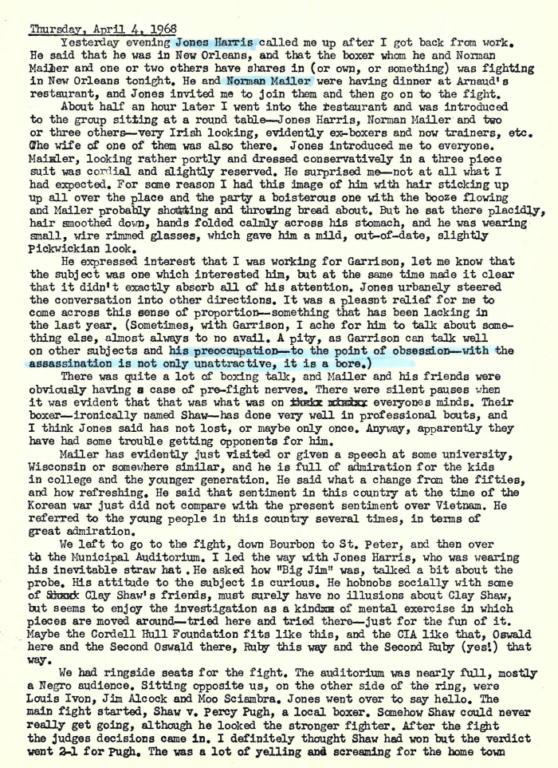
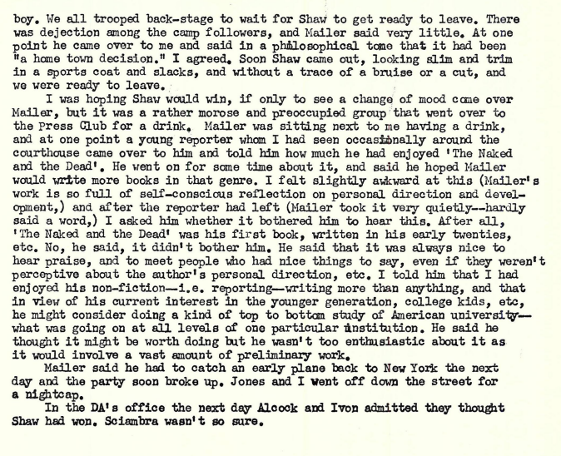
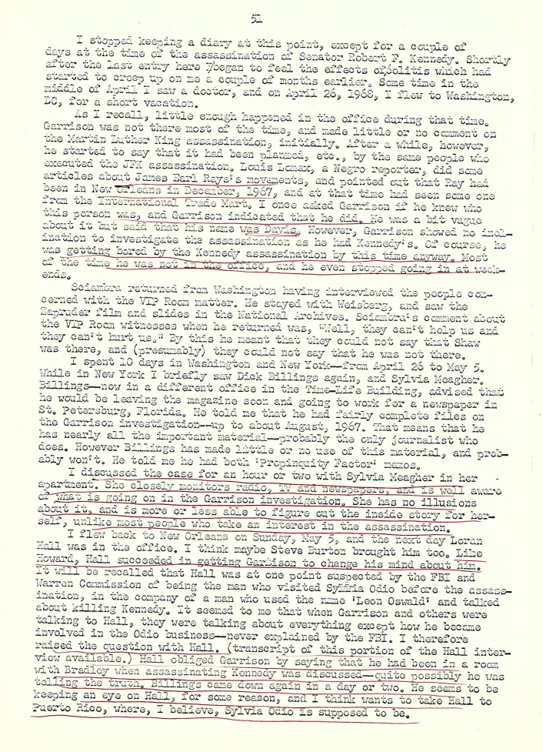
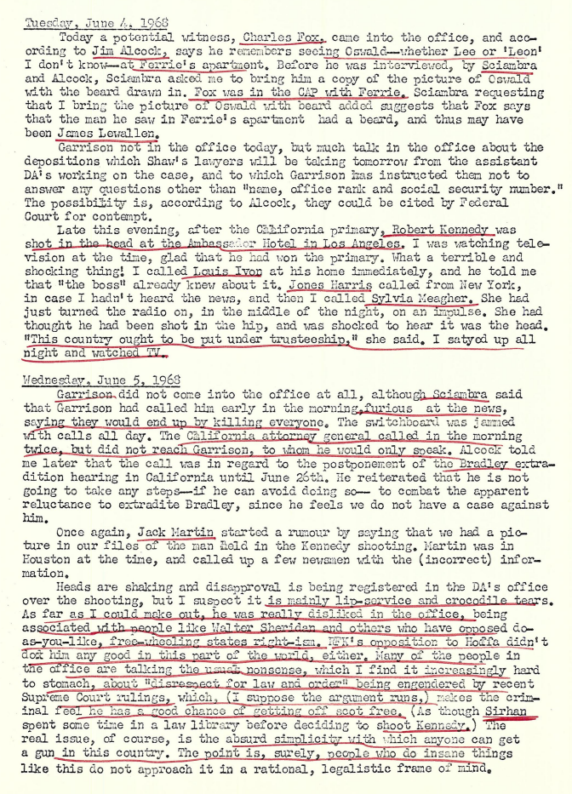
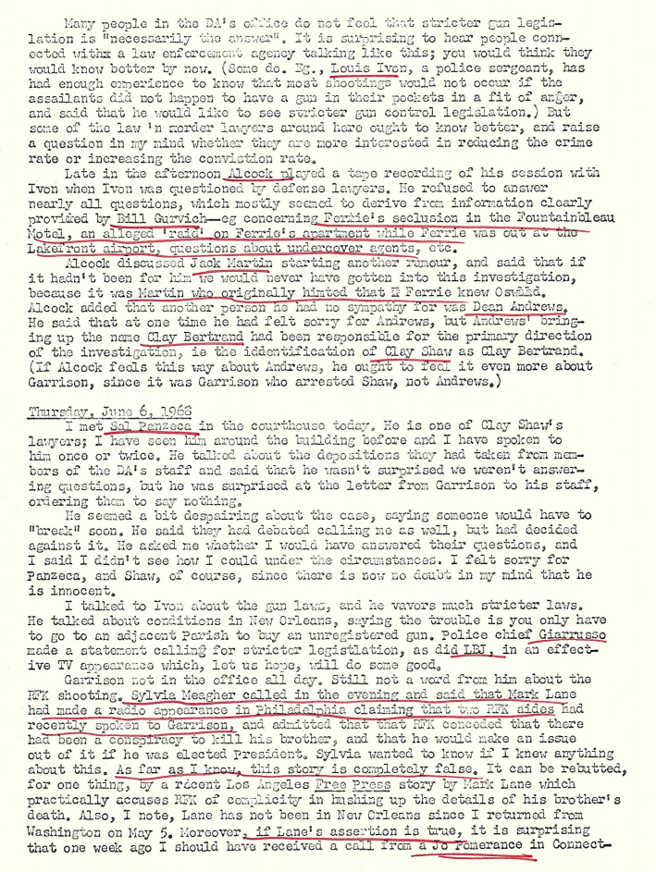
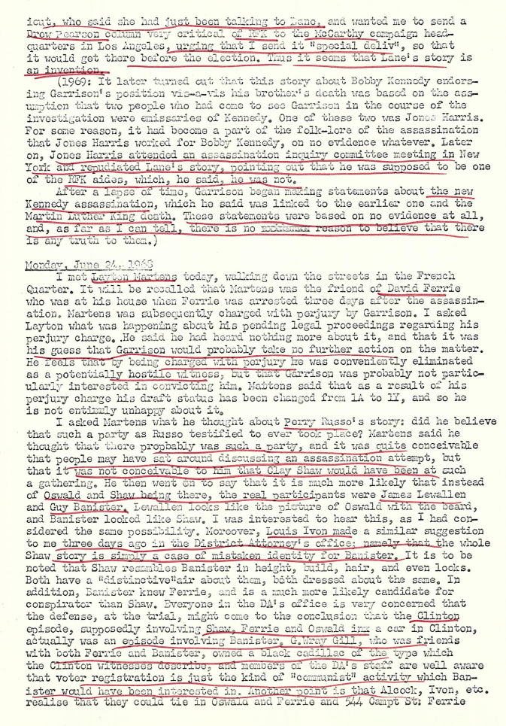
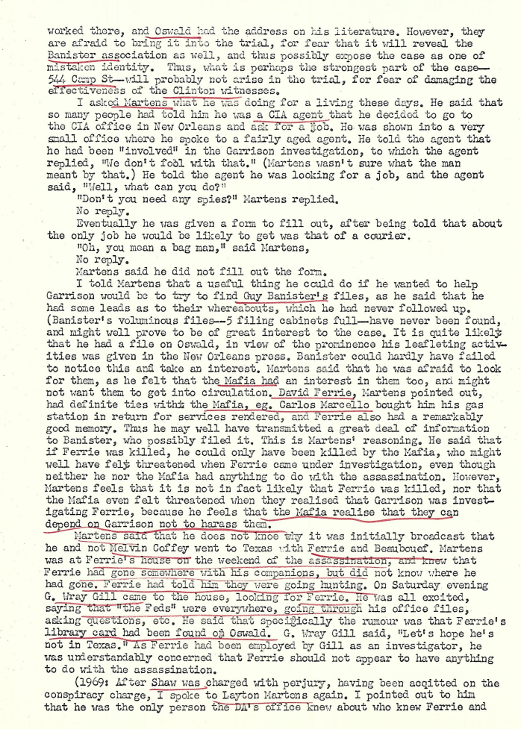
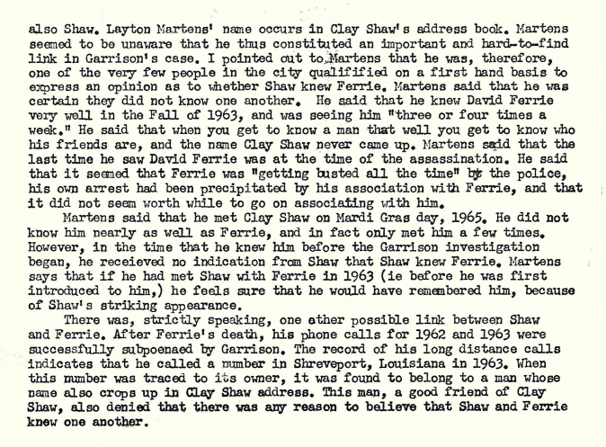

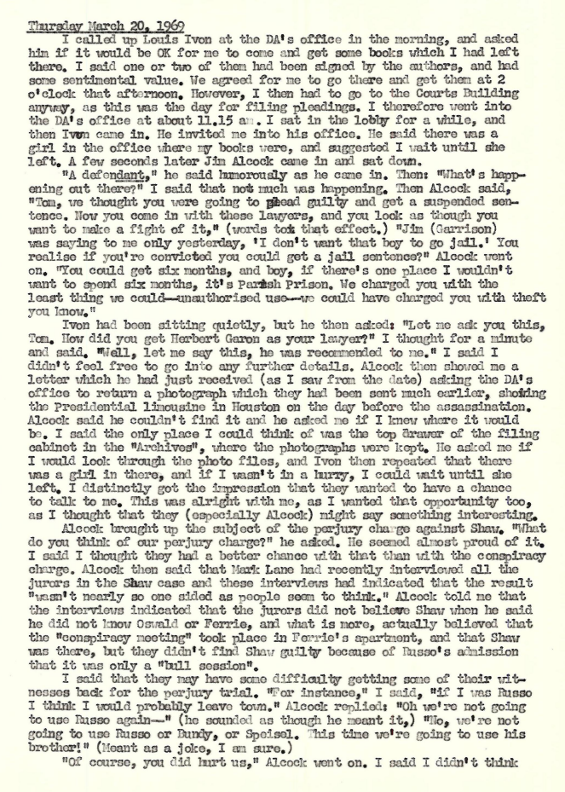
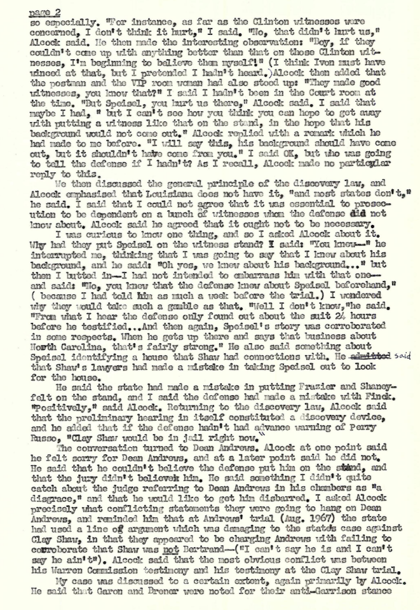
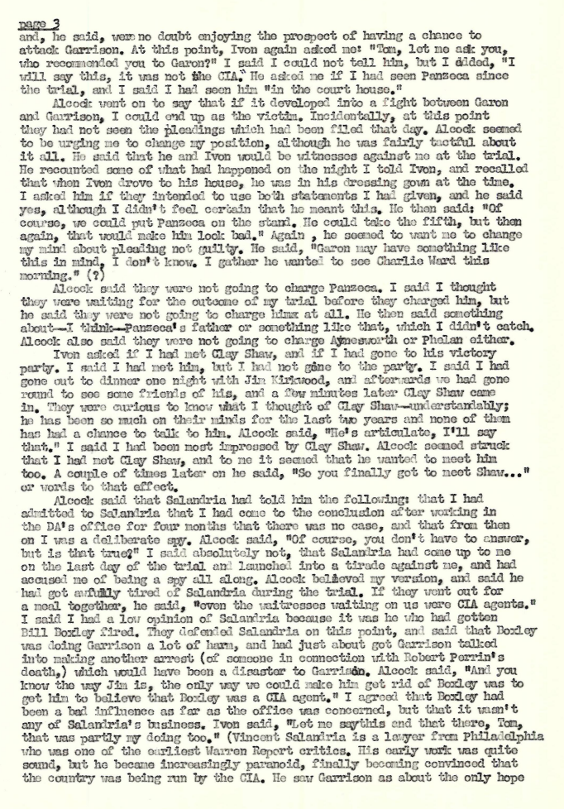
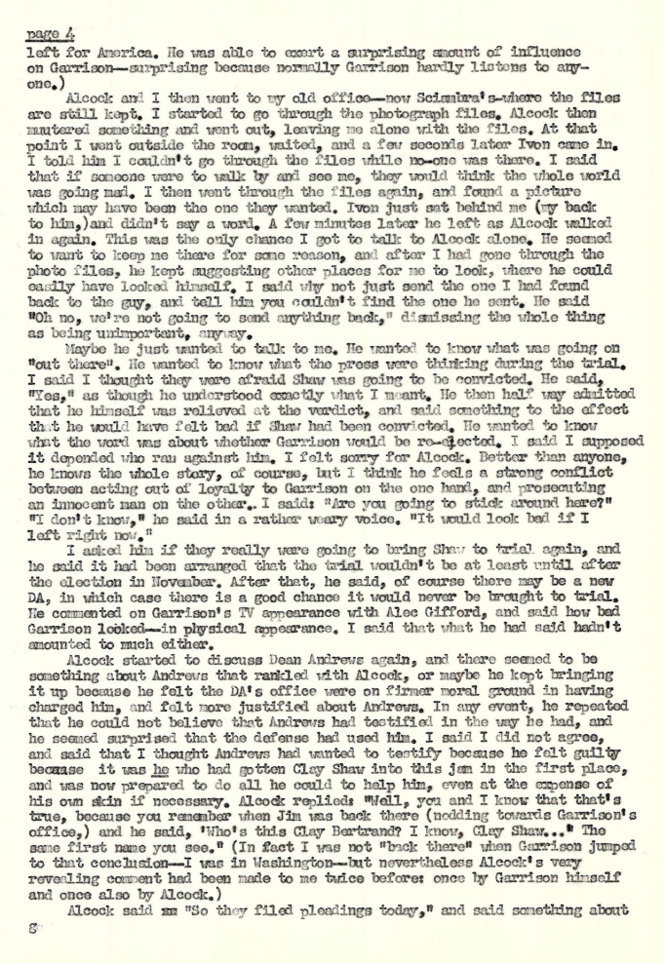
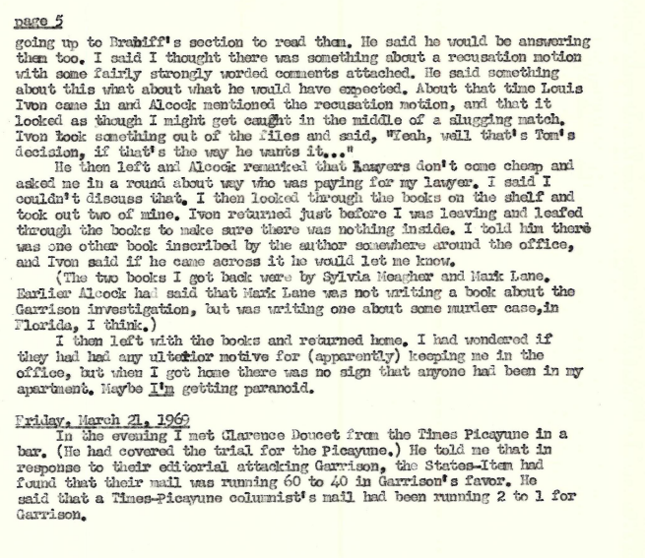

Richard Billings Journal
In late November 1966, Jim Garrison informed Life stringer David Chandler that he was secretly reopening the investigation into the John F. Kennedy assassination. In exchange for assistance from Life, Garrison offered the magazine the inside scoop on his probe. Life had just launched its own new investigation into the assassination, publishing some preliminary findings in an article of November 25, 1966, "A Matter of Reasonable Doubt."
The author of that article, Life editor Richard Billings, flew to New Orleans and struck a deal with the DA. "The arrangement was unorthodox and of arguable propriety," notes author Patricia Lambert. "Yet, theoretically, it could benefit all. Life would give Garrison free assistance and information on a global scale and in return obtain the inside story of the investigation, to be written by Richard Billings." (Patricia Lambert, False Witness [New York: M. Evans & Co., 1998), pp. 45-46.)
Life and Billings' participation lasted less than six months. It came to a halt when several members of Life's senior staff became convinced that Garrison was a fraud and his arrest of Clay Shaw a gross miscarriage of justice. (Lambert, pp. 82-83.) Billings himself, however, remained interested in the DA's investigation, as shown in the journal of NODA investigator Tom Bethell.
During his time with the NODA, Billings kept a journal that documents many of the day-to-day occurences in the DA's office and the evolving theories of Jim Garrison. That journal is presented here in its entirety. Approximately the first half consists of rough notes only. The remainder is presented in more conventional diary form, though it was clearly dictated and transcribed at a later date. Spelling, punctuation, and capitalization have been corrected wherever possible. Grammar and all ellipses are as in Billings' original manuscript. No text has been omitted.
Dick Billings's personal notes on consultations and interviews with Garrison
(notes transcribed)
December 1966-January 25, 1967
Early December (Dec. '66), trip to New Orleans after report from [David] Chandler that Garrison working on assassination -- had a suspect -- file from Chandler told of raid on Ferrie apartment, mentioned that two boys picked up held visa applications signed by Marcello Washington lawyer Jack Wasserman (this came from source outside Garrison's office who also alleged case was closed by a bribe, a report denied by DA's office) . . .
Met with Garrison, who outlined "the Smith case." . . . He began with history -- Oswald in New Orleans, the raid on Ferrie, Ferrie's arrest, description of Ferrie, and he produced B of I photo . . . Ferrie was arrested as fugitive from justice in Texas . . .
Garrison said further he was getting a file on Ferrie from private investigator agency (Southern Research) hired by Eastern as part of suspension proceeding . . . (Southern Research reportedly a Shreveport outfit . . .) . . .
Garrison said further about Ferrie he was helluva pilot, also a hypnotist, a defrocked priest and a fag . . . that he always seemed to have money, that he had worked as an investigator for Marcello New Orleans attorney G. Wray Gill . . . (Gill, turns out later, has an interesting black mark on his record . . . as a youth he was convicted of manslaughter in the death of a girlfriend . . . Garrison compares incident with Dreiser's "American Tragedy.") . . .
Garrison says that when Oswald in New Orleans in 1963 (April to September) he was seen two or three times with Ferrie -- at office of W. Guy Banister, former FBI agent (SAC, Chicago), right wing extremist, later a private eye in New Orleans until he died in June 1964 . . . Information apparently came from Jack Martin, the man who had tipped DA's office that Ferrie had known Oswald, had taught him to fire a rifle and had flown him to Dallas in September-October, 1963 . . . interesting point about Banister-Martin: police report shows Banister pistol whipped martin on day of assassination, reportedly -- by a secretary in office -- in an argument over JFK . . . Charges dropped by Martin, who turns out to be an undependable drunk and a totally unreliable witness . . .
Garrison, a former FBI agent himself (for months in [year crossed out]), says he turned file in 1963 over to Bureau, but he never heard from them again . . . He says, "you can't work with the Bureau . . . It's not interested in real investigation -- operates with 20/20 hindsight" . . . Garrison says after Bureau cleared Ferrie, "We let it go, but it has bothered me ever since." . . . Says he got interested again by reading critics' books, Esquire and Life . . . "There's no way to look at this in depth and not conclude there was a second assassin. There are too many coincidences . . ." 10 days before this meeting, Garrison had formed a special task force to devote total time to case . . .
Garrison mentions friend of Ferrie, possible second suspect -- Morris Levetin Brownlee, described as pillhead, weed boy, undercover man for narcotics squad . . . Had planned to arrest him on narcotics, a plan since dropped . . . But plan fits with Garrison MO throughout: get control of witnesses, accessories, suspects, etc. and, by eventually turning one or another, work for a break . . .
Information on Ferrie mug shot: 331 Atherton Dr., Metairie (address in 1961-62) -- pilot, Cleveland . . . ruddy, brown hair and eyes, 43, 195, 5'11" -- arrested 2/16/62 . . . Garrison says in 1963 Ferrie owned a Stinson . . . Knows he went to Texas by car or plane . . . Turns out later he went by car . . . Reports of bad weather that need check say he could not fly, so must have been important trip, for why else would a pilot drive seven hours . . .
Garrison suspects Cuban angle . . . Knows about Cuban liberation front (anti-Castro) . . . Cubans, Garrison suspects, felt betrayed in bay of pigs . . . Unless assassination was totally meaningless, the motive fits: vengeance . . . Garrison must assume possibility of a reason . . . Knows Ferrie was right in middle of Cubans, that his plane had been used for clandestine flights . . . Figures Ferrie the link between Oswald and Cubans . . . Oswald described by Garrison as prick peddler (male whore) . . . "He always came to see his lawyer, Dean Andrews, with a Latin type with a short haircut and a couple of faggots . . ."
Oswald and Fair Play for Cuba? Probably a cover . . . too much publicity . . . only evident for short time . . .
Garrison has 24-hour tail on Ferrie . . .
He figures Bureau now interested again . . . phone taps, etc.
Says he has names of people on higher level who were associated with Oswald . . .
More on Ferrie: organizer of CAP vigilantes who shoot up boondocks; speaks Spanish; reads a lot . . . No reason to arrest him at this point . . . Not a suspect beyond reasonable doubt . . . Though served him with a grand jury subpoena so he could be questioned (in DA's office, it turned out) . . . "He may not be the assassin, but he'll do." . . . "If he didn't actually do it, he knew it was going to happen and was involved . . . "
Garrison subscribes to grassy knoll theory . . .
Active investigation of Ferrie began midnight, Nov. 24, 1963 -- he turned himself in the 25th . . . Was questioned . . . Denied knowing Oswald . . . Said he went to Houston and Galveston that weekend to inspect an ice skating [rink] for purpose of possibly building one in NO . . . Also claimed to be duck or goose hunting, a story he maintained later was true, though boys with him said they didn't even take guns . . .
June 1963 in New Orleans . . . Ferrie, Oswald, and Ruby (?) . . .
Clay Bertrand . . . called Andrews and asked him to defend Oswald . . .
Frank Pizzo . . . always with Oswald in NO (?) . . .
Russell Long encouraged Garrison to take up investigation in New York couple of weeks earlier . . .
According to Andrews, Oswald had no ego strength at all . . . Says he advised Oswald on "garbage" problems, was never paid . . .
Garrison says Oswald came to Ass't. DA Ed Gillen to ask about a certain kind of drug . . .
Mrs. Odio mentioned . . . She has relatives in New Orleans . . . One, Dr. Guitart, lives in next block from Ferrie . . .
From May to July 19, Oswald worked for Reily Coffee Company, next block from corner of Lafayette and Camp, location of coffee shop where Cubans hang out . . .
Mentions testimony of Warren Reynolds, witness to Tippit slaying who was shot in January . . .
Garrison knows about Vaganov and article in Greater Philadelphia magazine by Gaeton Fonzi, 1500 Walnut . . . Kingsley 5-3500 . . .
DEC. 29 . . . second visit to New Orleans
Garrison says every day something new develops . . . Considers Banister office significant . . . Says Banister was shipping guns to Cuba with help of Ferrie . . . Ferrie had contacts in Tampa and Miami (Cuban); Banister knew how to get guns which were shipped from Miami . . .
July 15, 1963, a significant week: Ferrie's EAL hearing in Miami; Oswald fired by Reily Coffee . . . Garrison notes Reily Coffee around corner from Banister office . . .
Testimony of Adrian Alba . . . who ran garage near Reily . . . Says Oswald used to come there to read gun mags . . . When fired, Oswald said, "I'm going to Gentilly for that pot of gold at the end of the rainbow." . . . Gentilly a section of NO near airport . . . Garrison says he has a witness (Martin) who says he saw Oswald and Ferrie in Banister office, "But he's a liar who hates Ferrie." . . .
Delphine (or Delpine) Roberts, Banister secretary who talked to Andrews . . . Said Ferrie came to Banister's office almost every day . . . Also saw short, muscular Cuban at meetings . . . Probably same Cuban seen by Andrews with Oswald . . .
Alberto Fowler -- Cuban helping Garrison; Gen. Uria, former police official in Cuba under Batista . . . "These are legit Cubans who have contempt for wildcat, outlaw Cubans," says Garrison . . .
Banister -- probably insane before he died . . . former assistant chief of police in New Orleans (?) . . . A violent man, heavy drinker . . . Went all the way down before he died (in either June or July 1964) . . .
Sergio Arcacha Smith . . . Cuban leader, connected to Ferrie . . . Living in Texas (Houston or Dallas) at time of assassination . . . Prime suspect in early stage of probe . . .
JAN. 5 [1967] . . .
Garrison says he's "long past point of coincidence of motive," but he needs evidence . . .
JAN. 11 . . .
Garrison searching Miami for Manuel Garcia Gonzalez -- proves futile . . . thinks he may be short squat Cuban . . . has friend, Max Gonzales (no kin), who has infiltrated Ferrie . . . Gonzales, a Mexican, old army friend and a pilot has told Ferrie he's interested in buying a plane Ferrie says has been sitting in Tampico for three years . . . Gonzales wants to see it . . . Garrison also has an informer, old friend of Ferrie's named Jimmy Johnson, who is living with Dave and spying on him for Giant [Garrison] . . . Garrison has men in Dallas and Houston, and he's heading for Miami . . .
Giant says Ferrie getting nervous, says he can't wait too long . . . "People could disappear . . ."
JAN. 14 . . .
Giant thinks he has name of short, squat Cuban and thinks he's in Hollywood, Fla. . . . Says he is Manuel Garcia Gonzalez, nickname "Toro" . . . In the boat instrument repair business . . . Giant has asked Gerstein for help . . .
Giant has prints of moving pictures taken while Oswald handing out leaflets in front of Trade Mart, Aug. 9, 1963 . . . Is showing them to possible witnesses . . .
Has report that Ferrie and Arcacha arrested in Covington by FBI in 1963 . . .
Has another report that Ferrie was building a midget sub at his home . . . To be used to raid Havana harbor . . .
Giant has filed down .38 cal. bullets as part of theory that such bullets killed Tippit, so they couldn't be traced . . .
JAN. 16 . . .
Working on Miami angle . . . thinks he has "Bugs Bunny" [Manuel Garcia Gonzales] . . . Never found him . . . Wants to arrest Bugs Bunny so he won't bug out . . . Would arrest on narcotics charge, conspiracy later . . . Ferrie know Giant in Miami which J. G. considers a goof, result of things moving too fast . . . Gerstein has explained how Bureau taps phones using central phone co. office . . .
Giant thinks his presence in Miami may have flushed Bugs Bunny . . .
JAN. 21 . . .
Giant calling in Carlos Quiroga, Cuban linked to Arcacha who was seen by David Lewis with Oswald in Mancuso's Café in summer of '63 . . . Hopes to turn Quiroga . . . If not, will tail him when he leaves . . .
Al Oser checking area north of lake for old training camps . . . Has found likely spot . . . Old plane sitting unused on strip . . . Turns out to belong to W. F. Miller, 1877 Mt. Diablo Ave., Stockton, Calif. . . . Check of Miller determines he and wife recently died in plane crash en route from Reno to Calif. . . . .
Quiroga vehemently denies having known Oswald except when he tried to infiltrate Fair Play for Cuba . . . Says he knew Ferrie and Arcacha . . . Garrison has questioned Miguel Torres, who was brought from State Penitentiary in Angola . . . He turns out essentially negative . . . But he was approached by Manuel Santana and asked to work for Cuban cause . . . Torres an addict . . . habitue of Habana Bar on Decatur Street . . .
JAN. 22 . . .
Lewis has reported he was shot at on Chartres . . . Lie detector later proved this a lie to gain attention . . .
Giant interested in Christian Democratic Party, Cuban revolutionaries who had training camp north of lake in summer '63 -- has names: Diego Paneque, Ricardo Davis, Orlando Piedra -- CDP run by Lauriano Batista . . .
Giant questions Charles Steele -- negative . . .
Giant has from Gill 1962 and 1963 phone bills and thinks he knows l. d. calls made by Ferrie . . . Some interesting calls to Texas, but most interesting is fact that bill for November 1963 is missing.
Max makes trip to find plane in Tampico . . . Ferrie doesn't go . . . Sends plane broker named Price . . . They never leave Louisiana, end up in Hammond . . . mysterious phone calls made on landing . . . Garrison figures Ferrie has made Max . . .
Clay Bertrand -- may not exist . . . but may be Clay Shaw . . . He comes in for questioning, leaves saying, "Merry Christmas," and heads for Hammond, where his mother lives . . .
Garrison checking laundry mark found in jacket at scene of Tippit slaying -- negative . . .
Mrs. Odio located in San Juan . . .
JAN. 23 . . .
Giant going through Vol. 22 of Commission evidence . . . Finds application for Oswald's trip to Mexico in which he lists himself as a photographer at 640 Rampart . . . At 640 South Rampart there's a publication called Louisiana Weekly . . .
Giant interviews Andrews again . . . Certain he knows something about assassination training but won't talk . . . Has name of man training north of lake -- Hernando Cortes -- Giant figures original of 32 was cut -- Hernando was cut . . .
On Sept. 10, report shows, a Manuel Gonzalez was arrested by Officer Ortiz in 1100 block of Decatur . . .
Giant mentions Covington arms cache . . . Figures Andrews knows about, since he defends people in trouble with Customs . . . Andrews an ass't. DA in Jefferson Parish . . .
Giant checks note taken from Ferrie apartment with Oswald handwriting in evidence . . . Check proves negative . . .
Giant notes from evidence how Oswald paid off $435 debt to DOS . . .
Ferrie starts contacting DA's office to see what's going on . . . meets with Pershing Gervais . . . says Ferrie: "I've got some interesting ideas. There may have been a second assassin." . . . Gervais amazed by Ferrie's knowledge of ballistics . . . Ferrie also talked about JFK wounds . . .
Says Garrison, "The only way they can prevent me from busting this is for someone to kill me." . . .
JAN. 25 . . .
Giant has talked to two Cubans who convinced there was a camp set up to plan and train for Castro assassination . . . Camp was north of lake . . . A spy was found in camp in August, driven to Miami and questioned by Laureano Batista . . . CDP tried to turn spy over to FBI, but Bureau had no jurisdiction . . . Giant sends Fowler to see Batista . . . Another name attached to camp: Ledovido Interam . . . Fowler points out there were two camps -- one CDP where the spy, Fernando Fernandez, was caught; another run by ultra conservatives . . . Turns out CDP camp didn't break up when spy was caught (claim they knew he was there all the time and kept him for protection against other infiltrators) . . . Camp broke up because of raid on conservative camp . . . Davis ordered departure . . . CDP camp on land owned by Redemptorist Fathers, later located by Oser with help of Angel Vega, one of Cubans there . . . Ultra conservative camp reportedly on land owned by McLaney (see report on raid) . . .
Mrs. Decker, lady in Banister's office in 1963, connects Banister to Quiroga, who has refused lie detector . . . Mrs. Decker was secretary to Banister . . .
Ivon questions Jack Martin, described as a lush and a bum . . . evasive . . .
Giant now convinced Ferrie went to Houston, not Dallas, on assassination weekend, but he had been in Dallas before and after . . .
Giant points to Vol. XXIV, as it describes short, stocky Cuban with Oswald at Cuban embassy in Mexico City . . . See testimony of Guttierez . . .
Andrews says he saw Oswald with Cuban three times . . . Would say no more . . .
Giant says case now depends on locating the short, stocky Cuban . . .
Alcock and Fowler to Miami; Gurvich and Loisel to Dallas, looking for Arcacha, who dropped out of sight on Nov. 11, 1963 . . . Turns out he was in Dallas in September 1963 -- sent postcard to [Ronnie] Caire . . .
Giant questions Oswald whereabouts on Nov. 17, 1963 -- only weekend he did not show up at Paine apartment in Irving . . .
Ricardo Davis has also disappeared . . . Turns up later in Houston . . .
Independent check with rip on identity of leaflet picture: he says people can be named by NO police, but his friend in intelligence section advises against going any further . . . Says take it easy, for pursuit raises a touchy subject . . . But no involvement on part of Company . . .
Giant pursuing time and propinquity chart . . . Tries to link Oswald to Torres and Santana . . . Says Santana was brought in by underground from Cuba . . . Santana and Torres arrested together for burglary . . . Santana got three-year suspended sentence . . . still searching for him . . . Santana lived right around corner from Alvin Beauboeuf . . . Beauboeuf longtime lover of Ferrie, once took trip with Dave to Latin America . . .
Gurvich finds White Rock Airport in Dallas shows trace of Ferrie . . .
Time and propinquity centers on Parkchester, an apartment complex in north New Orleans . . . Arcacha lived there till he left in '62 (Sept.) . . . So did Davis . . .
Report on Banister files . . . Delphine Roberts, Banister mistress, tried to get them, but burned by Mrs. B . . . Mrs. B in Monroe, La. . . .

February 11-March 22, 1967
FEB. 11 . . .
Arcacha known to be in Dallas . . . Located by Gurvich . . .
More on CDP camp . . . Vega trapped Fernandez . . . Davis set up camp, but not there much . . . Davis lived in New Orleans till '65, then moved to Houston . . . Alcock has cleared CDP camp of involvement, but not Davis, who he thinks might have worked with both CDP camp and ultra right camp . . .
Oser has located house raided by Feds in summer of '63 . . . Arms and explosives taken . . . See Gurvich report . . .
Gurvich has purchased gun from guy who bought it from Beauboeuf . . . It's a thirty o six . . . Springfield army rifle converted for hunting . . . Got rifle by calling Ferrie at Lakefront Airport . . . Beauboeuf flew from Lakefront to Moisant . . . Sold a revolver, too . . . Checking sight mounting on rifle . . .
Giant says Clay Shaw and Clay Bertrand one and the same . . . Has a picture taken from a driver's license . . .
Ferrie's apartment staked out from across street . . .
Shaw, now engaged in translating plays, links to Ferrie through [James] Lewallen . . . old friend of Ferrie's who lived next door to Shaw . . .
Dick Burnes calls Shaw and asked for John Shaw . . . Clay's answer: "Who are you?" "Who sent you?" . . . which seems to prove Shaw used to having people sent to him . . .
Giant hasn't questioned Quiroga and Andrews again, because he knows they lied . . . Figures he'll catch them in a lie, then turn them . . .
Giant has now cut his team to hard core: Ivon, Sciambra, Alcock, Gurvich and Burnes . . . Says he needs focus, and figures ultimately he can turn people on basis of relationship structure . . . "We'll show them how their names will look on a charge sheet." Wants to move from phase one to phase two . . . Solve phase one first and develop things so people will be willing to reveal what they know about phase two . . . "Only thing to prevent solving the case now will be a Bureau steal . . ." Take Quiroga . . . We know when he's lying, because he tends to be evasive . . . He knows what happened, but don't think he was involved in assassination . . .
Giant fears Ferrie may kill himself . . . He talks a lot about not having long to live . . . "He's a sick man, and it's obvious to him we're not stopping . . . "
Conjecture on how Oswald have made visit to Odio's house while reportedly en route by bus to Mexico . . . Giant suggests he was flown there . . . Gurvich to check White Rock on this . . . Giant concedes no one but Oswald might have been involved, but he says it's doubtful . . .
Giant investigation to cover other homosexual murders that may give a lead . . . may 1, 1962 -- Jimmy Roop, 15-year-old boy found hung . . . Wearing mother's clothes . . . Termed suicide, but indications otherwise . . . He belonged to mysterious club, says his mother . . . Had voiced fear that kids might kill him . . . when found his ankles were tightly bound . . . Two queers about 18 or 19 known to have been hanging around . . . Had Ohio license on their car . . . Layton Martens lived four blocks from Roop . . . Does this link Roop killing to Ferrie?
Giant also checking narcotics links . . . Brownlee may have been bringing in stuff through Brownsville . . . Ferrie made calls to Brownsville . . . How about Torres' friends . . . His girlfriend died of an overdose . . . then there's O'Dell -- his name found in Ferrie's apartment . . . He sold LSD to girl in first New Orleans case . . .
Gurvich has Arcacha address: 9915 Donegal Dr. . . . Had moved from 10746 Lake Gardens . . . Had once lived near White Rock Airport . . . Giant plans to hold up on Arcacha . . . He may be suspect . . .
Giant turns up Oswald application for job at Cosmos Shipping Co. . . . Lists a Ruth Kloepfer (though misspelled) as a reference . . . She confirms . . . Is friend of Ruth Paine . . . Turns out she lives at 3033 Louisiana Parkway, right near Ferrie . . .
Giant interested in when Brett [sic] Wall, queer ex-roommate of Jack Ruby, arrived in Galveston . . . He was there night of Nov. 23, having driven from Dallas that day . . . Wall got call from Ruby at five before midnight on Nov. 23, same night Ferrie turns up in Galveston . . . Wall staying at home of respectable friends . . . Ruby explained call was about a complaint he had with theater guild . . . Wall in theater, produces revue called "Bottoms Up" . . . Ruby, often connected with perverts and gunrunners, was in New Orleans several times . . .
Gurvich locates in Dallas a Caridad Lopez, who lives with her mother, Carmen Zalvidar . . . He was looking for 3128 Harlingdale [sic], since Warren evidence shows many Cubans met there, left right after assassination . . . No 3128 Harlingdale [sic], but Caridad lives at 3218 Harlingdale [sic] . . . She has nothing to say that is helpful . . . But a Fidel Zalvidar, perhaps her brother, was at CDP training camp . . .
FEB. 23 [Thursday] . . .
Sciambra returns from Houston where he went to check skating rink Ferrie said he visited . . . Giant especially interested if Chuck Rolland, manager of rink, turns out to be gay . . . Winterland skating rink, 2400 Norfolk . . . First he met skating pro, Larry Rost, who is a swish . . . Rost says Rolland no longer running rink . . . Rost, former Canadian skating champ, slips when he learns Moo [Sciambra] wants to talk with Rolland about what happened in 1963 . . . he asks Rost about Ferrie and two boys . . . Rost says he knows what it's about but remembers nothing . . . Moo asks, "Haven't I seen you somewhere?" . . . Rost says he used to skate in New Orleans with "Holiday on Ice" . . . Know Miss Dixie's, a famous fag joint . . . Moo surmises Rost was guy Ferrie came to see that day in '63 . . .
Sciambra goes to see Rolland, now in office equipment business . . . Rolland knew immediately why he there . . . Says there's a lot more than he gave FBI . . . says Ferrie called him late on Nov. 22, said he wanted to skate next day . . . Rolland gave him hours: 10 to 12 and 3:30 to 5:30 . . . Ferrie arrived before Rolland got to rink on afternoon of 23rd . . . Ferrie asking for him . . . When he met, Ferrie almost screamed: "I'm Dave Ferrie. I'm from New Orleans and I'm here." Ferrie didn't seem to care much about skating . . . The two boys did . . . They stayed till 5:30 . . . Rolland thought Ferrie some kind of nut: "He made too much of an effort to tell me he was here . . . " Moo asked Rolland if knew Brett [sic] Wall . . . Rolland said he didn't but he'd ask his wife . . . Mrs. Rolland told of follies club, managed by a Keith Richards . . . It's a gay club, featuring female impersonators . . . She says she knows hairdresser who did her hair and also coifed for the boy-girls . . . She says Richards once lived in Mexico, was an ex-bullfighter, perhaps a pilot . . . He once was connected with rink . . . In May 1963 Rolland and his step-father (now dead) leased rink from Richards (?) . . .
Mrs. Rolland [said] there were three female impersonators whose names she would try to get from hairdresser, Vincent Mazzola, who worked at Joskes . . . She says the impersonators worked all over country, talked a lot about New Orleans . . . In fact, she thinks, two of them came from NO . . . She remembered Brett [sic] Wall, because "Bottoms Up" once played at Houston-Continental (check a Mr. Schaefer) . . . (Note: Sciambra relates "Bottoms Up" playing at Adolphus in Dallas at time of assassination . . . )
Giant says he has two witnesses . . . One participated in a 1961 raid on a bunker of explosives in Houma, La. with Ferrie and Arcacha in attempt, apparently successful, to get arms to ship to Cuba . . . This turns out to be Gordon Novel, a witness Giant wants to keep secluded, because he thinks he's got something . . . (Independent check later revealed Novel is a con man who is bragging about leading the DA astray . . . Also, he's a friend and confederate of Dean Andrews . . .) Novel an electronics expert who tells Arcacha location of explosives . . . presumably stored in Houma by an oil company . . . Second witness named [Rancier Blaise] Ehlinger . . . Novel and Ehlinger had seen the bunker while in Houma for drag racing . . . This in Sept. 1961 . . . Expedition to Houma consisted of Novel's Lincoln, a Chevrolet and a laundry truck . . . Laundry truck, says Novel, driven by a nutty ex-Marine named Andy, who Giant presumes to be Andrew Blackmon, known to be a Ferrie associate at the time . . . This name Giant did not give to Novel, who says he'd been questioned by the Bureau . . . Also on journey were Layton Martens and two Cubans, Ferrie and Arcacha . . . laundry van was used to transport stuff . . . Blackmon described as a guy who whenever he picks up a rifle, he can't resist firing it . . . Novel says when he mentioned laundry truck to FBI agents, "They nearly had a shit hemorrhage . . ." . . . This, Garrison presumes, due to reports there was a laundry truck on scene of assassination . . . Giant later photographed truck belonging to Golden Cleaners ([Walter] Sheridan, inexplicably, has copy print) . . . Giant thinks this is hot, but he's probably wrong . . . Back to Novel story . . . Arcacha, usually well-dressed gentleman, wearing a sport shirt . . . Everybody wearing work gloves . . . Metal clippers used to break in bunker . . . Says Novel, "I got the impression they were amateurs on the verge of becoming professionals . . ." Giant found Novel through Willard Robertson, one of angels . . . Robertson heard he'd been approached by Bureau . . . They took everything in bunker but the nitro . . . On drive back, says Novel, either Martens or Blackmon lit a piece of dynamite and threw it from laundry truck, making a sheet of flame 10 feet across . . . "It was then," says Novel, "that I knew they [were] nuts . . ." . . . Novel claims two weeks later there was a report in the papers concerning explosions in Cuba . . . Two weeks after that he claims he got letter of thanks from Tony Varona . . .
Giant says Andrews now tells him there is no such man as Clay Bertrand . . .
Sciambra tells story he got from levee cop Charlie Noto . . . Noto claims in Oct. '62, when Oswald supposed to be in Dallas, he arrested two men in a parked truck at Lakefront Airport . . . Figured they were deviates . . . One of them jumped out and yelled, "I'm Lee Harvey Oswald. I'm an official of Fair Play for Cuba." . . . Noto took the pair to his superintendent, Oswald protesting . . . Other guy described as a Latin . . . Noto says his superior let them off . . .
Sciambra also tells of trip to Morgan City . . . Statement from a Mrs. Villard, who claims in November 1963 was employed by a motel owned by a Mr. Guarisco, an associate of Carlos Marcello . . . She was a receptionist . . . On Nov. 14, a man she swears was Jack Ruby came in asking for Guarisco . . . He was followed by a kid who, she remembers, played nervously with the phone . . . While Ruby waited for Guarisco, kid kept picking phone off hook . . . The kid, she is certain, was Oswald . . . Ruby she remembered from seeing him at a Morgan joint called the Hub Club . . . Guarisco didn't return, so the pair left by separate doors, but Mrs. Villard says she saw them rendezvous at their car . . . Said earlier they were getting a plane at Patterson Airport . . . She says she told Guarisco, who said nothing, but the next day he placed a call to Dallas and charged it to a Patterson number . . . Mrs. Villard said she had been questioned by the Bureau, but because she's afraid of Guarisco, she said little . . . Then in late September, she says Oswald and Marina came by looking for a room . . . They came in an old beat-up car, Marina came in and said, "Room, room," but due to inability to understand answer, she left and they drove off . . .
Ivon tells of telephone operator in Alexandria who says on the Wednesday before the assassination, she monitored a call in which a voice said, "He's got to be killed in Dallas . . ."
Giant decides to concentrate on Arcacha and Shaw and establish a link to Oswald and Ferrie . . . He promises an arrest "for next Wednesday or the following . . ."
Alcock says he has a restaurant owner on lakefront who swears he saw Ruby and Oswald together . . .
FEB. 25 [Saturday] . . .
Going after Shaw . . . Talked to Andrews, but he wouldn't turn . . . Still unclear about Bertrand . . . plans to subpoena Shaw Monday morning . . . Giant planning to leave town . . .
Fowler has new information from Bernardo [de] Torres which proves unlikely . . . Torres has reidentified stocky guy in leaflet photograph, already positively identified as a Lebanese businessman . . . Torres claims his name is Verdaguer, a pilot, and his informant, Yito del Valle, was murdered the past Wednesday night . . . Del Valle turns out to be tied up with Santo Trafficante . . . Giant cuts Torres off as source . . .
Giant mentions receiving letter from Mrs. Luce referring to three Cubans who have proof Castroites murdered JFK . . . Mentions Justin McCarthy, New York flak . . . Mrs. Luce, she flew to Chicago on night of assassination, where she got a call from one of the Cubans, a doctor . . . He said Oswald had approached his people and tried to join their group (checks with Bringuier story), and therefore, the anti-Castro Cubans decided to infiltrate Oswald . . . The Cuban infiltrators say they saw and heard Oswald at Communist meetings, where he made speeches about plans to kill Kennedy . . . Acoca contacting Lanusa . . . Hellowell contacting Justin McCarthy . . .
Search for Ricardo Davis intensified . . . Fowler seeking Mrs. Odio . . . Fowler has heard from Phil Carter of Newsweek that Julian is Julian Buznedo . . .
FEB. 26 [Sunday] . . .
Oser with Vega found camp . . . Also, he's talked to Nick Chetta, who confirms Ferrie died of natural causes, "but he could have worried himself to death," said Chetta . . .
Gurvich and Alcock in Dallas after Arcacha, who uses Dallas Police as sanctuary . . . Sergio getting legal advice from Ass't. DA Bill Alexander . . . Giant tips CBS of his interest in Arcacha . . . Arcacha claims he's being hounded . . . Giant plans to issue warrant for Arcacha arrest . . . But later, Arcacha began to help . . . He located Davis and later still, he confirmed (through Aynesworth of Newsweek) identity of Julian Buznedo . . .
Andrews is scared, says Giant . . . He now vaguely indicates Shaw and Bertrand the same . . . Andrews calls Moo's uncle, says he's a promising lawyer . . . Andrews says Novel knows Shaw . . . Novel denies it . . . Andrews says he'll help find Davis . . . Gurvich told to look for Davis in Houston . . . Sciambra to Baton Rouge to find Perry Russo, who has told States-Item he knew Ferrie . . .
Sciambra reports on meeting with Perry Raymond Russo, who he describes as 25 or 26, an employee of Equitable, and very cooperative . . . (See report in file) . . .
FEB. 27 [Monday] . . .
Sciambra brings Russo to New Orleans . . . He identifies bearded picture of Oswald as Ferrie's roommate . . . He also remembers Blackmon's name . . . Has seen Santana . . . Plan is to have Russo identify Shaw . . . For a time Russo thought perhaps Arcacha had posed for porno films, but later he decided it was untrue . . . Then they give Russo sodium Pentothal in presence of Nick Chetta and two other doctors at Mercy Hospital . . . Some variations with earlier statement, especially significant were some new revelations and recognition of names, but it's possible he was responding to Sciambra's lead . . . (See Sciambra report of sodium Pentothal test) . . .
Ricardo Davis has told Bringuier he once saw and met Oswald . . . Gurvich and Alcock find him in Houston . . . He cooperates . . .
Giant certain things about to break . . . Lewallen has refused polygraph . . . So he's got a stakeout, as does Shaw . . . Planning to subpoena them both on Tuesday morning . . . Shaw becomes hottest suspect, because, said Russo, Ferrie said, "We're gonna kill Kennedy, and it won't be long." This said in Shaw's presence, says Russo . . .
Giant now knows his no. one priority is establishing the link to Oswald . . . Russo his star witness, but also has friends -- Kenny Carter, Niles Peterson, Ted & Jerry Kirchenstein -- who corroborate identification of Oswald as the bearded roommate . . . doctors who witnessed sodium Pentothal: James Wall, Richard Zepernick . . . He went under at 3:28 on Feb. 27 . . . Came out at 4:10 . . . Have certificate . . . Plan to have subpoenas issued for Lewallen and Shaw by Matt Braniff, a cooperative judge . . . Subpoenas will be on record and will indicate matter of interest . . .
FEB. 28 [Tuesday] . . .
Subpoena delayed for Chetta's press conference . . .
Giant talking to Novel at home . . . He confirms picture shows right laundry truck (?) . . . Says further they were trying to get a zoholoran rifle (fires an explosive 20 mm shell) to kill Castro . . . Says also Ferrie was planning in 1961 to blow up pipelines to Guantanamo to set off an invasion by US . . . Giant now thinks there was a fusion of motives in JFK slaying: anti-Castro obsession and Leopold-Loeb revisited . . . Thinks Julian was the field general . . . Subpoena to go to Lewallen, but not to Shaw . . . Will have Shaw tailed, but will not do anything until Russo identifies him . . . Russo at Shaw home with Moo . . . Giant to use New Orleans Athletic Club for HQ . . . If Shaw is identified, he'll be brought in and charged . . .
Garrison describes staff: he has 20 assistant Das and 10 investigators . . . Chief ass't. Charles Ward is running office, while Garrison concentrates on Smith case . . . He has picked a few to help him: Sciambra, Alcock, Oser and Burnes, plus Lou Ivon, chief investigator and private eye Bill Gurvich . . . But with private fund, Giant plans to hire young lawyers from around city and also get three men from the governor . . .
3:05 PM, Feb. 28 . . . Giant tells Ivon Russo has identified Shaw, so "grab him." Then decides to wait till 4 . . . Subpoena "for questioning in the investigation of the assassination of John F. Kennedy" has gone to Lewallen . . .
Ward comes in, says he's been contacted by inmate of the parish prison who has given a statement swearing he saw Ruby and Oswald in Chicago together . . .
Moo says identification is definite . . . But Shaw has spotted them . . . Says Russo, "You just don't forget that face." . . . Giant plans to arrest Shaw at 1313 Dauphine as an accessory? . . . "He knows he's involved. He's got to," says Giant . . . Now plans to charge Shaw as conspirator . . . "He sat there, giving assent," says Garrison . . .
Name of pilot who claims seeing Ruby and Oswald together is Eugene Sauner . . .
Russo says he saw Bertrand three times: at Nashville Wharf, at Ferrie's apartment and at gas station . . . The latter interesting because Russo first said it occurred before apartment, while we know from Ferrie's records he owned station in 1964 . . . (It was called Al [for Beauboeuf] and Dave's) . . . Franchise reportedly awarded to Ferrie by Marcello . . . Why (?) . . . This all cleared up under hypnosis later, for then Russo recalls it was in 1964 that he saw Bertrand and Ferrie at "Al and Dave's" . . . Russo says at dinner he now recalls Oswald was wearing a gold or brass wedding ring . . . But he's leery of name, Bertrand . . . "I don't remember name Bertrand now, so I'm very skeptical of what I'm saying . . ." . . . He well remembers muscled face and kinky hair . . . "When Kennedy was speaking at the Nashville Wharf, everyone but the Secret Service men were watching him . . . I thought Shaw was an SS man because he was watching the crowd . . ." He remembers Sandra Moffett at Ferrie's apartment . . . She had posed for sex movies . . . "Ferrie would pace back and forth -- he was very nervous -- while he was making a point." . . . Bertrand argued with him over plan . . . Oswald was quiet. So were others . . . "It seemed to me so remote and so far fetched . . . I said, 'You'll never get away with it.'" . . . Russo says he saw Ferrie 50 times over two years . . . saw "bearded wonder" four or five times at Ferrie's place . . .
MARCH 3 [Friday] . . .
The day after Russo identified him (Feb. 28), Shaw was subpoenaed . . . He was detained from one until eight . . . Giant says he refused to confirm or deny anything . . . He had desisted from making the arrest on advice from Ward and Ivon . . . He gave Shaw last chance to take polygraph . . . Shaw asked to go home and rest . . . Giant declined and placed him under arrest for conspiracy . . . (Details of arrest and events surrounding on record and well reported) . . .
Preliminary hearing set for March 14 . . . Requested by Garrison in move to beat defense, so to be able to pick judge . . . Would be three judges . . . Hearing to show probable cause to bind Shaw over for trial . . .
Search of Shaw home produces whips, chains, robe, etc. . . . Giant now convinced it was a sadist plot . . . Has read Marquis de Sade . . . Says sadists escalate from whipping to killing . . . "Shaw is a Phi Beta Kappa sadist," Giant surmises . . . Cuban plot now subsidiary . . . But it provided guerrilla team . . . Ferrie was a butch fag who hired Cubans instead of ex cons . . . Whips give away . . . Leopold Loeb key to whole thing . . . Giant convinced . . . "I am going to talk to a good psychiatrist -- Bob Heath -- and I will make sadism relevant . . . I'll develop expert testimony that a sadist would have motivation for a Presidential assassination." "He's a sadist, not a masochist . . . The robe and hood prove it . . ." . . . "When he came in yesterday he said nothing, knew no one . . . We asked if he'd take truth serum, and he said he would if he could go home and rest . . . I suspect he wanted to destroy the evidence of sadism . . ."
Giant mentions talking to [Hugh] Aynesworth, who "knows a lot about Dallas." . . . "He knew Ruby for ten years, and he gave me information that he was a faggot, and that his name among faggots was Pinky."
Giant admits Russo is his only link now . . . But there's the girl . . . And Peterson and Carter have also made Oswald . . . He plans to arrest Andrews as an accessory . . . Then again, he may charge Dean with perjury . . . Can use Grand Jury . . . "We'll give the Grand Jury a picture, and we'll communicate to them we know about Bertrand . . . They can then ask Andrews if he knows Bertrand . . . Any statement Andrews makes to the Grand Jury that conflicts with what he told the Warren Commission is automatic perjury . . ."
Dr. Chetta said to Oser, "There's not a chance at all that what this kid (Russo) said (under sodium Pentothal) is not true . . . it had to happen." Russo also undergoes hypnosis (see report) . . .
Garrison plans to use sadism evidence found in Shaw's apartment to rebut defense contention of good character . . . And if defense contends he's a peaceful, law-abiding citizen, Garrison will show human blood on whips (?) . . ."
Arcacha and Davis now considered accessories . . . "They know what happened . . ." "They will have choice of becoming state witnesses or being charged . . ." Giant predicts Sergio will be a major witness . . .
Conspiracy to murder carries up to 20 years or life . . . Accessory could get max of five years . . .
Aynesworth has told Giant Buznedo came to New Orleans from Miami to finance a camp . . . Friend of Arcacha . . . Knew Ferrie . . . This from Arcacha . . . Arcacha says he saw Ferrie and Buznedo together from time to time . . . Julian also mentioned by Landry after he was picked up in a car . . .
Giant is worried because public opinion giving aid and comfort to suspects . . . "What better allies can they have than the President . . . They have the US Army and the atom bomb . . . Shaw sounds like the Picayune's candidate for governor . . . He's been talked out of his fear . . ."
MARCH 4 . . .
Fowler and Pelham strike out on Sylvia [sic] Odio . . . Absolute dead end for now . . . Maybe Giant could see her later . . .
Schiller has guy was with Shaw in San Francisco during assassination . . . Jim Dondson his name . . .
Schiller says Garcia Gonzales may show in Fred Kaufman picture taken in Dallas . . . Was arrested . . .
MARCH 5 . . .
Schiller with Dondson and other gay folks . . .
Nancy checking Richard Sprague, a film buff . . .
Jones Harris wants [Richard] Popkin to talk to Garrison . . . Has some guy in a prison in Kansas [Richard Case Nagell] who claims to have been with Oswald during summer of '63 . . . And knew about assassination . . . Got arrested purposely (?) just before . . . Tried to warn the FBI . . .
Schiller says a guy named Bob Damron knows a New Orleans businessman who claims to have a job application from Oswald that lists Jack Ruby as a character references . . .
Byers reports DA's office has finally taped Russo . . .
MARCH 6 . . .
Schiller with Garrison . . .
Pelham and Fowler strike out with Annie Odio, but they identify Buznedo and get a Denver address . . . Giant plans arrest of Julian on Saturday . . .
Schiller says he's heard Oswald was gay, so was Michael Paine, and they did it together . . .
Schiller says Guthman told Liebeler it's been known for two months that Bertrand and Shaw are the same man . . .
March 7 . . . Talked by phone with Giant . . . He in touch with Denver DA Bert Keating re: arrest of Julian Buznedo . . . checking Julian's background, turns out he working for Collier (?) Encyclopedia . . . Tentatively plan to arrest Sat. . . . Later decided to wait end of preliminary hearing, for to extradite material witness requires a formal charge of Shaw . . . Giant sending Gurvich to San Francisco to check hotel records and do general research on gay hangouts -- negative . . . He mentions Dondson good only for liaison with Shaw . . . He has also contacted Dick Gerstein, who agrees to talk to Mrs. Springler, Parrot Jungle employee who told FBI of visit by Cuban before and after assassination . . . He to show picture . . . getting identifications on Julian picture -- Russo, Andrews, etc. . . .
March 8 . . . Morning Picayune carrying ACLU complaint . . . Answered by Dowd in telegram . . . Schiller reports from New Orleans he talking to Shaw's friends . . . A minister named Cross (married but gay) who says they have boys who will testify Garrison [sic] is queer . . . All of Schiller's sources backing Shaw all the way . . . Another, McKenzie, who runs Folly Bar (source also of Sciambra's, it turns out) says he's been questioned by Bureau about Shaw . . . Agents came three or four days before story broke . . . They asked if Shaw is a homosexual . . . Shaw making move in court to get case dismissed . . .
Interviewed Rep. Kupferman re: guy in Kansas prison [Nagell] who claims he knew Oswald in New Orleans in summer '63 . . . This is Popkin-Jones Harris discovery . . . Kupferman thinks guy is nuts, but he will go see him if family sets it up . . . Popkin wants to see Garrison about it . . . Kupferman hasn't been in touch with Garrison, is dubious, but he's still back with the California kooks, thought he is pressing in Congress for release of X-rays and photos . . . Call from Byers in New Orleans . . . She says Andrews going before Grand Jury . . . St. Gill still on Novel . . . Shaw's hearing still on . . .
Talk to Seymour Philipson re: Gongora angle . . . Turns out negative . . .
March 10 . . . LA Times reports Dallas cab driver [Raymond Cummings] drove Ferrie and Oswald to Ruby's club in '63 (?) . . . Also reports Josephine Hug, Shaw's secretary in '63, has told friends Ferrie had run of Shaw's office . . . she's to go before Grand Jury, where she decided she didn't want to get involved . . .
March 13 . . . Garrison visited by Chuck Glynn, self-appointed emissary from Bob Kennedy . . . Garrison promising immediate action after hearing . . . Buznedo, Sandra Moffett (who has declined to come to testify) . . . Dean Andrews suspended as Ass't. DA in Jefferson Parish . . . Garrison complains local papers creating illusion the case is closed . . . Fed. govt. officials supporting illusion, so that "what was mud a few weeks ago is now concrete" . . . He refers to the papers' "consistent subliminal obligado" . . . Garrison plans to blow Andrews out of his reluctance to talk by getting Grand Jury indictment for perjury or contempt . . . "I won't let anybody protect the people who killed Kennedy," says Garrison . . . plans material witness charge against Sandra Moffett . . . Garrison reveals Dondson told him Shaw got word of assassination from a Dick Randolph, who works for the May Company . . . Having Angeloff checking Seattle HQ of hotel chain to locate St. Francis records . . .
Garrison says Russo will testify that Ferrie told meeting everyone indirectly involved should be certain to be seen someplace . . .He would be in Hammond, Bertrand would be on West Coast . . . General plan for hearing is to put just a bit of the evidence on the scale . . . Must get pre-existing charge to extradite Julian . . . Will also go after half truths and lies of people like [Dante] Marochini, Martens and Lewallen . . . Gerstein has found man in Miami seen by Mrs. Springler . . . He denies involvement . . . Polygraph planned . . . Garrison claims Manuel Garcia Gonzales does exist . . . Max Gonzales found him quite by accident when checking pictures . . . He often came to the Casa de la Marina with Ferrie . . . He was picked up by NO police last September carrying a loaded Baretta . . . Arrested in 1100 block Decatur . . . Can't find him now . . . Garrison now knows Novel a complete phony . . . Not only did he sell print of laundry truck to Sheridan, but he also offered state police $150 for Andy's last name . . .
March 14-15 . . . First two days of hearing (see transcript) . . .
March 16 . . . Talked to Charlie Ward, who is skeptical . . . Says Russo bad witness, this contrary to ebullient optimism of other ass't. DA's, not to mention overconfident Garrison . . . Ward considers Russo half intelligent man, half dopey kid . . . Worst kind . . . He tries to soundarticulate . . . Ward also reveals Russo has been a homosexual . . . Says it came out in hypnosis . . . May not be now (Russo firmly denies it, though we haven't broached it directly) . . . But he did say on stand he'd been under psychiatric care . . . Ward, though generally pessimistic, does believe probable cause will be shown . . . But he worries about press and its effect on public acceptance . . . Public by and large anxious to accept evidence contrary to Warren Report, but a skeptical press works as a cross current to that stream of thought . . . Big problem, Ward feels: as presented thus far, case boils down to Russo's word against Shaw's . . . It's head on head, and this will persist if it turns out Russo is the only living witness to the conspiracy . . . It needs corroboration, and what exists thus far is quite circumstantial . . . But Ward shows ignorance of particulars, hasn't read Warren Report . . . Even suggests case must hang on proving there was more than one gun in Dallas . . . Then he contradicts himself by suggesting probable cause proves there was a conspiracy, all that is needed is proof of an overt act . . . He feels, therefore, Garrison should call federal government to prove Oswald fired the fatal shot, thus establishing overt act . . . Garrison, on the other hand, insists on theorizing Oswald did not fire fatal shots, that he was the patsy and that there were possibly two others firing . . .
(By the noon recess Ward had changed attitude toward Russo as a witness . . . He had done much better that morning . . .)
Garrison going after indictment of Dean Andrews for perjury . . . This morning he told Grand Jury he did not know Ferrie [sic] . . . Then another witness, Tom Clark, swore that Ferrie got him paroled twice by appealing to Andrews . . . This was in 1965 . . . Andrews was indicted that afternoon . . . Garrison appealed directly to G. J. . . .
Defense issues subpoena for Martens, Gonzalez, Buznedo . . . Never returned before hearing ends . . .
Gordon Novel subpoenaed before Grand Jury . . . Garrison has promoted him from confidential source to witness . . . He had given information, saying Bureau had talked to him and agreed to keep it confidential . . . Wanted same agreement from DA . . . Garrison agreed, then caught Novel selling information to NBC . . . (Novel told story of trip to Houma in laundry truck, then said truck operated by Golden Cleaners looked like the one . . . Suggested it was used to transport execution squad to Dallas . . . Got Garrison to take a picture . . . Then borrowed picture to study . . . Made black and white copy, sold it to Sheridan for a reported $1000 . . . He also offered state police $150 for Andy's last name, and Garrison heard about it) . . . "He broke our contract and got promoted to witness" . . . He knew Ferrie, knows Andrews, Shaw as well . . .
Garrison plan is to issue Grand Jury subpoenas to Martens, Buznedo, Gonzalez, when they show up for the defense . . . This never happens, so Garrison must go after them on his own . . . Plans to get Martens perjury, since he denies the trip to Houma, although it's his word against Novel's . . .
Tommy Clark -- 19-year-old boy who worked for Ferrie at Dave and Al's gas station . . . His Grand Jury testimony got Andrews indicted . . . He also says Ferrie and Andrews knew each other very well . . . Says further he saw Shaw come to gas station to meet Ferrie . . .
Jimmy Johnson -- agent number one, old friend of Ferrie's who spied on him for DA . . . Claims Ferrie once took him to Shaw's to get money . . . But can't positively identify interior pictures of 1313 Dauphine . . .
Owen Mitchell Wright -- friend of Shaw's . . . While DA's office was searching Clay's pad, he ran up to door yelling, "Where's my friend, Clay Shaw?" . . . He then busted a photographer in the nose . . . He's a homosexual, was once arrested in a men's room at Madison and Decatur with a Michael Marino of Havana . . . No record of Marino . . . Wright denies knowing Ferrie, but an informant says otherwise, which is logical, since he also a pilot, may have flown for a major airline . . .
Koming Daniels -- gay Negro picked up in '65 for exposing himself to young girls while driving Shaw's Thunderbird . . . Shaw said he had sold car to Daniels, but this believed to be untrue . . .
Garrison's policy is to follow hearing with action -- indict Andrews, arrest Buznedo and Sandra Moffett as material witnesses (which requires extradition, a lengthy process . . . DA intends a buildup of power to break the roadblock . . . action, action, action . . .
No plans now for Davis and Arcacha . . . No longer suspected in phase two, but their knowledge about phase one makes them prime candidates for witnesses . . .
March 16 (PM) . . . Andrews indicted . . . Interest in Novel increasing . . . "Knows too many people" . . . Novel, an electronics expert, put a tap on Garrison's phone, then told him . . . He plays both sides . . . Proprietor of Jamaica Inn on Rampart St. . . . May become a suspect . . . "He volunteered too quickly" . . . "He's already demonstrated he's a liar . . ."
Garrison now interested in possible connections between Shaw and the CIA . . . wants to check his tie to Mario Bermudez, international relations director for late mayor, Shep Morrison . . . Two leads re: CIA tie: article in March issue Humanite supposedly mentions Shaw's Company work in Italy . . . Garrison also mentions a phone call from Chicago in 1963 . . . From a guy named Krop . . . He worked for a Castro execution group in Chicago . . . And his two contact men in New Orleans were Ferrie and Shaw . . . This is speculation for further checking . . .
Garrison mentions new witness, a dope addict named William Vernon Bundy [sic], who claims he saw Shaw meet Oswald in summer of 1963 and give him money (see transcript) . . .
Curious questions posed: What about Shaw and the Company? Was Shaw Oswald's sponsor? What about Shaw's queer connections in Dallas? (Garrison becoming convinced he can link Shaw with Ruby) . . . What about Reily Coffee Co.? (Garrison suspects Shaw got him the job) . . .
March 17 (final day of hearing -- see transcript) . . . Garrison visited by Baton Rouge DA Sargent Pitcher, who has 1961 tape of Ferrie speech . . .
Bundy put on stand by Garrison against opposition of his staff . . .
Immediate plans: Ward to Denver, March 18, to question Buznedo . . . Then to meet Garrison in LA, Sat. night at DA's convention . . . Garrison, based on what Ward tells him, will follow up on Buznedo Sunday or Monday . . . Garrison considers Buznedo "most important man in world" right now . . .
At dinner -- Garrison in victory mood . . . Nothing can stop him now, he sense . . . just a matter of time and effort . . . Relentless pursuit of leads and witnesses planned . . . Yes, he'll cooperate with federal government, but on his terms . . . Sen. [Russell] Long has acted as intermediary for Ramsey Clark . . . Long says Clark wants to trade information . . . Garrison would agree, if he could maintain control . . .
Garrison -- March 22
Today the Orleans Parish Grand Jury indicted Clay Shaw for participating in a conspiracy with Ferrie, Oswald and others to assassinate the President . . . Garrison says he was reluctant to take it to the Jury, for he wasn't sure how they would respond (doubtful), but he decided to give them some witnesses "to chew on" . . . And like that, "they saw the picture" . . . So now Shaw has the DA's office, three judges and 12 citizens in accord as to his suspected involvement . . . Garrison calls the Jury decision "another level of seriousness" . . . He points out the Jury decided with no one from his office to con them . . . Angeloff will file legal perspective . . . Looks like Garrison wanted Grand Jury decision to take some of the heat off . . . It does lend substance to the charge . . .
Meanwhile, Novel has fled from town . . . At least he couldn't be found to answer Grand Jury subpoena . . . Garrison says he will be charged as a material witness "in the assassination of President John F. Kennedy," and the bond will be $25,000 . . .
Andrews arraigned on perjury charge . . . Pleaded not guilty . . .
Garrison says investigation getting back on track . . . He's getting special law enforcement fund from governor -- $5,000 . . . With it he'll hire two additional assistants, one of them a private lawyer with Latin contacts who will work undercover . . .
Buznedo may be in Saturday or shortly thereafter . . . Seems to be cooperating . . . Giant will call Pelham direct . . .
Garrison looking back over old testimony in light of new information . . . e.g., Russo mentioned Ferrie giving Oswald drugs . . . Giant recalls Oswald came in '63 to see ass't. DA Ed Gillen . . . Wanted to know if certain kind of drug was harmful . . . He's putting Gillen statement in mail . . .
Story about Shaw and CIA appears in Humanite, probably March 8 . . . Giant has copy datelined Rome, March 7, from La Presse Italien . . . It explains Shaw working in Rome in '58 to '60 period . . .
Garrison got anonymous note on CIA aspect . . . Says he a friend of Shaw . . . A Russian interpreter with Company . . . He came to New Orleans from Mexico in August or September '63 . . . Then to San Francisco . . . He's now in New Orleans, hiding at 837 Dumaine . . .
Giant refers back to Ramsey Clark statement: "Shaw was cleared" . . . Giant knows FBI never clears anyone . . . So what does this mean? . . . Does it mean he had Company clearance . . . Then he mentions that picture taken outside Cuban embassy in Mexico City, mistakenly identified as Oswald (Odum Exhibit) . . . Garrison theorizes that guy was Oswald's CIA shepherd . . . He also showed up in picture, but embarrassed government never explained . . . Yes, Giant believes, Oswald had CIA connection, but perhaps even he didn't know it . . . He was employed by Shaw in the New Orleans operation, "then the Leopold-Loeb characters took over . . ." Maybe Oswald just cracked up, or maybe that's what Company told the White House and the Commission . . . and Shaw could have been insulated by saying he thought the kid was strange, but that he'd never kill the President . . . but Giant doesn't absolve Shaw . . . figures he worked for Company, involved in something to do with Cuba, then the spin-off, and Shaw, the galloping sadist, was right behind it with Ferrie, etc. . . .
Garrison notes report from Chicago from man (Krop -- ?), may be a nut, who says he was told men in New Orleans who knew about plot to kill Fidel were Shaw and Ferrie . . . Report from this man Koming . . .
Mentions Drew Pearson column . . .
Sciambra talking to a lady, friend of Clay Shaw, who says he couldn't have been involved in the assassination . . . Why, she says, he worked for the CIA . . .
And then there's this fellow named Casey, John Casey, who came down Sunday on his own to tell Garrison he heard two stories in Washington . . . Casey, Georgetown graduate, says Giant, in his early thirties . . . Says one source. a lawyer, told him federal government had in custody man they believed fired the fatal shots . . . Second source told him government had name of the man . . . Casey said he called Clark Clifford, who said he didn't want to talk about it . . . Angeloff will look up Casey, who is some kind of an economist . . .
Garrison heard Davis was in town over weekend . . . Seems miffed he didn't get to talk to him . . .
Giant is pushing Gerstein to get Jorge Martinez, Parrot Jungle man, to take polygraph . . .
Garrison adamant about locating Garcia Gonzalez . . .
Garrison had three-hour talk with Russell Long . . . Wants federal government to cooperate . . . Knows he needs help, especially with CIA angle . . . Wants liaison but wants to maintain control . . . Would let Bureau make arrests . . . He is convinced Company has the names . . .
Ivon mentions one Alford Hartwick of New York who says he has information about the Trade Mart . . .
[Handwritten addition:] "Just another day at Tulane & Broad." -- Giant
March 25-April 20, 1967
Saturday, March 25 --
Garrison advises lay off Casey . . . Figures he was simply a feeler for someone more important . . . Seems person federal government "has in custody" is not so important . . . He's in an institution around New York . . . (Gongora) . ..
Now an attorney in Washington has told two people he is in touch with a man who says he was involved in shooting . . . This man is waiting until next December, when he feels prescription runs out to admit his role . . . The attorney seems confident his man was there, but he won't divulge his name . . . He is in Washington now, so perhaps is his client . . . Client is a Cuban and must register each January . . . Giant suggests checking Cuban registry for all Washington names . . . (Sounds like a phony) . . .
Garrison will see Popkin for dinner Monday night . . . Have him call Giant's home, say simply, this is Richard, etc. . . . Lane and Epstein, even Max Lerner, are in touch with Giant and want to come visit . . .
Re: Novel -- he must have been on periphery . . . When he became a witness, he became a fugitive . . . Look where he went . . . Columbus is significant for it is home of Ruth Paine . . . Garrison says Salandria has information that Michael Paine is or was CIA-connected . . . Anyway, Garrison thinks Novel offers great possibilities . . . An electronics expert, double agent who knows any number of FBI agents . . .
Garrison raises interesting point by asking, "Where was President headed when he was shot?" . . . Right, the Dallas International Trade Mart . . . To get there, he proposes, route requires Stemmons Freeway, and to get to Stemmons Freeway, caravan had to travel down Elm Street . . . So, who arranged lunch at the Dallas Mart? . . . Could Shaw have had anything to do with it . . . Could Shaw have set it up through Shep Morrison, JFK's ambassador to the OAS? . . . Tomorrow Garrison is to study Morrison's file of correspondence . . . Morrison was a friend of Shaw's, so Garrison feels he could have been unwittingly involved . . . And it could have been Morrison who introduced Shaw to the Company . . . Meanwhile, Moo is checking sexual history of the manager of the Dallas Mart . . . Can Life check history of the Mart?
Garrison tops off his theory of the Dallas Trade Mart by reminding that Ruth Paine got Oswald the job at the depository, perhaps knowing the probable route after all, since she could have been in touch with Shaw, who was arranging that President speak at Dallas Mart . . . (wild) . . .
What about Ruth Paine? Check Warren testimony of Deputy Sheriff Roger Craig . . . after hearing shots, he headed for grassy knoll . . . He saw an amber-colored station wagon with dark complected man at wheel . . . It drove to the rear of depository, and man who looked like Oswald ran out and got in . . . Then Penn Jones says he has a construction worker who was atop nearby building . . . Worker says he saw two men running from the grassy knoll . . . One was very dark, he thought a Negro . . . They hopped in an amber-colored station wagon, which drove to depository . . . One got out . . . Must put Craig and construction worker statements together . . . Also check statement Oswald supposed to have made after arrest, when asked about a tan station wagon . . . Did he really say, "That is Mrs. Paine's car, she's not involved . . ."
Garrison says Oswald almost definitely can be placed in the Carousel . . .Check statement of Harvey [sic] Wade (Vol. XXV, CE 2370) . . . Wade says Oswald was sitting with a white male, 30 to 32, stocky, dark, 200 pounds, etc. . . . The Spanish trace continued . . . Wade made his statement on Nov. 26 . . . Said he saw Oswald in club Nov. 10 . . . Furthermore, the mind reading MC, Bill de Mar . . . Also in CE 2370 . . . He says a photographer snapped picture of table, whereupon Ruby grabbed film and tore it up . . .
More on Spanish trace . . . Giant says the shepherd has a one-inch scar on left eyebrow . . . He was also seen by Bringuier and Miguel Cruz at Maison Blanche when Oswald passing out leaflets . . . He was wearing a coat and tie and sunglasses . . . He was taking pictures of Oswald . . . And was this not the guy driving the tan station wagon? . . . Garrison is convinced the reason the CIA sent the Commission the phony picture taken at the Cuban embassy is that the Shepherd appeared in the real one with Oswald, and the Company wasn't about to let him be implicated . . . "They didn't dare show the picture of the guy who was really involved" . . .
Garrison theorizes Oswald knew he was on some kind of mission, but he probably didn't know details . . .
Al Landry says Ferrie was involved with the Company . . . Says he was making flights from Miami to Cuba in 1961, that on one mission he got stabbed in the stomach . . . Garrison checked Ferrie autopsy . . . Sure enough, Ferrie's body shows stab wound in stomach . . .
Columnist Robert S. Allen, says Giant, has details of Shaw and the CIA and his activities in Italy . . . Sounds like Allen has accurate source . . .
March 25 . . . Conversation with Vincent Salandria, Philadelphia -- (215) Locust 3-2347 . . . re: Ruth and Michael Paine . . . He hasn't seen them for 18 months, but he interviewed them at length in Aug. '65 . . .
Other Paine sources: Mrs. Shirley Martin, Box 225, Owasso, Okla. 74055 . . . John Suchardt, the Experiment in International Living, US Office, Putney, Vt. 05348 -- (802) 387-5544 . . . Mrs. Martin probably knows most . . . She was once close to them, may still be . . . But she is convinced they are federal agents . . . She is working on a book with Penn Jones . . . Suchardt interviewed Paines in December '65 . . . Compared notes with Salandria . . .
Salandria says Mike Paine, an engineer for Bell Helicopter, has a top security clearance, and Salandria thinks this is odd, since his father was George Lyman Paine . . . Seems that Salandria did piece for The Nation with Harold Feldman (Jan. 27, '64), titled "Oswald and the FBI" . . . Carey McWilliams, Nation editor, called attention to fact that elder Paine was a leading Trotskyite on the West Coast . . .
Paines living together now . . . They had separated when Ruth returned with Marina to Dallas from New Orleans . . . Got back together on day of assassination . . . Salandria calls it a "separation of convenience" . . .
Some time ago Ed Epstein told Salandria that Mike Paine attended an intelligence school in South Dakota with George De Mohrenschildt . . . Both Salandria and Suchardt convinced Paines were (maybe still are) federal agents . . . Says further, Mike Paine a very weak link . . . Is under tremendous stress, prone to break, almost did with Salandria, once he got him away from Ruth . . .
Sometime in latter part of '65, Paines built and moved into a "beautiful new house," says Salandria . . . While he was there, Ruth left for short time . . . Mike became undone, said he didn't even know De Mohrenschildt, but later, he stuttered, "I was just kidding" . . .
Salandria told Paine there was evidence of another assassin . . . Paine said this impossible, for "Oswald was unable to maintain an interpersonal relationship with anyone . . ." . . . He said if there were another assassin, it would have to have been an independent accident . . .
Salandria convinced Paine had been alerted to interview by authorities . . . Thinks this because Michael at one point suggested he get involved in non-violent work . . . Salandria turned to Ruth and asked, "Is he a pacifist?" . . . He's not, but Salandria is, and how did Michael know? . . . (Could be Salandria is just overly suspicious) . . . (He certainly sees spooks in the shadows . . . One day in Dallas, he tells, he was taking pictures of the grassy knoll when a creepy-looking guy with sandals came out of the County Court Building . . . He asked about Mark Lane and conversed about the assassination . . . Then he talked about the death of the Catholic President, and he excoriated the Jews . . . Finally, he said threateningly to Salandria, "Next time you write an article, make sure you note that a socialist President was killed at a socialist project" . . . Seems Dealey Plaza was built by WPA . . .)
Salandria mentions car parked outside Paine's home, a blue and white mid-fifty [sic] Olds . . . Convinced it had belonged to Oswald, though Paines claimed it was theirs . . . Salandria thinks this because when asked if it had power steering by Salandria's wife, Paine, an engineer, said he didn't know . . .
Then Paine, shaking and stuttering, started talking about civil liberties . . . Paine, says Salandria, supposed to be a civil libertarian, yet his definition of civil liberties was "rules we must learn to live by" . . . Paine said he took Oswald to ACLU meetings, but authoritarianism didn't seem to bother Oswald, said Paine . . . he talked about right wing activity . . . Paine said Oswald had been a spy on the Dallas right wing . . . Had attended rightist meetings, where he took extensive notes . . . Paine didn't know or wouldn't say for whom Oswald was spying or what has happened to the notes . . . But Salandria certain it means Oswald was working for US intelligence . . . Other witnesses to conversation agree . . . They are Mrs. Salandria, Shirley Martin and her daughter, Vicki . . . "That was Oswald's work," said Salandria, who further theorized that Oswald thought he was spying on potential assassins . . .
Paine insists Oswald was the assassin . . . He claims to know nothing about assassination, hasn't read Warren Report, but, Salandria says, he seems to know a helluva lot . . .
Salandria feels the Paines, like Oswald, were patsies . . . They were not knowingly involved in assassination, but were used . . . They were a surveillance team keeping tabs on Oswald . . .
Since assassination, Ruth P. has had psychiatric care . . . Michael P. is terrified and ready to collapse . . .
De Mohrenschildt, says Salandria, obviously CIA . . . Unlike Paines, he's a very sophisticated man . . .
Ruth Paine a Hyde, comes from Ohio . . . Her mother living in Phila. . . . Michael went to Harvard, flunked out . . .
Salandria says sexual business is rumor only . . . But thinks Paines a fruitful subject . . . Shirley Martin is key . . . She has history and Salandria confident she is sitting on dynamite . . .
March 27 -- Garrison by phone . . . He [sic] interested in Paines and West Coast connection (Michael's father) rings bell . . . Says Bureau has withheld documents on Paine activities on West Coast . . .
Popkin and Lane in New Orleans . . .
Newspapers running story quoting Oswald associates who claim LHO was always clean-shaven . . . Conflicts with Mrs. Odio statement to Father Machann (CE 2943) . . .
Buznedo, interviewed last Saturday, turns out clean . . . Had peripheral exposure to Ferrie in '61 and '62 . . .
Material witness charge filed against Sandra Moffett McMaines . . .
March 28 . . . Schiller in Dallas to recreate picture of Oswald with weapons . . . says he has information that Shaw has used Bertrand name, not as alias, but as a legal name . . . Says Schiller, Bureau reportedly has documents signed by Clay Bertrand and handwriting checks with Shaw's . . . These are supposed to be checks or contracts . . . Schiller also in touch with Liebeler, who has index of all FBI reports . . .
Arrived New Orleans . . . Bribe report has reached New York . . . Rowan via Cate and Clurman . . . Cate has been offered tape and manuscript by lawyer for Beauboeuf, Hugh B. Exnicios, Jr., Exnicios says Ivon and Loisel went to Beauboeuf's home on night of March 9, offered him $3,000 and a flying job if he would make statement . . . Beauboeuf called Exnicios next day . . . Exnicios got Loisel to come to his office in Jefferson Parish to repeat offer . . . Exnicios put tape recorder behind curtain . . . Transcript has been turned over to US attorney (Louis Lacour) . . .
Talked with Cate, then with Cate and Exnicios . . . Exnicios is 34, practicing law for four years . . .Was Ferrie's attorney till last Nov., when they apparently broke over Marcello . . . Exnicios was running for Jeff. Par. DA against Frank Langridge . . . Exnicios planning to give tape to Langridge in attempt to get Ivon, Loisel and Garrison charged with bribe offer . . . Exnicios, also executor of Ferrie's estate, plans suit against Garrison in name of Ferrie heirs (Beauboeuf) . . .
Cate has seen 12 of 29-page manuscript . . . 30-min. tape . . . Three things offered -- $3,000, a hero's role for Beauboeuf, a job with Space Airfreight . . . Loisel identified himself on tape . . . Exnicios asked how [Beauboeuf] would square new statement with earlier denial of knowledge . . . Loisel said now that Ferrie's dead, there are 99,000 ways to skin a cat . . . Could say he was scared of Dave . . . Then Loisel left room . . . When he came back, Exnicios said he knew nothing, that his statement would be the same as in November (December -- ?) . . . Loisel said no deal . . . Beauboeuf didn't know room was bugged, knows now and he's scared . . . Exnicios thinks bribery can be charged under criminal code, title 14, paragraph 118 . . .
Meeting with Exnicios, who has bone to pick with Garrison . . . "He has built a formidable structure, but cracks are appearing " . . . Knew Ferrie as client and friend for two years . . . calls Ferrie highly moral, intelligent individual . . . Ferrie introduced him to Beauboeuf . . . "Ferrie not the kind of man who would be involved in a crime of this magnitude," but Exnicios didn't see Dave during recent investigation, though he says he planned to go see him the day he learned of Dave's death . . . Admits Dave was never clean (and the hair), but he attracted people with his magnetism . . .
Exnicios says it's important that Al signed earlier statement, because if he hadn't, he couldn't be coerced to change it . . . On night of March 9, Ivon asked Al to come outside, where he said, "We could really fix you up . . . You could come out smelling like a hero" . . . Beauboeuf, now an unemployed welder, responded to offer . . . His eyes lit up, says Exnicios, 'cause he's nuts about flying . . . But he wanted to call his lawyer, etc., etc. . . .
Exnicios wants to sell tape for $5,000 . . . Will not reveal content, but will hold press conference after charge is made to tell essence . . . Defense has copy . . .
Met with Garrison . . . He has heard rumor that Dymond has a tape that alleges bribe offer to Beauboeuf . . .
Talked with Loisel and Ivon on March 29 . . . Asked Ivon about offer . . . He says, "It is probably true" . . . He and Loisel approached Beauboeuf, asked him to tell the truth, all of it . . . If he did, DA's Office could help him get a job . . . Later, Beauboeuf came to office twice without his lawyer, Hugh B. Exnicios, Jr. . . . seemed to be cooperating . . . Had he been offered money? Ivon answered, "I would think yes . . . But on the stipulation that he would only tell the truth . . . I wish you wouldn't call it a bribe . . . We felt he had information on Layton Martens and Dave Ferrie, and that he was holding back . . . So, if he would talk, we offered financial help . . ."
Talked with Loisel . . . His story: It was during the Shaw hearing . . . Sometime during period Beauboeuf said he believed Dave to be innocent until he saw Russo's statement . . . He then changed his mind . . . So back on March 9, we went to his house . . . Yes, we offered two or three thousand dollars and a job, but all we were interested in was to find out the truth about the assassination . . . Said to Al, we understand you're broke . . . He said, that's right . . . I said our office has an expense account and good contacts, and maybe we could help . . . Al said, "You really mean that," and he agreed to cooperate . . . but Lou told him again to stick to the truth about the assassination . . .
The next day, about lunch time . . . We got a call from the lawyer, Exnicios . . . He said his client, Beauboeuf, was in his office . . . He suggested a meeting there, we agreed and I went over . . . Met with Exnicios and Beauboeuf . . . Exnicios repeated what Al said had been offered the night before . . . He said, "I understand you offered Al certain things to get certain information about the assassination?" I said, "That's true" . . . He said, "Was part of the offer two or three thousand dollars?" . . . I said, "That is correct, and I repeated the offer" . . . He said, "What about the job?" . . . I said, "Al wants a job with Space Airfreight, and I figured we could get him one with the boss's connections" . . . Exnicios said, "Wouldn't this classify Al as a paid informer?" . . . I said, "Now that you mention it, it would" . . .
Exnicios said he didn't think Al knows anything . . . "What exactly do you want to know?" So I asked a few key questions . . . Why did Ferrie go to the skating rink in Houston and loudly announce his presence there? Why did Ferrie [go] to Southeast Louisiana College in Hammond and tell people he had to be seen there?
At the very beginning I said this offer is predicated on Al's telling the whole truth . . . there would be no deviations, and Al would be subjected to sodium Pentothal and hypnosis . . .
Then I stepped out of the room . . . When I came back, Exnicios said, "My client doesn't know anything" . . . He said, "I guess the deal is off" . . . I said, "I guess so" . . .
But later, without his lawyer, Al offered to try to help us . . . He met with us twice . . . once at the Fontainebleau and again here in the office with Jim Alcock on March 20 (which was taped) . . . We asked if he would try to swing Layton Martens our way . . . If he did, we might still come up with part of the offer . . .
To me, we did nothing wrong . . . I spent five years on the narcotics squad and I learned you don't get information for nothing . . . We sure didn't try to blackmail him . . .
March 28 . . . Garrison checking the late Rose Cheramie [sic] . . . Had many aliases, one of them Melba Christine Youngblood . . . She died in auto-pedestrian accident in Upshur County, Texas on 9/4/65 . . .
Two sources say Oswald was passing out leaflets in 1963 in Mobile . . . One, a man from Fla., says he was with a lady friend of Jack Ruby . . .
Beauboeuf is cooperating . . . Not Martens, who is going before Grand Jury . . . Ricky Davis says he once saw Martens with Oswald . . .
There are two men in jail who seem to know something about Latin American and CIA involvement . . . one is Popkin's [Nagell], who is incommunicado in a mental ward in Springfield, Mo. . . . A federal institution . . . Other is in El Paso, jailed for transporting stolen property across state lines . . . His wife in Laurel, Miss. . . . getting his letters to her . . .
Putting Alcock in charge of Shaw case . . . Sciambra going to Dallas . . .
Looking into murder in July 1964 of Dr. Mary Sherman, a cancer specialist, a lesbian . . . Think she knew both Ferrie and Shaw . . . Her murder an unsolved sex crime . . .
Ivon asks about a Shelly Estrin or Estren, who was told by phone in 1964 that Ruby was a homosexual . . . Her informant a Robert Bienvenu . . . Conversation overheard by another party . . . Estrin at 200 E. 17th St., NYC . . . Informant who overheard conversation same one who gave tip on Dooty . . .
(Schiller thinks he may be able to locate picture of Ruby watching motorcade . . . taken by an outpatient at Oak Cliff . . . He also list from Bureau report of all 71 people taking pictures at time) . . .
Garrison at dinner . . . Says he's being nibbled to death by ants . . . Popkin only trying to justify the "Second Oswald" . . . Jones Harris a curious man . . . "They think I'm some kind of wagon train leader" . . . But Jack Anderson and Mark Lane are helpful (?) . . . Lane scratching Giant's back, supporting investigation . . . Anderson has told him about FBI attempt to discredit . . . Says Hoover has President prepared even for Shaw conviction . . . "They've convinced LBJ I'm a drunk and that I'm committed to Marcello" . . .
Garrison sore at Novel . . . He wrote his own lie detector questions . . .
Will fight back . . . Plan to make release as follows: assassination originated with Bay of Pigs . . . There was an operation in New Orleans to counter a Castro plot . . . It required a decoy, who was Oswald . . . But a spin-off occurred . . . And the Castro assassination plot caused death of Kennedy . . . Will show evidence right from Warren Report . . . The heavy-set fella . . . We must find him . . . Would allude to CIA involvement . . . Plan to release to LA Times . . .
March 29 . . . Schiller tips from Dallas gay source . . . Check records of Polaris branch of NO library . . . (Doesn't exist, but could be Napoleon branch mentioned in CE 2650) . . . Banister was blackmailing Ferrie over homosexuality . . . Fair Play for Cuba meetings may have been held at Ruth Kloepfer's home . . .
March 29 -- Garrison . . . Knows of priest who says he knows of two plays written by Clay Bertrand . . . Talking to Novel's ex-wife, Marlene Mancuso . . . Certain Grand Jury will indict Martens 'cause he claims not to know about trip to Houma . . . this would be next week . . . Gurvich wasting time checking fishing island where Ferrie reportedly flew group of men, one of whom might have been Shaw . . . Sciambra has letter from Dallas cop who says he worked partners with one of men who arrested Oswald . . . Wants to be treated gently . . . Sounds nutty . . . Oser handling Catholic priest . . . Sciambra also to meet in Dallas with a painter named Gibbs . . . He's from Fort Lauderdale, but he lived in Dallas in '63 . . . Says he was painting lady's home after assassination . . . Six days after Ruby shot Oswald, he found her crying . . . Gibbs says she was a secret partner of Ruby . . . claimed she was crying because "a friend had shot a friend" . . . May be Bertha Cheek (Gibbs thinks so, can point out house) . . . Bertha Cheek is sister of Earlene Roberts . . . May link to Ruby as part owner of Carousel . . .
April 3 . . .
Garrison plans to charge Arcacha, Novel, et al, with burglary for Houma escapade . . . He figures they have lost their right to play cute . . . He also detects a CIA angle in the raid . . . Boxes marked with Schlumberger name and apparently arms shipped in those boxes . . .
Martens to be indicted for perjury . . . "We are turning the screws on people who know what happened" . . . says Garrison . . . He points out Novel knew Ferrie, Shaw, Andrews and Arcacha . . . Garrison also finds significance in fact many of people somewhat or somehow involved now working for government or government contractors (Chrysler, Boeing, etc.) . . . Then he injects, for what it's worth, that in 1964, Shaw rented an apartment to a Mr. Kloepfer who now works for Chrysler . . . He doesn't know relationship to Ruth Kloepfer . . .
Garrison is hot in the CIA angle . . . He is reading "The Invisible Government" . . . mentions "Friends of Free Cuba," an organization of interesting types: Bill Dalzell, for one, who came to New Orleans week before to confer with Novel's lawyers . . . Also a man named Logan who worked or works for Company . . . Regis Kennedy, an FBI agent who told a lady (Betty Parrott) that Shaw was a Company man . . .
Garrison tells of a new witness, Clyde Johnson, who in summer of '63 was running for governor on extreme segregationist ticket . . .Tells of meeting in Roosevelt Hotel with an "Alton Bernard" and of a subsequent meeting in a Baton Rouge motel with Bernard, "Leon" and "Jack" . . . Source swears Bernard is Shaw, and Leon and Jack are Oswald and Ruby . . . Also a Spanish-looking [sic] present at meeting in Baton Rouge . . . At meeting they talked about getting Kennedy to come south by attacking him politically, "Then we can get him" . . .
Then Garrison submits theory that JFK was shot with frangible bullets, which, he proposes, are only obtainable by the CIA . . .
He then mentions the Cuban Freedom Committee for a mysterious reason . . . head of this group is Dr. Casa Riego, who lives at 3523 Louisiana Avenue Parkway . . .
April 15 . . . April 16
Garrison has 24-hour intestinal flu . . . Able to spend short day in office . . . Goes there mainly to see Epstein, who claims to be doing a New Yorker piece on the way the press has muffed the story . . .
Garrison sights now set again on the anti-Castro Cubans…This due mainly to story of Richard Nagel [sic], a man now in psychiatric ward of federal prison in Springfield, Mo. . . . (more on Nagel [sic] later) . . . Garrison convinced Arcacha and Quiroga very much involved . . . So Quiroga to get lie detector test under threat of arrest as a conspirator . . . Garrison points out Dr. Guitart said Sylvia [sic] Odio knew Quiroga, so it is possible Carlos was one of the visitors to her apartment . . .
We discuss Yito del Valle briefly . . . Garrison interested in fact he knew Ferrie, but this aspect has not been developed by New Orleans . . .
More propinquity . . . Garrison interested in Nick J. Matrana, who lived next door to Oswald on Magazine St. (still lives there) and ran a restaurant near the Reily Coffee Co. and the Newman Bldg. . . . He is sending Ivon and Gurvich to talk to Matrana . . .
Interest in Andrews higher than ever . . . Garrison curious as to real nature of illness that put him in Hotel Dieu . . .
Pershing is checking hangouts . . . Put Cosimo's on list . . .
Garrison using Magel [sic] as a basis for further investigation, but nothing he says can be put in evidence . . . That is the deal, and Garrison has signed a paper saying he will protect Nagel [sic] . . . Nagel [sic] afraid of being convicted for treason, and for a good reason . . .
Garrison will use sledgehammer on Quiroga . . . he will arrest him if he declines to take the polygraph . . . "I can't let him control the situation . . . This is the way we will make the case . . . Most of our cases aren't proven when they come to the complaint desk . . . It's between then and the trial that we put the evidence together." . . .
Nagell (correct spelling) is being handled by a special assistant DA named Bill Martin . . . Martin is a New Orleans attorney with Latin connections and background . . . He was born in Domrep [Dominican Republic] and brought up there, and Spanish is his first language . . . He went to see Richard Case Nagell under guise of his attorney of record . . . Nagell had written a letter to his sister in New York (?) and asked her to see Garrison . . . She came with message that Garrison on right track . . . And that Fair Play for Cuba was a cover . . . Nagell said he had a tape . . .
Nagell is 35 to 37, a Korean War vet, officer who was wounded three times . . . and decorated . . . After Korea he became a Marxist and went to work for the Soviet government . . . He was a reporter for Soviets, reporting to their embassy in Mexico City . . .
Message sent via sister to effect he had tape that could break the case . . . But Garrison would have to agree to certain conditions . . . The conditions: the tape is in Spanish, so man to contact him must speak Spanish . . . He would then go to man who has tape with letter from Nagell authorizing man to turn it over . . . But no effort to be made to obtain any other material Nagell keeps in a foot locker . . . This material could convict him for treason . . .
Martin went to visit Nagell April 10 . . . At first Nagell declined to talk, then changed his mind again . . . They talked that day and the next . . .
Nagell gave Martin name and address of the contact man, but he not to be contacted until Nagell can get letter out . . . This impossible unless he requests private meeting with Martin or is transferred back to Leavenworth . . . Nagell was assigned to Springfield for 45 days' observation, but that has long since passed . . . his Soviet assignment was to keep an eye on the Dallas assassination plot the Russians knew was brewing . . . There had been two previous ones, says Nagell: one in Miami when Kennedy went to the Orange Bowl, the second in California, but Nagell vague on details . . . Plan was to kill Kennedy and blame Castro and prompt an invasion . . .
Nagell realized plot was for real . . . He was in Dallas and San Antonio in summer of '63 . . . He was in a tight spot . . . If Kennedy were assassinated and he had known about it, he would be implicated . . . He would have to skip country, but then he was fearful of his Soviet superiors (for an unclear reason) . . . At any rate, he wanted it stopped, but was powerless to even save his own neck without taking drastic measures . . . Which he did . . . First, he reported precise plan to Soviet embassy in Mexico City . . . This was a couple of days before Nov. 22 . . . Then he drove to San Antonio, where he staged a phony bank holdup by shooting a couple of pistol shots into the ceiling of a federal bank . . . He was arrested, got 10 years . . . Says he told FBI about assassination plan before it happened, but this is also unclear . . . Claims he was only questioned about Soviet espionage . . . Later he wrote Hoover and claimed he had warned of assassination . . . And he corresponded with Senator Russell . . .
Tape is in both Spanish and English . . . Four voices . . . Two of them are Arcacha and man identified only as "Q" . . . Martin planning to go see Nagell again and to pursue tape . . . Garrison considers this a possible big break . . .
Garrison . . . Awaiting results of Quiroga polygraph . . . Going after Matrana . . . Sandra Moffett has fled, reportedly to Des Moines . . . Garrison also looking for another man reported by Russo friends to have been at Ferrie's party . . . He [sic] quoted as saying Sandra was there, but he [sic] shipping out . . . A seaman, apparently . . .
Gurvich interviewing a John Vicari who runs restaurant at Camp and Girod . . . He knows some principals . . . He says Alba told him Oswald often went to Banister's office . . . Garrison certain Alba has lied . . .
Sciambra has a phony lead on some kids who put a note on a motel room mirror two days after assassination that mentioned Oswald . . .
Garrison planning to bring up all questions about Dealey Plaza at trial . . . Getting architects' bids for scale model . . . Will air the whole grassy knoll theory . . .
April 20 . . .
Garrison . . . He is sending today some clippings covering old battles and his career as DA . . . Mentions to support the point that he gives no favors the fact under Louisiana law district attorneys have parole power, and it is used elsewhere . . . "But we don't use it as a matter of policy" . . .
Garrison refers to Warren Volume XVI, CE 18, page 58, in which Oswald lists a number in an address book that was found at his apartment, 1021 [sic] North Beckley, Dallas . . . Number is 19106 . . . It is preceded by two letters which are deciphered to be DD, but Garrison reads them to be PO . . . He logically assumes it is a lost office box number . . . In Clay Shaw's apartment they found a loose leaf note book which he used for addresses . . . And on a page there is this entry: Lee Odom, PO Box 19106, Dallas, Texas . . . He is sending copy of page . . . Also, he has sent inquiry to Dallas for check of the box, and if he fails to get results, he will make request to Post Office Department in Washington . . .
Garrison also sending copy of result of Quiroga's lie detector test . . . He busted some interesting questions . . . Samples: You said you were in Oswald's company only once, and that was when you tried to infiltrate his Fair Play for Cuba organization. Were you not with him on a number of occasions? Answer: No. Evaluation: specific reaction (meaning lie) . . . In the late summer or early fall of 1963, Oswald was often accompanied by a stocky, Latin-looking man. He has been described by various witnesses as being heavy-set, extremely muscular and dark. Do you think you know the name of this man? Answer: No. Evaluation: SR . . . You said you tried to infiltrate Fair Play for Cuba . . . Did you not know Oswald used this organization as a cover? No. SR . . . Is it not a fact that Oswald was taking part in an anti-Castro operation? No. SR . . . Did Arcacha know Oswald in 1963? No. SR . . . Did Banister? No. SR . . . Did any other persons you know of know Oswald, and we don't mean on a chance encounter? No. SR. Prior to the assassination, did you ever see any of the weapons used to kill Kennedy? No. SR . . . But Quiroga passed on details of Dallas . . . Garrison figures him for phase one only . . .
Bill Martin heading for Springfield, Mo. on the coming weekend . . .
Garrison considers del Valle murder in Miami a side alley not worth pursuing at present . . .
The trial, for planning purposes, will begin in September . . .
Cliff Sessions, Dept. of Justice . . . He hopes to have answer shortly on request made by George Hunt letter to Attorney General Ramsey Clark for declassification of reports . . . Two related requests made to Sessions: for background briefings with Department experts; for a piece of comment by Clark after he has read our story . . .
April 21-May 8, 1967
Garrison -- April 21, 1967
He is in touch with Senator Long's office trying to check out that post office box number, and expects to hear back in a number of days. Now, meanwhile, he is planning to file the information from the notebook and the post office box number in his answer to the attempt by the defense to have the evidence taken from Shaw's apartment suppressed.
On April 24 I talked to Jack Newfield of the Village Voice because of a report we have that he had heard from Bob Kennedy that the Senator feels that Garrison should not be ridiculed to the point of disbelief. Newfield said in a phone conversation that the Senator had had information that Garrison might be on the right track, this apparently from either Ed Guthman or Dick Goodwin, who apparently is in touch with Ed Epstein. However, according to Newfield, the Senator has heard since from Sheridan, and is now more inclined to think Garrison's case is a hoax.
April 24, conversation with Jim Garrison -- He is working hard on the Cuban involvement. He learns that three Oswalds, apparently all members of Lee Harvey Oswald's family, worked for the Reily Coffee Company in the summer of 1963. He has also learned that four months before the Bay of Pigs, an organization known as Friends of Democratic Cuba bought ten, or contracted to buy, ten Ford trucks from the Bolton Ford Company. There is an FBI report on this dated Nov. 25, 1963. Essentially it says that a man named Joseph Moore talked to an assistant manager of the Ford company named Oscar Deslatte. They negotiated, and at the end of the negotiation, this man, Moore, told Deslatte to change the name on the papers to Oswald. Garrison suspects this unknown Oswald may have been one of the relatives, since the FBI report indicates that, A. the incident occurred while Lee Harvey was in the Soviet Union, and B. it is recorded in the FBI exhibits that a picture of Lee Harvey Oswald was shown to Deslatte, and he did not recognize it.
April 25 -- conversation with Jim Garrison. He is still trying to check out the records on the box through Russell Long's office. He is having no success. Now Garrison is hard on the trail of the CIA; he has taken a great deal of this from the statement by Gordon Novel, as reported in the States-Item, that he, Novel, was working for the CIA when they stole the explosives from the bunker in Houma, La.
We know on our own information, and later, my check with Holland McCombs, that Oswald is known to have had two post office boxes listed under his name, or names recognized as his affiliations while in Dallas. The first of these, Box 2915, was rented from the main Post Office from Oct. 9, 1962, until May 14, 1963. The second, Box 6225 in the Terminal Annex Post Office, was the one rented from Nov. 1, 1963, until Oswald's death. It was in this box that he received correspondence with the Russian Embassy in Washington under the name of Lee Harvey Oswald.
Discussing the boxes again with Garrison, he suggested that if there was no such box as 19106 in 1963, which there was not, then it must have been some kind of code, and he [is] now proceeding to decipher the possibility of a code. He also suggests the possibility that the box could have been a CIA front; it could have been a box used temporarily by the CIA -- but nevertheless, Garrison does suspect that involvement.
Garrison returns to the point that there were three Oswalds working for the Reily Coffee Co. that summer, yet whenever any one of them was interviewed by the FBI, they denied knowing that Lee Harvey Oswald was also employed by the company. The names of the other three Oswalds working for the Reily Coffee Co. are: William S. Oswald, Julian Oswald, and Mary Oswald. Garrison is now proceeding to make a family tree of the Oswald family based on birth certificates that he is trying to obtain. We point out to Garrison that Box 19106 came into existence in 1965, in May; that there very well could be a person named Lee Odom, whose name Shaw would list in his book since May 1965. Garrison scoffs at this, convinced that this is impossible.
Conversation with Garrison, April 27 -- He vows that he will solve the post office box riddle by using logic. He says the number is a riddle, and feels it would be even a stranger coincidence if there were such a box, a real box 19106, but that there isn't such a box makes the connection a certainty. He finds there is a uniqueness in the non-existent quality, and that a certainty will be developed, so we now have the riddle of the non-existent box. Garrison uses the analogy that two people who are not supposed to know each other, listed in their respective address books the address, 504 Park Avenue -- an existing address -- that would only mean there was a probability that they knew each other; but if they each listed 25000 Park Avenue, they would certainly know each other, due to the fact that address does not exist. In a word, he said, "most people don't write down non-existent post office numbers." Nevertheless, he is still having Long's office check the ownership of boxes that are in combinations of 19106 or any variations thereof.
April 29, conversation in Garrison's office in New Orleans -- Garrison is hard at work on certain possible codes of the Oswald numbers. He is convinced, furthermore, that the CIA involvement is greater than ever. He has information from a New Orleans reporter that one of Novel's lawyers, a man named Plotkin, has admitted that he is being paid by the intelligence agency. Garrison refers to the fact that both Novel and Sandra Moffett, people who certainly have not shown great financial means in the past, have very high-paid lawyers. Then he starts to talk again about the number of Oswalds living in New Orleans, both now and back in 1963, and he says he has 43 drivers' licenses of people named Oswald now living in New Orleans, and he makes reference to the very interesting fact that no person -- aside from Marina and Marguerite -- no person named Oswald was called before the Warren Commission. Garrison intends to show shortly that there was another Oswald working for the Reily Coffee Company in 1963, who was a member of Friends of Free Cuba or Friends of Democratic Cuba -- at least it will be one of the anti-Castro groups -- and he intends to call public attention to the fact that the CIA was involved with these groups; and for that reason, the affiliation with Lee Harvey Oswald with these groups has never come to light. He says that further demonstration of this fact is the difficulty he has had getting extradition papers returned and approved from the states in which Sergio Arcacha, Sandra Moffett, and Gordon Novel are now residing.
Garrison says that his present Grand Jury is very aggressive, and not above issue subpoenas to Earl Warren or Ramsey Clark, or anyone else, for that matter. He takes great confidence from this, and is educating the Grand Jury by bringing before them members of the cult of critics, like Ray Marcus or Harold Weisberg or Mark Lane, and he even suggests the possibility of sending a subpoena to the US Attorney General, for the purpose of getting documentary evidence of the US Government's investigation of Clay Shaw, and to further determine what a government spokesman meant when he said, as reported in the New York Times, that the Department of Justice had information that Bertrand and Shaw were the same person.
Garrison then introduces me to a former CIA agent he has hired. This man, whose name will remain out of this [William Wood, aka Bill Boxley], is an agent who was with the CIA back in the early '50s. His apparent value to Garrison is, for this purpose, supplying him with general information as to the operation of the agency -- he has no apparent value as to what was going on in the early 1960s in New Orleans or anywhere else. Garrison apparently, though, has other CIA sources, who seem to be giving him a little more pertinent information. For example, one of them suggested that to find names that were used as aliases by these people possibly involved in a CIA plot in New Orleans, one should go to the London phone directory in the period 1959-63. This we did independently -- we found no Hidell, which was Oswald's alias. We did, however, find one C. Bertrand.
For the purpose of argument, it is possible to hypothesize that the CIA did have some number of operations going in New Orleans in the early 1960s up through 1963, operations that had to do with the Castro regime in Cuba. We checked this hypothesis with our source in the CIA, and it's altogether likely that out of the anti-Castro opposition, with the CIA green light, that there was an assassination apparatus set up. This apparatus, conceivably operated in a number of cities, certainly New Orleans, could have been a likely place for it to have been organized. This simply means that with the CIA's help and with the help of an agent, that a team could have been set up in New Orleans, trained for the purpose of assassinating Castro. It is further quite likely that in 1962, in October, the time at the end of the missile crisis, that President Kennedy agreed in his messages with Khrushchev that this country would take some of the pressure off Castro in return for a removal of the Soviet missiles. This could again conceivably mean that the assassination plan was called off, and if it were called off by the President, this would mean that the CIA would have to turn off the green light, and that would mean that their people, the CIA agents who had organized the Castro assassination would pull out, leaving in New Orleans a trained guerrilla team, which later, in 1963, could have used the CIA training, and even possibly have used one or more of the CIA agents or former agents to plan the assassination of President Kennedy. We repeat, this is pure hypothesis, but it is extremely logical.
There is certainly evidence that Novel, at least by his own admission, had worked for the CIA. There are reports that Clay Shaw, in the later 1950s in Italy and probably later, had worked for the CIA, and we specifically asked our source if a homosexual could ever have been an agent, and he said simply that if you wanted to steal an identification card from a Soviet diplomat, you would hire a pickpocket.
We might add here that Garrison's CIA consultant is in accord with Garrison's theory that the CIA had at least trained the initial apparatus, and that possibly Oswald, after the assassination, was known to have worked for such a CIA apparatus, and that this, according to the Garrison source, could have well motivated Oswald's execution. The source was asked if it could be possible that a CIA-trained group such as [sic] might have consisted of Oswald and Shaw and Ferrie [sic] would have talked about the assassination plan in front of Perry Russo, and the source feels that this is quite unlikely, only leading to the conclusion that Russo must have been more involved if he were to have been telling the truth in the first place.
Along with this possibility of a greater Russo involvement than he has admitted, Jim Alcock, the assistant DA in charge of the Shaw investigation, reports that he had heard from Harold Weisberg, it turns out, that in 1963, Fair Play for Cuba leaflets were seen in Russo's apartment. Alcock agrees it would be almost impossible to check out.
Back to Garrison. He is even more interested in Friends of Democratic Cuba, which he is to find out shortly was chartered, was incorporated by none other than W. Guy Banister. He now has this FBI exhibit on the Bolton Ford report, of which we have a copy.
Sunday, April 30 -- I talked to Leon Hubert. Mr. Hubert, a professor of law at Tulane University, former district attorney, was a professor of Garrison's at the University, also was a district attorney when Garrison was an assistant in Orleans Parish. Professor Hubert has nothing but praise for Garrison. He seems quite afraid to speak out on the matter; he can only suggest that Garrison might have something. He leaves open the door for our return if we want to pursue him further, but for the moment, he is of little help.
Now back to Garrison. April 30 -- he is re-interested in the testimony of Charles Noto, the levee policeman who reports having seen Oswald with another man, parked in another truck on the levee in October of 1962. Garrison plans to pursue the Noto statement further.
We discussed the possible greater involvement of Russo, and Garrison plans to have Sciambra pursue that further.
Sciambra has gone this day, this Sunday, to visit Mrs. Banister, who is the widow of Guy Banister, to see if she can produce any of Banister's records. He returns late in the day, empty-handed, but says that Mrs. Banister claims that these records, perhaps interesting records, were taken by Banister's secretary to the office of G. Wray Gill, the lawyer for whom David Ferrie worked just prior to the assassination. Mrs. Banister, reports Sciambra, said that she also gave some files to Aaron Kohn, who is the head of the Crime Commission, and that an index of all Banister's papers was turned over to the State Police.
Phone conversation with Garrison on May 1st -- he is going forward on this pursuit of the CIA. He has called in Oscar Deslatte, the assistant manager of Bolton Ford, who now says that he was not contacted by the FBI, and he doesn't know what Garrison is talking about when he, Garrison, refers to the FBI exhibit quoting the interview by the Bureau and Deslatte. Garrison says he intends to take Deslatte before the Grand Jury, and if he doesn't tell the truth, he will be indicted or charged as an accessory.
Garrison says he thinks it's time people knew about the Reily Coffee Co., and he intends to make known the fact that other Oswalds worked there.
Garrison points out now that he has been working with these two States-Item reporters named Hoke May and Ross Yockey. These reporters, Garrison says, plan to explode the CIA involvement in the States-Item; a first report has already appeared, one which dealt mainly with Gordon Novel's alleged involvement, stated involvement. Garrison reports that these young reporters have the Pulitzer Prize on their horizon, and that they have done their homework. It was to Hoke May that the lawyer, Plotkin, said he was being paid by the CIA.
Other tidbits from Garrison: 1) Oswald, he says, had a high security clearance, and that Weisberg has learned that Oswald had something called a crypto security clearance. 2) It was from the reporter, Hoke May, that the information about Plotkin having been paid by the CIA came. 3) Clay Shaw was arrested in New York in 1939 and 1940 under the name of Claude Bertrand or Claude Claycut.
Conversation with Garrison on May 2 -- He now plans to subpoena the Oswalds who worked for the Reily Coffee Co. in '63 before the Grand Jury. He has talked to the younger W. S. Oswald, who says he doesn't know any of the other Oswalds, and he intends to call in Julian Oswald the following day. He described W. S the younger as very effeminate, and has been tentatively identified as the one who was at Bolton Ford, although this turns out to be erroneous later. Garrison has been in touch with the manager of Bolton Ford, a man named Sewall, who contradicts the assistant manager, Deslatte. He said indeed there were two men who came to the company in 1961 to order 10 trucks; he describes the man referred to as Oswald as one who would fit the description of either W. S. or Lee Harvey, although it is not possible it is either of those two men. Garrison realizes it may not even have been a man named Oswald, but was using the name. More significantly [sic] to Garrison is the manager's description of Joseph Moore, whom he describes as "olive complexion, very dark, very powerful, very muscular, Latin, with a scar over his left eye." This, of course, describes the so-called Cuban who was seen often with Oswald in 1963.
A little more on W. S. Oswald who [sic], though he doesn't seem to be important; he is a school teacher during the school session and works for the Reily Coffee Co. as a salesman during the summers.
Another bit of incidental information from one of these States-Item reporters, who says that a man named Clement Bertrand -- Clem Bertrand to us -- appears in French history as the man who got the Marquis de Sade out of the Bastille. We are making an independent check of that.
Now Garrison goes into his deciphering of the number 19106. He says that if you take the number, you have to arrange it in a certain pattern, which he has figured to be -- you take the first number of a series, the first digit, then you take the last digit, and then the next one after the first, and then the next-to-the-last, and you keep that pattern. In other words, if you take a normal ABCDE, the digits would then fall in the order AEBDC, and if you apply AEBDC to 19106, you get 16901. This, Garrison says, is a key number to which Oswald would have applied another number, so Garrison began playing with numbers common to Shaw or to Oswald, and he comes up with the number 1300, which is the block in which Shaw's New Orleans address is located; and if you subtract 1300 from 16901, you get 15601, which Garrison points out is, or was, Jack Ruby's unlisted phone number in Dallas at the time of the assassination -- Whitehall 1-5601. He is not certain what the apparent PO -- letters PO -- mean, although he later figures out that P and O on the phone dial, if you look at P and O, you see the numbers corresponding to them are 7 and 6. 7 and 6, he feels significantly, add up to 13, as do the numbers corresponding to the letters W and H, so that PO, adding to 13, equaling WH, adding to 13, could be Oswald's code for the exchange, Whitehall, appearing before Ruby's unlisted phone number.
Conversation with Garrison, May 4th: The manager of the Bolton Ford Co., Mr. Sewall, has said that the man, W. S. Oswald, is not the one who came to the Ford company.
Garrison makes note of the fact that G. Wray Gill, the lawyer, has also seen a heavy-set Latin in his office with David Ferrie, so Garrison now is aiming all his guns on locating the heavy-set Latin.
Conversation with Garrison -- May 7th -- The story has now appeared in the States-Item linking Oswald to the CIA -- the story that Garrison will, this evening in a statement, corroborate. He says the two young reporters for the States-Item are beginning to see the picture, and that the paper is now interested, and has taken a turn in the direction of supporting the investigation. The Garrison statement will show all the indications that the people surrounding Oswald were involved with some operation against Castro, an operation that had the CIA backing. He says that, in answer to the story in the States-Item, the CIA has replied with the same old sanctimonious hogwash, and would make no comment, except to refer to statements in the -- before the Warren Commission. He says the States-Item ran the picture of the Odum Exhibit -- that's the one of the unidentified man outside the Cuban Embassy in Mexico -- and that Garrison is now calling for the CIA to turn over the real picture to his investigation; he is certain they will not answer. Garrison is convinced these stories (one also appeared in the Times-Picayune this morning) -- that these stories will help people accept the investigation, and put his points in perspective. He intends to press on this FBI exhibit of the attempt to purchase trucks from Bolton Ford, and he will bring that out in his statement to the papers tonight; and he will further put emphasis on the constant Cuban relationships of Lee Harvey Oswald. He is also getting all the driver's licenses of Oswalds in New Orleans in 1961, further trying to build up this family tree and relationships to Lee Harvey Oswald.
Instead of our earlier hypothetical theory that the Cuban organizations had the CIA green light turned off in October of 1962, Garrison is convinced it was still a CIA operation until August of 1963, when a large supply of explosives was taken in a raid at Mike McLaney's place, north of the lake, and he is further convinced that in that summer, the CIA was operating with the FBI, that the FBI was fronting for the CIA, because they were operating within the US. Garrison has therefore issued subpoenas to two men who were FBI agents at the time in New Orleans -- one, now apparently retired, Warren de Brueys, and Regis Kennedy, still an FBI agent, and in 1963, a member of Friends of Democratic Cuba.
Garrison now has more of his code deciphering for us. He refers to a number in Oswald's notebook, on page 35 of the notebook, which appears on page 50 of Volume 16 of the Warren exhibits. He says you find there the number 6.3.91-92, and if you apply the letter arrangement ADBC, you then get 6139. He says then Oswald subtracted 4900 from that, 4900 being the block on Magazine Street which Oswald lived, and you get the number 1239, which Garrison says is the last four digits of Clay Shaw's phone number, Clay Shaw's number being 522-1239. Asked how 522 might have been part of that code, Garrison says the first letter after the dash is 9, and if you add 5, 2 and 2 -- it equals 9. He has no explanation for the 2 that follows the 9 that follows the dash.
Garrison now has an unconfirmed lead that Shaw was involved with the shipment of arms to Cuba, and this he will pursue.
Garrison says that the defense has filed its expected motions; he says he isn't bothering to even read it, that they've asked for the evidence to be suppressed, and for the names of his financial backers.
He says he has filed a complaint with the Louisiana Bar Association against the lawyer who has sold a copy of the alleged bribe to Alvin Beauboeuf. He says of all this, the reason bombs are being thrown is because "they are afraid we have something" -- and that it has become much more of a whitewash than he ever realized it would.
This Wednesday or Thursday coming up, he plans to answer the defense motions, and at this time he will put into evidence a memorandum about the numbers in the notebooks and his own deciphering of the code.
Finally, May 8 conversation with Garrison -- He says he is going to head in engaging the opposition before it picks the time and the place. He admits to moving ahead with a certain amount of audacity, but that is the way he is going to win the case.
May 18, 1967 -- Recap of notes of week prior, trip to Chicago & NO up to present.
The trip to Chicago was to talk to Albert Jenner, the senior staff Warren Commission Counsel, who handled the New Orleans investigation. We gave Mr. Jenner a list of questions that are taken from the Garrison case and he is studying them, and next week, about May 21st, we will return to Mr. Jenner and continue that interview.
The following day, that was Wednesday, May 10th, I went to New Orleans. I arrived there in the afternoon. The amazing thing about this case is the great difference of interest, the total change, the encounter when you arrive in New Orleans and find two main stories on Page One of the afternoon newspaper about Garrison and his investigation, and every local news broadcast is leading off with reports from the courthouse and Garrison making his statements. The story this day, and the continuing trend of the investigation, seems to be Garrison's fight against what he now calls the "new" or "second" conspiracy, that is, in his words, the conspiracy by the federal government to counter his investigation. Garrison is convinced that the CIA and the FBI had a role in the assassination of President Kennedy. It is a little unclear as to whether or not he insists or feels that this role was an active role; one would think not. It is simply to say Garrison feels the CIA had set up an apparatus for an assassination, probably the assassination of Fidel Castro, that turned at some point, very likely without the knowledge of the Agency headquarters, certainly, but with the implementation of certain people who had worked or maybe or even still work for the CIA, and it then became a plot to -- having been frustrated from the Castro assassination -- it then became a plot to kill President Kennedy. Garrison says that the federal government knows this, that people in the Agency, and perhaps in the FBI too, know that this was the case, knew it in 1963, and that there has been a whitewash ever since. So at this point in his investigation, at this very critical time, when he should be nailing down evidence to present to a jury against the one man he has named as a conspirator, that being Clay Shaw, Garrison is plunging on ahead, taking on the entire federal establishment. This, we submit, is highly dangerous. It is obfuscating important points of the investigation, these points being, was Shaw, or Ferrie, or anyone else involved in a conspiracy to kill the President.
The issue at hand, as reported in the papers, has to do with this federal conspiracy that Garrison claims happened. Garrison makes these points: he says the CIA is paying lawyers who are representing people who are fugitives from the investigation, namely, Gordon Novel; Garrison claims his New Orleans lawyer, Novel's New Orleans lawyer, a man named Plotkin, has admitted to a reporter for the New Orleans States-Item that he is being paid by the CIA. Garrison claims that this would hold true, although he has no proof of it . . . but he asks where does Novel get the money to pay people like Plotkin and Jerry Weiner. Jerry Weiner is Novel's lawyer in Columbus, Ohio. Garrison is convinced that the same is true for Sandra Moffett's lawyer in Des Moines, Iowa (name coming), and perhaps true also for legal counsel to Sergio Arcacha. Now, this is his proof, and he is probably -- probably -- correct in his assumption that the federal government is trying to stave off his onslaught. We might submit here, though, the opinion that even though the federal government had no knowledge of the conspiracy, it would seem likely and reasonable that they would attempt to stave off attacks such as Garrison has been mounting even before he named the federal government as a conspiratorial element. The point here is that, yes, we agree the government is putting up a defense, and Garrison is giving them every reason to put up a defense by attacking them as having knowledge of a conspiracy to kill the President.
So, what Garrison is doing, then, is going before his Grand Jury and making all sorts of demands via subpoena to the federal government. He has subpoenaed CIA Director Richard Helms, he has demanded that the CIA produce the -- what Garrison says is the real photograph of Oswald coming out of the Cuban Embassy in Mexico City, he has subpoenaed two FBI agents, Warren de Brueys and Regis Kennedy in New Orleans -- he has subpoenaed them to answer questions before the Grand Jury -- and he has made his statements to the press about the second conspiracy, and furthermore, he is leaking stories to the States-Item that impugn the federal government. So, it is an all-out attack on this monstrous foe that Garrison feels the federal government must be.
The other Garrison hang-up at the moment is his only investigative research that seems to be going out at the present, and it's that damn code that he is convinced Oswald used in that notebook. Now remember, Oswald wrote the number 19106 with two rather cryptic letters preceding the number, and when Garrison found in Shaw book the name Lee Odom, PO Box #19106, Dallas, Texas -- he thought (we think, reasonably) that there was some significance. But, now, instead of trying to locate Post Office Box 19106 or Mr. Lee Odom, Garrison proceeds to decode these numbers, and, by his intricate method described heretofore he determines and convinces himself (and, may we say, no one else) that 19106 with those cryptic preceding letters is Jack Ruby's unlisted telephone number. Now, this isn't bad enough that he convinces himself -- he then proceeds, and as we were departing last Thursday, he had intended to do this, and indeed he did, the following day submit to the Grand Jury his decoded answer to that number. His presentation to the Grand Jury was that 19106, preceded by these cryptic letters, was indeed, or in fact, Jack Ruby's phone number.
To jump ahead a little bit, that story did get to the papers, and indeed it was given some play in New Orleans and, as one might expect, this week, just a couple of days ago -- that would have been probably on Tuesday, May 16th -- Mr. Lee Odom of Irving, Texas, it turns out, a rodeo and bullfight promoter, turns up, and in November of 1966 he met with Mr. Clay Shaw in the Roosevelt Hotel in New Orleans; he'd come to New Orleans with the purpose of trying to promote a bullfight there, and doesn't this make Garrison look silly.
Okay, getting back to notes -- we will recap briefly what the essence of our trip to New Orleans produced. First of all, we had dinner Wednesday night (we meaning Acoca and myself), had dinner with Garrison and his new entourage. Now that includes any critic of the Warren Commission who shares this mutual conviction that Lee Harvey Oswald by no means assassinated the President all by himself. So, present at this dinner were Mark Lane, Ray Marcus, who is an independent sleuth, author of a tract on the famous bullet -- bullet 399 -- and also there was comedian Mort Sahl. Sahl seems a good friend of Lane's, has become an avid supporter and stimulator of the New Orleans District Attorney. Now, the dinner produced very little in terms of progress in the investigation, which is all right, I suppose, because there seems to be very little progress; Alcock and Sciambra, two assistant DAs, were there as more or less part of the audience while Mort Sahl and Mark Lane and Marcus did their little act for Garrison. One can't help getting a little bit disgusted by this performance, which goes back into all the old negativisms -- here we go, it isn't a matter of proving that this or that took p1ace; it is still the same old game of disproving what the Warren Commission has put on the record. I submit that we've been through this, been along this road many times before, and that Garrison has little purpose in his constant conditioning amongst the critics.
Lane did produce one bit of information, which we will follow up; he produced a letter from Arthur A. Cohen of Holt, Rinehart & Winston, his publisher. Mr. Cohen said that if we checked Shaw's record at Harvard, we would come up with the name Bertrand. We did pursue that; we talked to Mr. Cohen by phone the next day and he said a high official at Holt, Rinehart & Winston had told him this, an official whose name he would not give, and we are now proceeding; we have learned since then that, contrary to reported fact, that Shaw did not attend Columbia, which is a bit of a surprise. So we now checked the records at Harvard and we find that over a period of 11 years, from 1927 to 1938, a man named Clayton Bertrand Shaw attended Harvard on three different occasions. He got no degree and he lists his home in the alumni records as Shaney, Washington, and we find from the atlas there is no such town, so we are having that checked in Cambridge.
There is very little more to report of the dinner, except to say that Garrison seems to be feeling in good spirits in spite of his difficulties of the past few weeks. He doesn't seem to be dismayed at all by the specter of the federal government; he seems almost stimulated by his moving into this area, a stimulation which we have found all the more alarming and detrimental to this investigation.
The following day Acoca and I paid a visit to the Criminal Courts Building, where we had a talk with Alcock. A word on Alcock: here is an assistant district attorney who must present the case to the jury in September against Shaw. Now, Alcock is a level-headed guy, he believes in the case, he's loyal to Garrison, but he admits that all the evidence he's got comes from Perry Raymond Russo. There is nothing else to support a case against Shaw, and he knows it, and he says it, privately. He says that he would not be embarrassed to go before a jury, but he damn well wishes that Garrison would get off the numbers game and would stop flailing at the CIA and would get down to cases, but he admits and knows, and though he almost reveres this boss of his for, I suppose, ambitious reasons, he says Garrison knows little and cares less about the law. Well, we've known that for some time. Anyway, we discussed with Alcock ways of trying to pin down the evidence, making it clear to him that if he could do that, we would rather write a story about the case and not become so damned concerned about Garrison's misbehavior. Acoca discussed with Alcock the possible questioning of certain witnesses like Jose Antonio Lanusa, and a program that Acoca will proceed in the following week with Alcock to try and nail down some evidence.
We then talked to Garrison for a brief time, to summarize the case as it now stands. As we've said before, the CIA involvement is the major item of interest at the present time; Garrison is certain that the Agency was deeply involved in the New Orleans conspiracy against Castro up until the summer of 1963, which we find a little late -- we know that such involvement might have preceded the missile crisis, and ended somewhere around October 1962, but Garrison feels the CIA green light was turned off at the time that cache of ammunition was raided up in Lacombe; that would have been in July of 1963. Now, this is more than a quibbling difference, because if Garrison is right, that means that Oswald was inducted into the plot while the CIA [was] still on the scene. If Garrison is wrong, as we are convinced he is, it would have this CIA apparatus from which the CIA had pulled out, and the people who inducted Oswald into the conspiracy would have been trained by, but not members of, the intelligence agency -- we found that a lot more palatable than Garrison's version. Anyway, as far as his investigation goes, he has Carlos Quiroga coming before the Grand Jury in the next few days, and that really is about it, as far as witnesses who may have knowledge about the conspiracy before his Grand Jury or being questioned by his staff.
The battle with the opposition continues on the subject of Alvin Beauboeuf. Beauboeuf, as we know, has been the subject of an attempted bribe by Lynn Loisel. Beauboeuf seems to be working one side against the other; he makes statements and signs affidavits for Garrison that he was only asked to tell the truth, then he turns around and is taken by the defense and by others opposed to Garrison and makes statements affirming that he was threatened in order to buy [sic] the DA's office before he signed any affidavit.* Garrison makes the point that he has a high-priced lawyer by the name of Burton Klein. Burton Klein used to be an assistant district attorney and a friend of Garrison, who now is representing Beauboeuf, and who, Garrison says, took Beauboeuf to Washington, where he was interviewed by the Justice Department. All this tends to support Garrison's case of a federal conspiracy to block him. On the subject of Beauboeuf, we learned later -- that brings us up to this week, only yesterday, as a matter of fact, that would have been May 17th -- that Garrison now has some tapes, one taken at an interview of Beauboeuf by Hoke May, a reporter for the New Orleans States-Item, in which Beauboeuf says he was taken to Washington, and it involves the Justice Department a little, but it involves more of the defense lawyers and Walter Sheridan of NBC. And apparently, we understand, at least, there is another tape which has an NBC local reporter in New Orleans insisting to Beauboeuf that he helped them block Garrison; Garrison is collecting these tapes as a defense, defense against the NBC program, which is going to, we are certain, get into this point. How Garrison plans to use this defense and why he wastes his time defending himself against such nonsense is beyond us, but that is the shape of the situation right now.
Going back to last week, we found that there is a lot more constructive information to come from this reporter, Hoke May, than we were able to fathom from the District Attorney's office. While Garrison is Billing [sic] with the lawyers that he insists the CIA employed, trying to battle with them in the arena of the Grand Jury, May comes up with an interesting story; it involves Schlumberger, the oil driller equipment company that owns that bunker, ammunition bunker down in Houma, La.; the one that was raided and from which explosives were stolen by Novel and Ferrie and Arcacha in 1961. Briefly, May has dug up the following information: Schlumberger, a French company, is run by French Republicans and anti-Gaullists, and prior to 1961 they were using this bunker in Houma, La., to store weapons which they intended to use in some kind of a raid or invasion of the islands of Guadeloupe and Martinique. It was after that that this bunker may have been used by the CIA, and indeed it seems that Novel was aware that the, that this bunker might have been under the direction of French intelligence. At any rate, the materials that the French had in there were seized in 1961 in January and it is possible that the CIA used it thereafter. And it was in August that Arcacha and company made this burglary, expecting to find weapons but all they found in fact were some explosives that indeed are used in the oil industry. May has interviewed the president of Schlumberger; he has offered me the notes on this, though he is convinced the man was lying to him throughout the interview. This is all interesting history and background, useable only if we ever break through to find some kind of a case that can be solved here.
Back to Garrison. One positive thing, let's call it a positive promise which we doubt will ever happen -- he says that he will detach Lynn Loisel for the purpose of working only on making a connection between Shaw and Bertrand. This is the one area that would seem to require the most ambitious searching at the present date.
We come now to May 16th, where we now have Acoca back in New Orleans; he reports that the situation is quite the same, Garrison continuing to flail away at Don Quixote windmills -- he seems to enjoy now holding court with reporters like Hoke May and his own staff. Acoca had dinner with Alcock, [during] which Alcock confirmed what we've already said concerning his views toward the case -- such matters as Russo being the only evidence that they have. Acoca reports, as we've already noted, the emergence of Mr. Lee Odom.
Now, May 17th, Acoca reports that Garrison is quite upset, because the States-Item didn't develop further the decoding of those numbers; he apparently had leaked them to May. He feels that he needs to get this in the papers -- God knows why -- and Acoca says that Alcock has spoken to this man Odom on the telephone; he seems to check out clean, and nothing more than a legitimate rodeo promoter. He told Alcock he used the Post Office Box 19106 for promotional literature for his rodeo work, and he had the box from July 21, 1966, until January 11, 1967. Acoca had dinner the second night in New Orleans with Loisel and Ivon. They discussed at length the tracking of Shaw, but there doesn't seem to be too much developing there. Acoca says that everyone down there is playing with theories on ________ the big picture.
We asked Acoca to check out a letter we got reporting from a man in the prison that Miguel Torres had a story to tell. Torres is being questioned by Richard Burnes this week; it seems that this letter had also [sic] to NBC, and it was, we suspect, a report that Loisel had threatened to beat up Torres. Acoca will pursue this, but the letter doesn't seem to have any evidence; it's just another one of these attacks on Garrison's method, which we will keep an eye on.
One development that did occur yesterday, that would have been May 17, Regis Kennedy was ordered by Judge Bagert to appear before the Grand Jury, and he will appear before the Grand Jury, but his appearance is being appealed by the federal government; it's very doubtful that Regis Kennedy, that's the FBI man, Regis Kennedy, will have anything to say to the Grand Jury, but we'll see.
Acoca mentions that Garrison is very worried about this NBC expose, as well he should be.
He has sent somebody, though Acoca doesn't know who, to interview Lee Odom in Dallas.
Alcock continues to make a futile attempt to stop this nonsensical battle with the CIA, and he makes note of the fact that the CIA has answered Garrison's request for the real picture of Oswald at the Cuban Embassy in Mexico City, and said that no such picture exists.
The next step -- Garrison says he will go before the Grand Jury and ask that a letter be sent to Ramsey Clark, the Attorney General, asking that they give all the information that they have, the federal government has about the statement that they did make to the New York Times that the Justice Department was satisfied that Shaw and Bertrand are one and the same.
We end this with the note that they have little better to do in this investigation than work on tapes of Alvin Beauboeuf refuting the reports of the Loisel bribe.
On the afternoon of May 18th, we talked to Garrison by telephone, and he was characteristically buoyant; he said that things were going fine, and that the morale of his staff was very high -- all this despite all the controversy over the battle with the government and the battle with the press and his inability to communicate and the reports of bribes, and what he calls Lynn Loisel's fight for survival. It is Garrison's contention that the other side, and by the other side, he now includes the federal government, not only, specifically the CIA and the FBI, but on beyond into the entire federal establishment. He says, feels, that the other side must be really worried, because they are working feverishly to defeat him. He mentions Walter Sheridan, who, he claims, is interviewing people in the Parish prison, people he, Garrison, claims to have had no dealings with on this investigation. He mentions one convicted burglar named -- nicknamed "John the Baptist." He says Sheridan is claiming or will have this burglar claim that the DA's office tried to get him to burgle Shaw's apartment before Shaw was arrested. Garrison says that he has it confirmed now that Beauboeuf went last week or the week before to Washington with Burton Klein -- he says also that Newsweek magazine had suggested to Beauboeuf that he hire Klein as a lawyer, and that the trip to Washington was expenses-paid by the government. Then he mentions Layton Martens' lawyer, a man named Milton Brener. Garrison says that he has an uncle by marriage named Irving Grad, who runs a printing shop of some kind, address, either home or business, is 115 Decatur. This fellow, Irving Grad, Garrison says, is on the payroll of the CIA. He is also the husband of Rosalie Grad, who was Shep Morrison's secretary when the later Morrison was mayor of New Orleans. What the CIA connection of Milton Brener's uncle has to do with anything is a little beyond us, but Garrison sees significance in all of these lawyers' having some contact or connection with the CIA. For example, he mentions that Burton Klein has a brother who was once in Naval Intelligence. Another far-fetched point, it would seem.
Garrison now has a transcript of the tape that was made of Loisel allegedly offering the bribe to Beauboeuf. He has studied it, Loisel has studied it, and claims that there is a large part that has been removed, and they feel they can prove that, because in the part removed, Loisel sets up three kinds of tests that Beauboeuf would have to take to determine that he was telling the truth. These tests would be a lie-detector, sodium Pentothal, and hypnosis. Though this has been taken out, says Garrison, later in the tape the lawyer Exnicios says, "Now, what about the three tests?" which Garrison feels traps him into admitting that parts of the tape were removed from the transcript. Garrison is forwarding a copy of this tape to us.
Now he is continuing, when he is not fighting the CIA-hired lawyers, to work on this code in Oswald's book. He says that he had turned over the way he got the CIA phone number out of the book to the States-Item reporters who wrote a story, but the paper refused to print it. Now he comes up with this following deciphering of the unlisted numbers that appear on page 38 of Warren Commission Volume 16, and on the top of page 38 there is a page of the notebook identified as the flyleaf. Here Oswald has listed figures which he adds up; they are the following figures that appear in the vertical column: the numbers 25, 29, 16, 16, and 19, and they add up to 105. The 105, says Garrison, has no significance, but the numbers do, and what Garrison does to decipher this code is that he takes the numbers listed vertically and adds each pair, and writes down their sum in a horizontal line -- 2 and 5 equal 7; 2 and 9 equal 11; 1 and 6 equal 7; 1 and 6 equal 7; and 1 and 9 equal 10 -- giving him the number 7117710. He then removes 711, which would be the exchange -- it's a coded exchange, he says -- it adds up to 9, as does the common New Orleans exchange of 522; so Garrison would have 711 mean 522 for the exchange, and then he takes the numbers 7110. He applies to them the same rearranging process he has in the past; he takes 7 and then takes the last digit, 0, and makes that the second and the third digit, 1 -- it comes out to 7071. Now he must find something to subtract from that, as he has in the past, to make it meaningful. We recall in the past Garrison has found the block numbers 1300 and 4900 useful; they don't seem to do anything here, but Garrison notices on the same flyleaf page the number 2400. It is a number that appears under the words, "south Main," which he claims is an address that does not exist. So he then subtracts this 2400 from 7071, giving him 4671, and, lo and behold, 522-4671 is the phone number in New Orleans for the FBI office. Garrison finds again significance in this; we think it's Garrison trying to make any set of numbers fit what he would like them to fit, namely, the FBI number.
Now he has another part of the code -- this is something that's going to take a little more study -- but he refers us to page 41 of the volume, which is page 12 of the notebook. On page 12 of the notebook, he finds the word, as the FBI has determined it, the word Znanie, or at least that is the Americanized way of spelling it -- it is also spelled in the translation or at the bottom of the page, Znanya, the Russian word, Znanya, or znanya, meaning knowledge. Under that is the word [sic], Gary Street. Garrison claims that if you really examine znanya, you'll see that the number 3110 has been changed to read znanya. This takes a magnifying glass and some imagination, but Garrison has determined or learned that the address for the CIA headquarters in San Francisco is 31 Geary St. He allows for Oswald's inability to spell, making Gary become Geary, and znanya somehow becomes the number 31. It is Garrison's charge or suspicion that Oswald had written this number, 31, or perhaps 3110, in his book, and that the FBI saw this and had someone overwrite the word znanya to obliterate the number, so that it wouldn't show up as so obvious[ly] 31 Gary Street. This is the first time he has accused the government of doctoring this notebook.
Garrison does not seem too disturbed, as disturbed as he should be, about the appearance of the real Lee Odom in Dallas -- he says this doesn't bother us _______ over there looking into this Mr. Lee Odom, there are some things about him that do make Garrison suspicious -- first of all the fact that he comes from Irving, Texas, home of the Paines, and where Oswald's family was living at the time of the assassination. Then Garrison points out that this man claims to have been working on a bullfight deal, but the bullfight deal never went through, and he makes the point that the man had no phone, and he finds it very strange that a man in that type of promotional business had no telephone. Even more strange to Garrison -- admittedly, this does seem interesting -- that it took the defense something like four days to discover Mr. Lee Odom, but once that they had found him in another two days, the defense, according to Garrison, was able to come up with the fact that this number 19106 with the cryptic letters before it is a Russian telephone number, or a Russian number. I find this interesting because of a file today from Holland McCombs suggesting the same thing. I quote from McCombs' file: "As you know, we are of the persuasion that Oswald's notation in his notebook was made while Oswald was in Moscow; the letters are not for a PO box, but rather are Russian lettering. You will note in Oswald's notebook that letters OVIR are written above the series of letters including 19106. As we understand it, OVIR are the initials of the Visa and Tourist Information Center in Moscow. We suggest that, to clear this notebook thing up once and for all, that you get Moscow or Washington to check it out." I think this is quite interesting, and I think that Holland probably came upon it himself; what I wonder is, has there been communication between Holland and the defense. Either he has perhaps told them about the possibility of this being a Russian number, or they have suggested it to him. Garrison, of course, suspects that the defense got it right straight from the government. At any rate, there seems to be information that the number 19106 is going to turn out to be some kind of Russian number, which, the way things are going, wouldn't surprise me at all. Now, in the same point, another interesting development since the name, Mr. Odom, has come up -- suddenly Holland McCombs and the defense and the New Orleans newspaper are able to determine all the people who have held this box 19106 since it was first put into use in May of 1965. Quoting again from Holland, he says that "earlier we were unable to get a case history of Box 19106. Yesterday we hit it lucky, and with the help of a friend, we got the case history, and here it is: there was no Box 19106 in Dallas until after May of 1965. This box was first rented on July 12, 1965, to Adobie Associates, 127 Payne St. Adobie Associates held the box until July of 1966. Lee Odom and his brother-in-law, Joe Briggs, rented the box on July 21, 1966. The Jaycees said that he used this box as his address during the promotion of the bloodless bullfight, which started in September of 1966. Odom says the box was also used for the barbecue and grocery business, and Odom gave up the box on January 11, 1967. The box was vacant until March 1st, on which date it was rented to Tel-Tex Electronics, which holds the box today." Now, it does seem that the information, when it's to the benefit of the defense, is a lot more forthcoming than when it seems to be evidence for the side of the state. This is certainly Garrison's charge, and it seems to hold up. However, he does admit that the appearance of Lee Odom is a tentative victory for the defense; it certainly is a victory for the defense, and Garrison makes the point that this has nothing to do with the code that he has broken; well, we'll see about that.
Garrison is beginning to see all sorts of new characters coming on the scene; he now feels that, oh, Fred Edward Grady Partin, friend of Walter Sheridan's and old Jimmy Hoffa nemesis, is somehow involved; he's got him identified with Jack Ruby in Baton Rouge, and makes the point that Ruby was once seen by a witness in Baton Rouge with Oswald and Shaw. Where this will lead, we have no idea.
Garrison has some further suspicions about old Hugh Aynesworth of Newsweek. He feels that Aynesworth is not completely objective, refers back to the time that he had a conversation with Aynesworth, which was off the record, which had quite a bit of -- which appeared in the piece that Aynesworth wrote for Newsweek. He recalls that Aynesworth said at the time that he had been a friend of Jack Ruby's for many years, that he also was a friend of Sergio Arcacha, and when Garrison was trying to extradite Arcacha, he got a call from Aynesworth. He said he was doing a terrible thing by going after this man. So I guess we'd better put Aynesworth on the list of some kind of accessories or witnesses, material witnesses or something.
One of Garrison's main campaigns at the present seems to be to get his darned code into the press; he tried to get Paris Soir to run a story on it, but that didn't seem to work. Now he says that Hoke May, the New Orleans reporter, sold a story on it to the London Daily News. I asked him what he felt all this was going to prove, and he was talking about (unclear) he needs to get communication. My personal opinion is that this kind of news release communication is going to do him more harm than good, but he is not about to listen to that kind of argument.
Carlos Quiroga, the Cuban associate of Arcacha, and a man who has been identified as having been seen with Oswald during the summer of 1963 on 4 or 5 occasions, has denied this, and in so doing, failed a lie-detector test -- is due to appear next week before the Grand Jury, and Garrison is threatening to release to the papers the fact that he failed a lie-detector test prior to the appearance. We wonder what that will do to the people who criticize Garrison for his methods; we think it will do Garrison more harm than good, but he seems determined.
Garrison does admit, however, that it appears that the other side is trying to build a case against him on intimidation of witnesses, so they can take him into federal court. I would suspect that's true; Garrison doesn't think they will dare again -- we must wait and see.
Back to this press-release war: Garrison has taped an interview with WWL, in which he has gone into great detail on the role of the CIA in the whitewash of the real assassins; he says that in this interview, he says that the role of the CIA was nothing short of criminal, and said that if it happened in Louisiana, he would not hesitate for one minute to charge Richard Helms. This little bomb will be on the radio in New Orleans on Sunday night, but coming shortly after it will be some real bombs from the other side -- the NBC white paper, which Sheridan is working out, which Garrison now knows about; and WDSU, the local NBC affiliate down there, has a show coming up, which is entitled "The Rise and Fall of Jim Garrison."

May 22-23, 1967
Continuing with my notes: first, on May 22, conversation with Garrison by telephone. Garrison, interviewed on television the previous Sunday night, did say as reported that it was his belief that Oswald did not fire the shots that killed the President. He said he has known that for some time, and he is certain that Oswald was simply a minor character in the plot, clearly a decoy or patsy, or both; and it's Garrison's opinion that Oswald probably thought he was at least deluded into thinking he was infiltrating some kind of group, but that his role, though he had a role, was a minor one. Now, the key to this, says Garrison, is the statement by Deputy Sheriff Roger Craig of Dallas, who swore that he saw Oswald leaving the Texas School Book Depository in a light-colored station wagon, testimony that is not believed by the Warren Commission, incidentally. Craig said that later that afternoon, after Oswald was arrested, he saw the suspect in the office of Police Captain Fritz, and he says, Craig testified, that Oswald said at that time: "Now everyone will know who I am." Garrison further finds it interesting that the police in Dallas failed to record or take stenographic record of Oswald's statements for 12 hours after his arrest, which he considers to be quite suspicious; and moreover, Garrison has studied the location of the Mannlicher-Carcano rifle, where it was found in the Book Depository building. It was far from the window where Oswald allegedly fired the shots, and it was under a couple of boxes. It is Garrison's opinion, in which he concurs with many of the critics, that Oswald would not have had time to try to hide the rifle under those boxes at such a distance from the window.
Garrison, of course, is working closely with the critics and a man who, to a large degree, is responsible for this new step in the certainty is Raymond Marcus. Marcus has satisfied Garrison that the trajectory of the shot that hit Connally could not have come from the book depository. He also is quite impressed by a photographic study made by Richard Sprague, who is examining the photographic evidence. Sprague is able to see five people on the knoll behind the picket fence in the picture -- from a photograph taken by Mary Moorman. It is apparent, however, that Garrison sees what the critic see, and they all see what they want to see, and they won't regard any countering evidence, such as the study made of the Nix film by the Itek Co.; they just won't listen to any argument that differs from their point of view.
Now, back to the New Orleans case. Garrison mentions that he has a statement by a man named Fred Leemans, who in 1959 and '60, ran a massage parlor at 517 Canal St. Leemans swears that a man who identified himself as Clay Bertrand came to the massage parlor regularly. He remembers this because this man wrote the name Clay Bertrand on a brown envelope, in which his valuables were placed. He further describes Clay Bertrand as Clay Shaw, and once [sic -- what's?] more, he says that on at least one or two occasions, a younger man came with him, and he remembers the younger man had the name, Lee, and he describes the younger man as a loudmouth. More coming on this.
And then Garrison says that a letter has been found in the apartment that Gordon Novel vacated, a rough draft of a letter, apparently one that was later typed by Novel, to a Mr. Weiss. This letter, if it's not a plant, or if it's not a Novel trick, clearly links his past activities with some kind of intelligence operation in New Orleans.
Now, on May 23rd, we went to New Orleans to track down this new information, this letter supposedly left by Novel, and with the primary purpose of gaining more insight into the Garrison-alleged conspiracy No. 2. This, he claims, is an attempt by the federal government to block the trial, to end the case, or to see that the case never does come to trial.
Arrived at Garrison's office about noon, and the first topic of discussion is the statement by this man, Leemans. We have a copy of his statement, which we won't go into in detail. Mr. Leemans now is the owner of something called the Stardust Lounge in Slidell, La. He owned the massage parlor until 1961. In 1961, in May, he sold it to a Mr. Emerald. Now, it's possible that Oswald could have gone to the massage parlor during his brief stay in New Orleans in 1959, from where he departed on his trip to Europe. Tracking Oswald from New Orleans is a point of interest, in that he went first to Le Havre, and then to Southampton, with the intent of going to the Albert Schweitzer College; but from England, he switched plans and went to Russia via Finland. Garrison assumes with certainty that by 1959, Oswald was an agent for the United States Government. He cites as one bit of evidence here that at this time, Oswald was fluent in Russian, never having known any foreign languages, never having had an aptitude for language prior to the time he entered the Marine Corps.
At any rate, there is some doubt about Leemans' statement, certainly unless he can corroborate in some kind of written record that Clay Bertrand had visited the parlor, and can then point to Shaw as the man using the name, Clay Bertrand, it will not be of any great value. Whether or not a man named Lee, who may or may not be Lee Harvey Oswald, was with him seems to be a secondary issue that will not be proven one way or the other. But, in the words of Jim Alcock, whether Lee was there or not is incidental; the nailing down of the Bertrand thing is what is important.
I'll read into this transcript the letter that was found in Gordon Novel's apartment:
"Dear Mr. Weiss:
This letter is to inform you that District [sic] Jim Garrison has subpoenaed myself and an associate to testify before his Grand Jury on matters which may be classified Top Secret. Actions of individuals connected with Double-Check Corporation in Miami in first quarter of 1961.
We have no current contact available to inform of this situation, so I took the liberty of writing you direct and apprising you of current situation. Expecting you to forward this to appropriate channels.
Our connection and activity of that period involves individuals presently about to be indicted as conspirators in Mr. Garrison's investigation.
We have temporarily avoided one subpoena not to reveal Double-Check activities or associate them with this case. We want out of this thing before Thursday, 3 (it's a little hard to read) / blank / '67. Our attorneys have been told to expect another subpoena to occur and testify in this matter. The 5th Amendment and/or immunity and legal tactics will not suffice.
Mr. Garrison is in possession of unsworn portions of this testimony. He is unaware of Double-Check involvement in this matter, but has strong suspicions. I have been questioned extensively by local FBI recently as to whether or not I was involved with Double-Check's parent holding company during that time. My reply on 5 queries was negative. Bureau unaware of Double-Check association in this matter. Our attorneys and others are in possession of complete sealed files containing all information concerning matter. In the event of our sudden departure, either accidental or otherwise, they are instructed to simultaneously release some for public scrutiny in different areas simultaneously.
Appropriate counteraction relative to Garrison's inquisition concerning us may best be handled through military channels vis a vis DIA man. Garrison is presently colonel in Louisiana army National Guard and has a ready reserve status. Contact may be had through our attorneys of current record, Plotkin, Alvarez & Saper."
End letter. This letter was turned over to Garrison by States-Item reporter Hoke May, who received it from a professor at Loyola University, who in turn received it from a boyfriend of one of two girls who moved into Novel's apartment. The girls have said that they were redecorating the apartment, and were tearing up the linoleum in the kitchen, and it was under this linoleum that the letter was found. Now, if the letter is authentic, there are some very revealing points there, if it wasn't, as we said, a plant, or if it is not some figment of Novel's imagination. Some points have been checked; he mentioned, for example, "DIA man" -- this is the Defense Intelligence Agency, which was organized in 1961, in October, to take on the responsibility of intelligence for all military components in the Pentagon.
It is necessary here to go back over Garrison's relationship with Novel. Novel set on Garrison during an election campaign, and he told the District Attorney that he had done some bugging for one of his opponents. Garrison says that he, Novel, wanted me to know my phone was bugged, and he wanted to do some counter-bugging for me. Seems to be, according to Garrison, Novel's modus operandi to work both sides, and during this investigation -- this would be in January -- through a friend and supporter of Garrison's by the name of Willard Robertson, Novel got in touch with Garrison and told him that five FBI agents had interviewed him over the past three or four days, wanting to know if he, Novel, had been hired by Garrison to do any bugging or any counter-bugging. It was obvious by this time to Garrison, he now says, that Novel is working both sides, and Garrison asked him to specify the names of the FBI men, and Novel surprised him by doing so. Novel was anxious to tell about an adventure that he was aware of in Houma, La., which involved the -- a burglary of weapons and explosives. Novel said that he could tell about the thing, but he wasn't involved; it turns out later that he was, although it was Novel's intent to keep himself on the sidelines of this operation. For a short period, Novel was a confidential source, but the manner of his providing Garrison with information, phony information, and then turning it over to news media, prompted the District Attorney to promote Novel first to material witness and later to defendant, and that is when Novel skipped town. Apparently, right after he wrote he letter to Mr. Weiss, and then, at a later time, he was interviewed in Columbus, Ohio by a reporter named Endicott, the story that was picked up and developed further and run in the States-Item. We understand from the States-Item reporter, Hoke May, that Novel told Endicott a story of his working for the CIA; he told the story late one night, he was tired, he had been drinking, and he spieled out this story and said, you can print it; and then the next day he called up Endicott and pleaded with him not to print it, but the story broke anyway.
It is important to note here that, though it appears to be fairly certain that Novel had a connection with the intelligence agency, this in no way ties him or the agency to the assassination, though the tone of the letter and statements in the letter and Novel's apparent -- obvious fear of Garrison would seem to indicate at least a high degree of suspicion.
Now Bill Martin, the Assistant DA, has received another letter from Richard Nagell. Nagell is a man who claims to have pulled a phony bank robbery in San Antonio because he feared that his involvement and his knowledge of the assassination would get him in serious trouble, since he had been working in this country as an agent for the Soviet Union. Nagell has offered to put Garrison in touch with some tapes which recorded planning of the assassination, and has offered to tell his story to Garrison's office if this is kept on a confidential basis. Martin has been to see Nagell twice in Springfield, posing as his attorney of record. The last time he visited the institution, Nagell discovered Martin discussing the case with an official of the prison, and announced in animate and angry terms that he wanted no more to do with Martin or Garrison. A subsequent letter by Martin, which he wrote after consulting with a psychiatrist in New Orleans, was not received by Nagell, he refused to receive it, and, although Martin had the name of the man who is holding the tape, it has been decided by Garrison not to pursue that until -- letting Nagell, giving Nagell a chance to come back and proceed with an earlier plan. The plan was for Nagell to get a letter to Martin which would -- Martin would give to the man who has the tapes, and this would assure that the tape by [sic] turned over to Garrison's office. Now, this letter that Martin has just received is dated May 19th, in which Nagell says he is preparing for a writ of habeas corpus, and a long attached memorandum which he intends to file with the US District Court in Missouri or in Kansas if he, Nagell, is returned to Leavenworth before he is ready to submit the memorandum. He says that he will send a copy to Martin or to Judge Bagert, and in the memo, he will name names of people that Garrison's office may well want to subpoena. He says, "The reason for my contemplated action stems from the belief that my involvement, which, as you possibly know by now, is deeper than I admitted to you or to my sister, is going to be made public eventually anyway; in this respect, I only hope that the authorities furnish adequate safeguard for my children." And at the end of the letter, Nagell says that he has been informed that he will be returned to Leavenworth on or about June 12th.
Garrison believes that Nagell has no intention of submitting this memorandum to a court, where it would become public record. He feels that Nagell wrote the letter in order to arouse or re-arouse Martin's interest, and that when Martin returns to see him another time, that he will proceed with the plan to put Garrison in touch with the tapes and the information and the evidence that Garrison hopes will be authentic documentation that there was a conspiracy to assassinate the President. Everyone, Garrison included, is concerned with the possibility that Nagell is nothing more than [a] paranoid man with insane delusions. But he has obtained a transcript of Nagell's trial, which we have borrowed, and claims that in this trial, it comes clear that Nagell is not a nut, and that he committed no horrendous crime, certainly not one worthy of a ten-year prison sentence, and that this gives him reason to believe that Nagell's knowledge was known by the federal government, and for that reason, he was put away to -- in order that he be kept quiet. Certainly, Nagell is well worth pursuing, and Martin plans to make a trip to Springfield immediately.
A little more information on the tape that Nagell claims to have possession of: he says it was made on Aug. 20 or 21, 1963, but this conflicts with another statement, in which the tape appears to have been made in the latter part of September 1963, but Nagell swore to Martin this tape would be conclusive proof that there was a plot to kill President Kennedy.
Another point on the Novel letter. Garrison has employed a handwriting expert named Gilbert, who has determined from analyzing the draft of the letter, comparing it with letters Novel wrote to his ex-wife, that this letter was indeed written by Gordon Novel.
Now a note on Lee Odom of Dallas, the man who emerged as the holder of Post Office Box 19106. Odom will be interviewed this evening by Bill Boxley, the former CIA man who is helping Garrison. A telephone tip was received today from a man, unidentified man in Dallas, who claims that during the period Lee Odom was supposed to be the holder of Box 19106, this man received 10 letters, all from the Junior Chamber of Commerce in Dallas, and each one had a return address of Post Office Box 19106. The tip will be pursued through the source, but if he is not located, Garrison will go to the Junior Chamber of Commerce, to determine if they were using that box in that period. Garrison, of course, wants to pursue this tip, to attempt to expose the fact that Odom may have been a plant by the defense to explain the entry in Shaw's notebook of Lee Odom of Post Office Box 19106, Dallas.
Garrison has received a letter from Jules Streiso of 540 Tucaho Road, Yonkers, dated May 22, of which we have a copy. The letter refers to a man named James Nicklass, who, Streiso claims, has worked for the CIA, knows the names of all the people involved in an alleged plot, and offers to attempt to locate Nicklass, and we have a copy of the letter and we will pursue Streiso.
We are independently checking now the strange story of Lorenzo Hall, Lawrence Howard, and William Seymour, who were arrested in October 1963 in Dallas on a drug charge, and who have received some interest from Weisberg. Now, we're pursuing this a little more energetically now because Acoca has come up with a report in Miami that Seymour has been known to use the name, Leon Oswald, and we are obtaining from Tom Dunkin pictures of these three men, and we have an interesting tape from Weisberg from an unidentified source that further links their activities with a possible right-wing conspiracy.
[Unintelligible handwritten notation, followed by bold handwritten "23"]
Lynn Loisel, Garrison's investigator, has received a report from Lieutenant Fruge of the State Police. Fruge advises that in October 1963 there was a voter registration drive going on in Clinton, La. On a certain day, date coming, a black Cadillac drove to Clinton. There were four men in the car; one was described as tall, grey-haired, well dressed, fitting the description of Clay Shaw. Second man, not so well dressed, but bushy eyebrows, possibly fitting the description of David Ferrie; and two other men, both of whom got out of the car, got in line, and attempted to register to vote. One of these men was described as appearing to be Lee Harvey Oswald. This man, when attempting to register, was refused because he did not have a New Orleans or Louisiana address, though he said he lived with a doctor at the Jackson State Hospital, a mental institution. The other man was identified by name, because he did register as Estes [sic] Morgan. Mr. Morgan, however, was killed in 1966.
In line with this, it should be noted that Rose Cherami, a dope addict who has testified to the FBI that she knew of a relationship between Oswald and Ruby, and who also testified that she had some prior knowledge of the assassination, was in this Jackson hospital at the time of the assassination, and Rose Cherami is also dead, having been killed by an automobile since the assassination.
This report of the appearance by these people identified as Oswald, Ferrie, Shaw, and Estes [sic] Morgan is being checked out by the State Police, though they do have little further information. For instance, the Cadillac is reported to have been registered to the International Trade Mart. The registration was checked that day, and by going back into the records of what licenses were checked in Oct. of '63 in Baton Rouge . . . (end of Side A of tape marked "NO, May 23")
Alcock then reported he had an earlier call from Lieutenant Fruge, in which he said he had a report that Oswald had applied for work in October 1963 at the Jackson Hospital. He was turned down because he was not a registered voter in Louisiana, which [sic] a requirement for employment at a state hospital, which might explain why Oswald would have attempted to register to vote.
It was later determined by Loisel that the name of the doctor with whom Oswald stated he was living at the time is a Doctor Frank Silva, who was born on the 10th of October, 1929, in Havana. He reportedly married a girl from Jackson, which is a town as well as the name of the state institution. And he lived in Jackson from 1958-64; he was employed as an associate professor and consultant at Tulane University, though he lived on the grounds of the institution. He did consulting work for the institution, and was on its payroll for a very short time in May of 1963, for the month of May 1963. The source of this information is a Mr. McLeury of the State Sovereignty Commission. Garrison's office is checking the report further.
Garrison has a feeler now from Layton Martens through Hoke May, and the word is, indication is that Martens may want to become a state witness. Hoke May is going to see him this evening.
At this point, Hoke May came to Garrison's office; he had a report about Jerry Weiner, the Novel lawyer in Columbus, who, according to Hoke May, has admitted being paid by the CIA. This makes two lawyers who told reporters they were on the CIA payroll, the other being Plotkin, who is Novel's lawyer in New Orleans, who told States-Item reporter Ross Yockey of his CIA retainer. There is a brief discussion of the report that Novel was shot at in Nashville, Tenn. last Sunday; May says that Weiner had made a statement to a reporter before the incident that he had received a warning against Novel's life, and the suspicion is that this is all a hoax to convince the state of Ohio that it would be too dangerous for Novel to return to the South.
Hoke May has a tip that Juan Valdez, a Mexican who has come up earlier as the man who discovered the body of cancer specialist Mary Sherman in a 1965 [sic] murder. A description of Juan Valdez was given to Garrison by Hoke May; it turns out he is a big, fairly bull-necked pugilist-type Latin, and this description places him in an area of interest, since Garrison is continuing to look for that short and stocky Latin who keeps turning up with Oswald in 1963. Mary Sherman, the late Mary Sherman, is of interest because of reports that she knew Ferrie, worked with him in cancer research, and is quoted in a paper that Ferrie wrote on the cure of cancer, and it's also been reported that she was acquainted with Clay Shaw. Garrison is interested in Juan Valdez for another curious reason. He goes back to the lie-detector test administered to Emilio Santana. A list of names was read to Santana, and one of them was thrown in for no particular reason -- the name Jean Vales, who is a piano player in the French Quarter. And Garrison couldn't understand at the time why, when saying he didn't know Jean Vales, Santana flunked the question, and he now suspects that the similarity between the names Jean Vales and Juan Valdez could have been the reason.
Historical note: we're continuing research on the source of the name, Clay Bertrand, or Clement Bertrand. Hoke May points out that the real name [of] Pope Clement I was Bertrand (which is spelled a couple of ways . . .) -- D'Agoust, or De Got; he was the Pope from 1305 to 1316, and it is suspected by May that this may be the source of the name, pseudonym, Clement Bertrand, the man who, may still insists, was the one who got the Marquis de Sade out of the Bastille.
Garrison plans to re-question Emilio Santana, and he also has plans for Carlos Quiroga, who has been subpoenaed to appear before the Grand Jury tomorrow, that would be May 24th.
Perhaps the most interesting revelation of the trip came from Garrison on the way to the airport, in which he said that the -- one of his early suspects was now cooperating with him. This man, still a suspect, in fact, his involvement is considered by Garrison to be more likely than ever, is Morris Brownlee. Brownlee came to Garrison again through the reporter, Hoke May. He got in touch with Garrison, as did a friend of his, a man named John George. Back in November of 1966, George and Brownlee and two Cuban dope addicts, a man named Gomez-Cortez and a man named Guajardo, these four men were stopped at the Mexico border returning from Mexico to the United States. They were stopped in Brownsville by Customs officials for either the alleged possession or actual possession of narcotics. John George was a new character on the scene, but a very interesting one, is described by Garrison as very frightened, a man who lived in Dallas in 1963, a man who has known Brownlee for many years, a man who has worked for the CIA, and a man who moved to New Orleans after the assassination.
Now, out of fear, or because they think or Garrison feels they think he [sic] protect them, these men are cooperating with Garrison. For one thing, they are taking tape recordings of attempts by the news media, primarily NBC, to get them to make statements that will incriminate Garrison, and these tapes are being turned over to Garrison. They are also giving Garrison information such as the fact that Layton Martens' lawyer, a man named Milton Brener, is the son-in-law of a man named Irving Grad, and Irving Grad has been, perhaps still is an agent for the CIA.
George is further described as an informer for the Customs Bureau, and when asked what his other livelihood is, Garrison answered, his business is staying alive. He demonstrates his fear of reprisal by keeping a .45 pistol very apparent in his home. He has one in the living room, one in the kitchen, one in the bedroom. Garrison says he is not an addict, but he probably has sold dope. He is more cooperative than Brownlee at the present time, but Brownlee is also cooperating. Garrison feels the reason they're cooperating now is that up to now, they had no one to tell their story to. Garrison thought at first that George was just plain crazy, but now he begins to believe his story, and even if the story isn't true, he feels that using George and Brownlee as bait for NBC is of some value, since he is trying to get as much information as to what the television people are doing for that white paper that Sheridan is (Walter Sheridan) is putting together [sic] for an appearance in about four weeks. NBC has gone to Brownlee, as they have to all people who have been charged by Garrison, but but [sic] Garrison has charged Brownlee with possession of marijuana in order to make him talk to him, which he admits is intimidation. Brownlee, he doesn't really think, was guilty of possessing marijuana; he thinks he has him on a charge due to an act that Brownlee was performing as an informer. Nevertheless, he will use any lever possible to get important people to talk. Brownlee is important because he was very close to Ferrie. He and David Ferrie were almost like brothers, and at the same time that Ferrie was working for Carlos Marcello and G. Wray Gill, so was Brownlee; and on Nov. 22, 1963, it turns out Brownlee had been missing for a number of days. George has told Garrison that Brownlee was involved with the assassination, and that if Garrison is patient, Brownlee will tell about it in due course. In fact, when Garrison said to George that he didn't think Brownlee was directly involved, George contradicted him and said he was more involved than he, Garrison, might suspect.
Then came the real bomb of the day, the bomb that is most destructive to Garrison's case. It turns out that Sheridan has gotten to Roy Jacob, the lie-detector technician who has been performing the polygraph tests for Garrison, and Jacob is telling NBC on tape that Perry Russo failed his lie-detector test. Now Sciambra, the assistant district attorney who handled Russo, claims that when he took Russo for a lie-detector test, he left him with Jacob for 45 minutes, and when he returned, Jacob claimed that Russo was too nervous to take the test; he also told Sciambra that Russo is a psychotic, and when it was determined that Russo would not be able to take the test, Russo and Sciambra left, and Russo then stated that Jacob had intimidated him, Russo, to the point that he became enraged. He claimed that Jacob called him a liar, and said he gave Russo -- "he gave me the impression he just wanted to shoot me down." Nevertheless, on tape from the expert is the charge that Russo had failed the lie-detector test, and the only thing Garrison can do now, and what he plans to do, is to take Russo to another lie-detector expert.
Garrison agrees, as does Sciambra, that one of the problems with Russo is that he probably knows more than he is willing to tell, that it is quite likely that he had some kind of a relationship, homosexual relationship with either Ferrie or Shaw, or both, and that he was unwilling to come forward until after Ferrie's death for this reason. It is also possible that, if he indeed did see Oswald in Ferrie's apartment, as he testified he did, that he knew it all the time, for how else would they have, under what other circumstances would they have permitted him to listen in on the conversation he testified to if they didn't trust him; and if they trusted him, he must have been more deeply involved.
As an example of how the opposition is getting to Garrison's witnesses, we take the case in point of Vernon Bundy. Vernon Bundy is an addict, narcotics addict, a Negro in the Parish Prison, who testified in the public hearing in March that he had seen Oswald and Shaw together on the lakefront. It seems a social worker, a lady who works for Ruth Kloepfer (Ruth Kloepfer is a friend of Ruth Paine, she also is known to have known Oswald, and her name is in Oswald's notebook. She is an employee of Parish Prison.), this social worker who works for Mrs. Kloepfer is reported to have gotten to Vernon Bundy and told him that he was a liar and that he was working on the wrong side, and he should change his testimony and talk to NBC. Bundy, according to Garrison, has refused.
Garrison has a report from Bill Boxley that he has found out that a name in Shaw's notebook, the name, Lady D'Arcy, is the wife of a Mr. DeCoursey. Now, DeCoursey is in jail in England for sedition; he is the former publisher of a neo-Nazi publication called the Intelligence Digest.
Then we have a tip from a man named Gilbert, admittedly not the right name, to Sciambra, involving a report that a few months ago, a man named Myers, who is leader of the Minutemen in the Tucson area, and is also head of a large insurance company, received a telephone call from Dallas approximately 1 hour and 5 minutes before the assassination. The caller told Myers not to worry about the assassination, because the job was as good as having been done. And then another man named Stafford told an intermediary between himself and this guy, Gilbert, Stafford told the intermediary while in the presence of Gilbert that one of the Cubans that Jim Garrison was looking for hid out at Myers' home and also in Stafford's home for a while before leaving the country. We have this report; it is being followed up by Sciambra.
Garrison has a report from Eddie Saper, a city councilman and a lawyer and a partner of Plotkin, that Clay Shaw has been in the gunrunning business, has been involved with running guns to Cuba, and, according to Saper, Plotkin can tell Garrison all about it if he wants to.
Garrison indeed would like to get Plotkin to talk to him, because he knows that Plotkin knows the details of the Friends for [sic] Democratic Cuba, the allegedly CIA-front operation that was set up in New Orleans in 1960, and was incorporated in 1961 by Guy Banister and two other men. The background of this organization is sketchy; Garrison only knows that the organization lasted for about 5 weeks, and then it became another organization called the Free Voice of Latin America. The Free Voice then moved from the Balter Building to the International Trade Mart, and it was represented by an attorney named William Crais III. Garrison would like to get more information on this man, Crais, and also on William Dalzell, who is also instrumental in forming the organization.
Final point on Garrison's FBI suspects. He subpoenaed Regis Kennedy before the Grand Jury. Kennedy denied, or took executive privilege on every question, and Garrison is quite concerned and interested in the fact that on the question, did Kennedy know of any people in New Orleans with whom Jack Ruby associated in 1963 when he was there, Kennedy took executive privilege. We asked Garrison about Warren de Brueys; Garrison said that he hopes to get to de Brueys, but that de Brueys, still an FBI man, is in Washington.
Final bit of information from [sic] -- that Garrison has received from George and Brownlee to the effect that certain papers belonging to David Ferrie were taken to Mexico, and that George and Brownlee know their whereabouts, and promise to turn them over to Garrison, and from them, Garrison hopes to establish a documented link between Ferrie and the CIA and perhaps other members of the conspiracy he believes resulted in the assassination.

